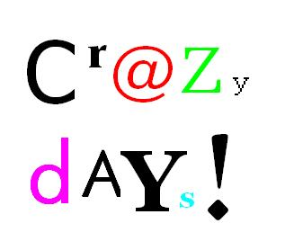
GRADED WRITING UNIT 6
Read the text and continue. Write about 6 more people.
An unusual day
Today is a crazy day at Praxis NMS.

What’s the matter today? Everything is different? It’s a crazy day at school! Mrs Bergmann usually speaks English or German but today she is speaking French. I can not understand her! Mr Grasser usually teaches maths but today he is singing and dancing in class. He is very happy…..



GRADED WRITING UNIT 6
Read the text and continue. Write about 6 more people.
An unusual day
Today is a crazy day at Praxis NMS.
What’s the matter today? Everything is different? It’s a crazy day at school! Mrs Bergmann usually speaks English or German but today she is speaking French. I can not understand her! Mr Grasser usually teaches maths but today he is singing and dancing in class. He is very happy…..


This Photo by Unknown Author is licensed under CC BY-SA

