M6: graded writing
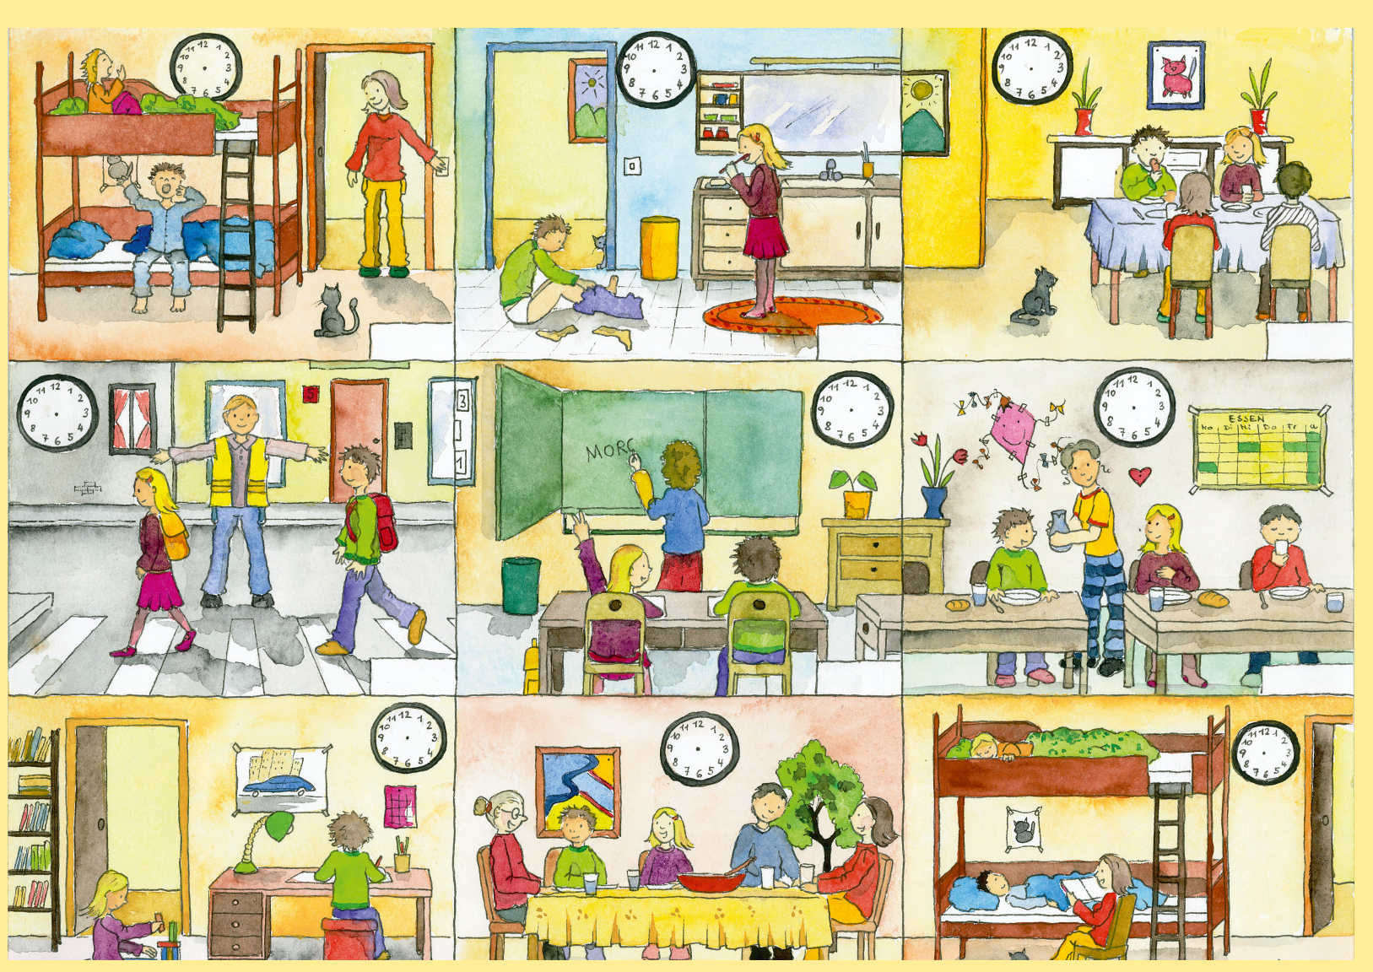
cc by Sprachförderzentrum | Referat 4, Elterleinplatz 14 / EG 23, 1170 Wien | sfz@ssr-wien.at
What are they doing?
Write 2-3 sentences about each picture: Say where they are and what they are doing.
Start like this:
In picture 1 they are in the children’s bedroom. The mother is waking up the kids. The cat is watching them.
In picture 2…

