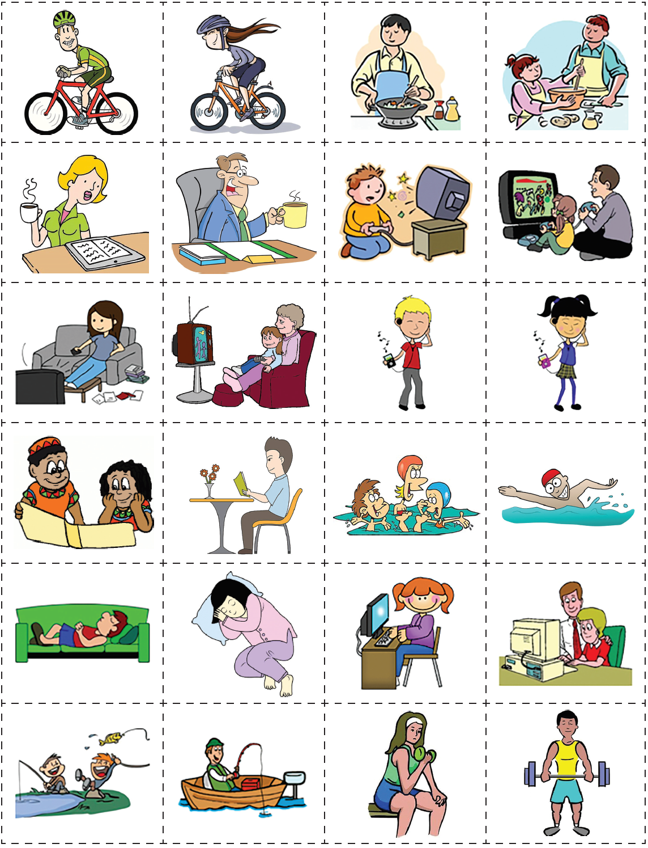
PAIRS: 1. Deal out all the cards. 2. Ask: What size shoes do your wear? Answer: I wear size …. shoes.
The student with the smalles shoes starts. 3. Read one of your TEXTcards. The student with the matching
PICTURE card collects the pair and reads out the next TEXT card. 4. Who can collect most pairs?
The boy is riding his bike. | The girl is riding her bike. | The man is cooking. | The man and the woman are cooking.
The woman is reading and drinking coffee. | The man is drinking coffee at his desk. | The child is watching TV. | The girl is watching TV with her father.
The girl is sitting on a sofa and watching TV. | The girl is sitting on her grandmother’s lap. They are watching TV. | The boy is listening to music on his phone. | The girl is listening to music on her phone.
The children are reading a book. | The man is sitting at a table and reading a book. | The children are swimming. | The boy is swimming.
The man is sleeping on a green sofa. | The woman is sleeping. | The girl is working on a computer. | The man and the woman are working on a computer.
The boys are fishing. | The man is sitting in his boat and he is fishing. | The girl is sitting on a bench and lifting hand weights. | The man is lifting weights.

Adapted from: https://www.teach-this.com/grammar-activities-worksheets/present-continuous

