What is Ruff doing?
6B

Watch the video and answer the questions.
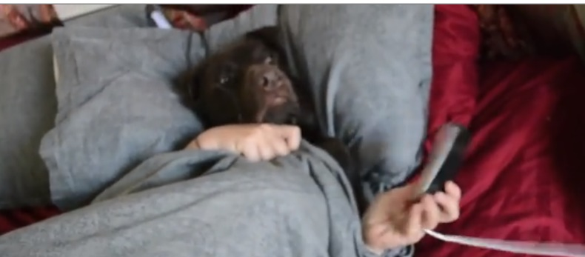

https://learningapps.org/view2169928

1 | In which room is Ruff? | Ruff is in the bedroom
 | What is he doing? | He is sleeping. / He is waking up.
2 | In which room is Ruff? | Ruff is in the bedroom / in front of his wardrobe.
 | What is he doing? | He is getting dressed.
3 | In which room is Ruff? | He is in the bathroom.
 | What is he doing? | He is brushing his teeth.
4a | In which room is Ruff? | He is on the loo
 | What is he doing? | He is reading the newspaper
4b | In which room is Ruff? | He is in the kitchen.
 | What is he doing? | He is having breakfast. / He is eating.
5 | In which room is Ruff? | He is in the living room.
 | What is he doing? | He is watching TV.
6 | Where is Ruff? | He is in the car.
 | What is he doing? | He is driving
7 | Where is Ruff going?  What is he going to do next? Write down your ideas. | LET YOUR TEACHER CHECK

