Reading comprehension for M6 Raw version – Quiz is already on Moodle
Source: https://www.roundtheclockrestaurants.com/breakfast-menu
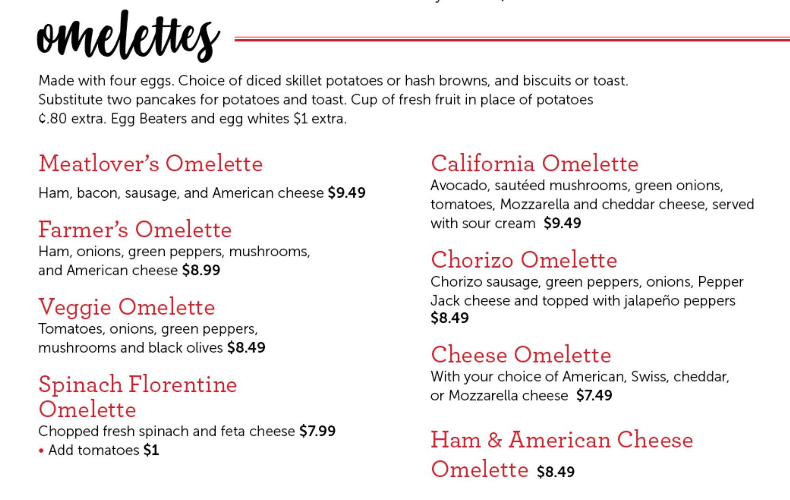
True or false
You get toast with each omelet.
no
Can you also get pancakes with your omelet?
yesThe Cheese Omelette is made with all four kinds of cheese: American, Swiss, ChedMeatSpinach Florentine OmeletteCadar and Mozzarella
If you do not want potatoes with your omelet, you can also get a cup of fresh fruit.
yes

The Cheese Omelette is made with all four kinds of cheese: American, Swiss, cedar and Mozzarella cheese.
No
The Spinach Florentine Omelette always comes with tomatoes.
no
The California Omelette is vegetarian.
yes

Recommend an omelet to the following people:
Max loves meat and hot spicy food. (Chorizo Omelette)
Mary is vegetarian, which omelets can you recommend to her? Veggie Omelette, Spinach Florentine Omelette, California Omelette, Cheese Omelette

Tony hates vegetables. Which omelet would you recommend to him? (Meatlover’s Omelette)

???????????

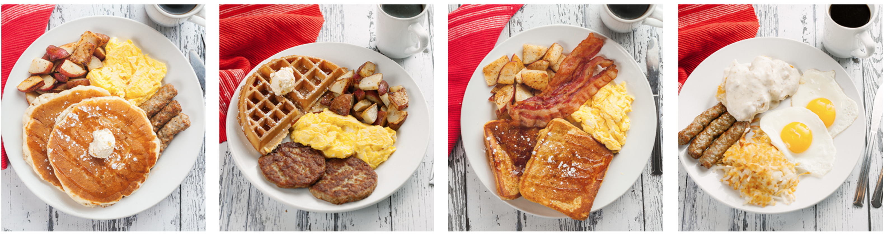

Match the pictures with the descriptions on the menu.
