M6: Write a text on paper
Complete the menu (Speisekarte) of the PARK Burger CAFÉ
Write typical ingredients into the menu. Write as many things as you can.
Soups
Salad bowls | Design your own salad: All our salad bowls are served with fresh bread. Choose from the following ingredients:
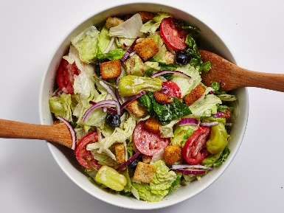
Our BURGERS | Fresh bun, juicy beef patty and …
Our burgers come with fresh beef patties. Choose 3 ingredients from the list.
Any extra one, add 50 cents.
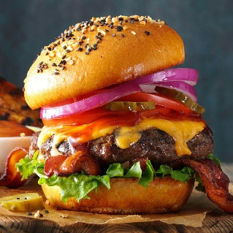
Deserts
Cakes | Browies
Cakes | Cupcakes
Cakes | Chocoloate cake
Cakes | American cheesecake
Icecream cups

Choose from these flavors

