1. Watch the video: Cooking with Mrs. Pölzleitner and Mrs Bergmann
Then make your own video. Click on the pictures to watch the videos.
http://www.polzleitner.com/epep/0-NMS/LisandLaura/2017-1b-Flexi/Module6-2017/com-phone-muffins.mp4
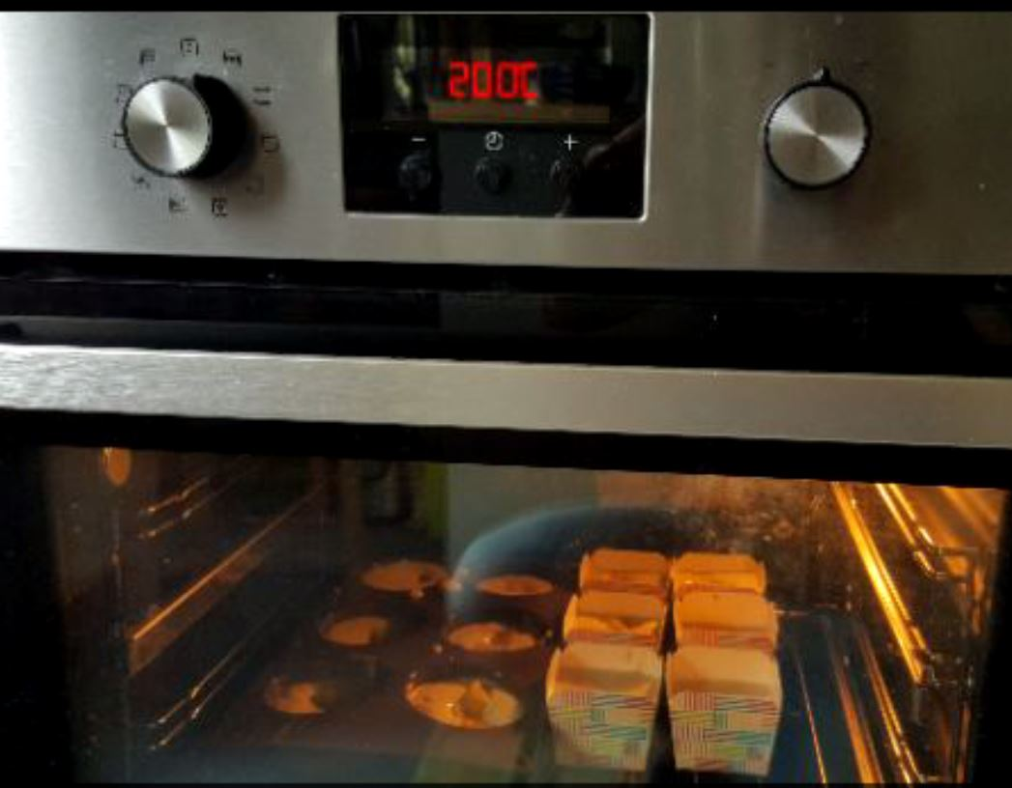 ..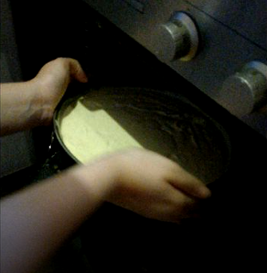
Step1: Download the app Com.phone on your mobile phone. 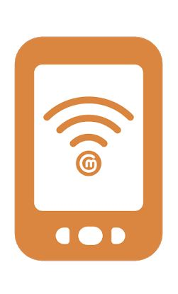
Try it out with 2 photos in your mobile phone. Ask a friend or your teacher if you need help.
Step 2: Plan your recipe:
Choose a simple recipe. Ask your parents to help you prepare it.
Step 3: Prepare all the ingredients and take a photo on your mobile phone.
Step 4: While you prepare the food, take photos of all the steps. Choose the photos that you want to use.
Step 5: Open the app Com.phone and add the photos in the correct order.
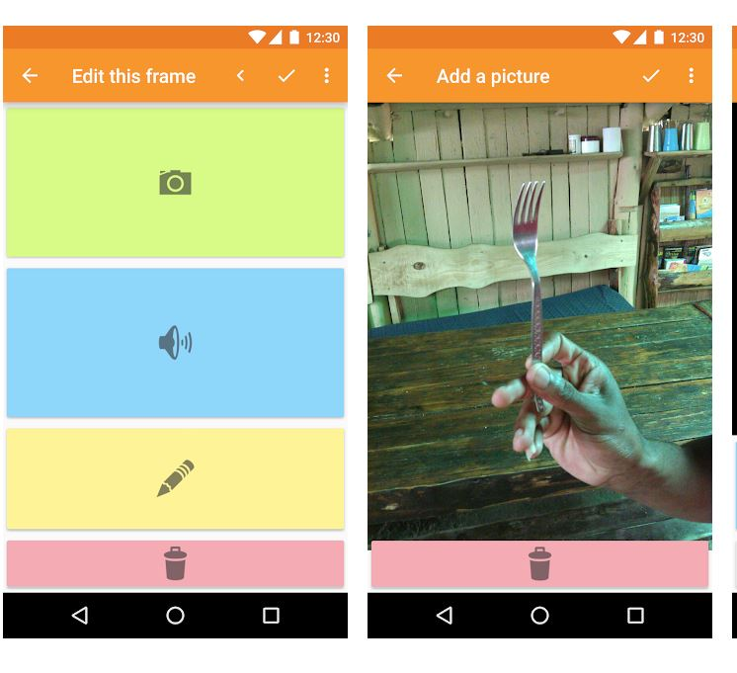
Step 6: Writing the text
a: Ask your teacher to help you find an English recipe that will help you with vocabulary.
Suche aus einem ähnlichen englischen Rezept alle Sätze aus, die du für dein Rezept brauchst.
b: Write your recipe steps on a sheet of paper.
Ask your teacher to check the language.
Step 7: Then write the text for each picture in the app.
Step 8: Practice reading your text. Then record it in the app.
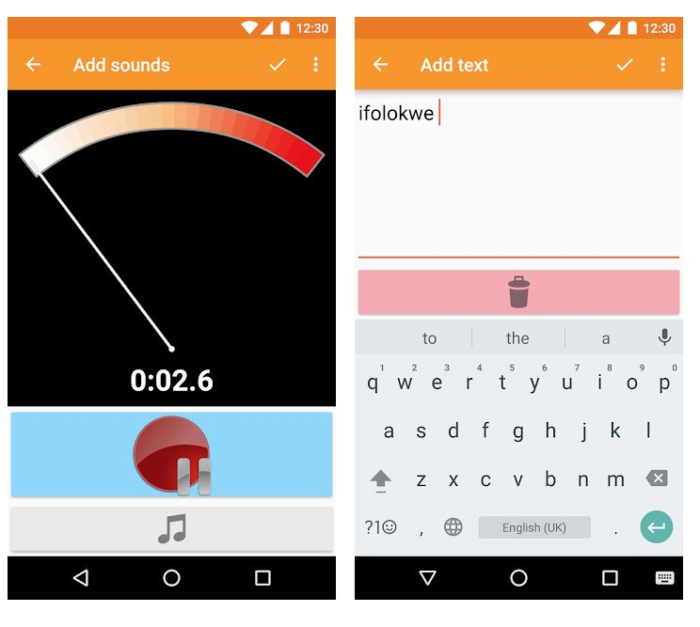
Step 9: Share your video with your teacher. 
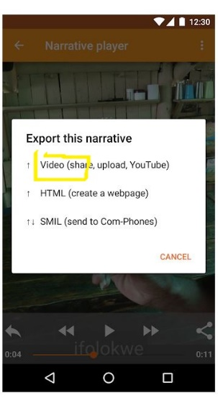
Choose "e-mail" -- and send your video to elisabeth.poelzleitner@phst.at
Congratulations!!!

The BEST 3 videos will win a prize.

