Delicious, fresh smoothies

Hello, would you like a fresh smoothie?
Yes, what kind of smoothies do you have?
You can choose the fruits yourself. We have
banana , mango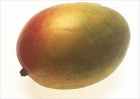apple 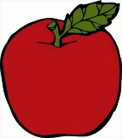, pear 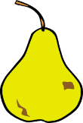, peach 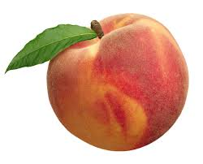, nectarine 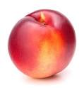, apricot 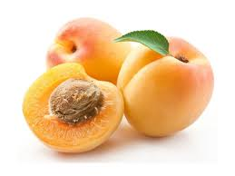
and you can choose between yoghurt and milk in your
smoothie.
How much does it cost?
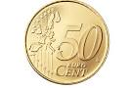
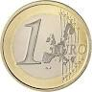
It’s 1 euro and 50 cents.
Great. Then I’ll have a smoothie with …………………………………………………and MILK // Yoghurt
Here you are. Enjoy your smoothie.

