Writing
A camping trip
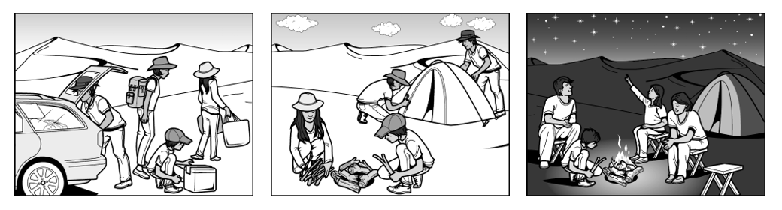
??
(task taken from https://writeandimprove.com)
Look at the pictures and write a little story in the past tense. How did the story end?
Write 50-70 words. Use good words to structure your story.

Listening
Do the listening task on moodle
Reading
Do the reading task on moodle
Alle Teilbereiche sind gleich gewichtet
Reading | % |  | Grade Writing |  | %  according to assessment scale – see online (eduvidual)
Listening | % |  |  |  | %  according to assessment scale – see online (eduvidual)
Schularbeitennote Einstufung  AHS  STANDARD |  | %

Notenschlüssel

AHS
Sehr gut: 90 – 100%
Gut: 80-89%
Befriedigend: 70 – 79%
Genügend: 60 – 69%
Nicht genügend <60%
STANDARD
Sehr gut: 70 – 100%
Gut: 60-69%
Befriedigend: 50 – 59%
Genügend: 40 – 49%
Nicht genügend <40%
https://writeandimprove.com/workbooks#/wi-workbooks/7485eb41-a047-4d23-ae25-5afb7387eba9/tasks/6385baa4-6355-421d-aa0b-6ddce2ad4030

