MODULE 7 Personal Time Planner
Week 1 |  | Week 2 |  | Week 3 |  | Week 4 |  | Week5
Date: ________ |  | Date: ________ |  | Date: ________ |  | Date: ____ |  | Date: ___
Date: ________ |  | Date: ________ |  | Date: ________ |  | Date: ____ |  | Date: ____
Date: ________ |  | Date: ________ |  | Date: ________ |  | Date: ____ |  | Date: ____
Week 6 |  | Week 7 |  | Week 8 |  | Week 9
Date: ________ |  | Date: ________ |  | Date: ____ |  | Date: ____
Date: ________ |  | Date: ________ |  | Date: ____ |  | Date: ____
 |  |  |  |  |  |  |  | 
Date: ________ |  | Date: ________ |  | Date: ____
normaler Zeitplan (2 Jahre) Zeitplan für 3 Jahre:
Start: Anfang Oktober Start: Anfang Februar
Abschluss: Mitte November Abschluss: Ende April

Module 7: Telling Stories in the Past
M7 Telling Stories
Task A

Task A - Greyfriars Bobby - Guess the story

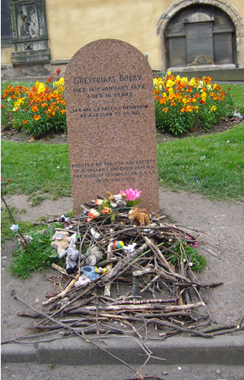
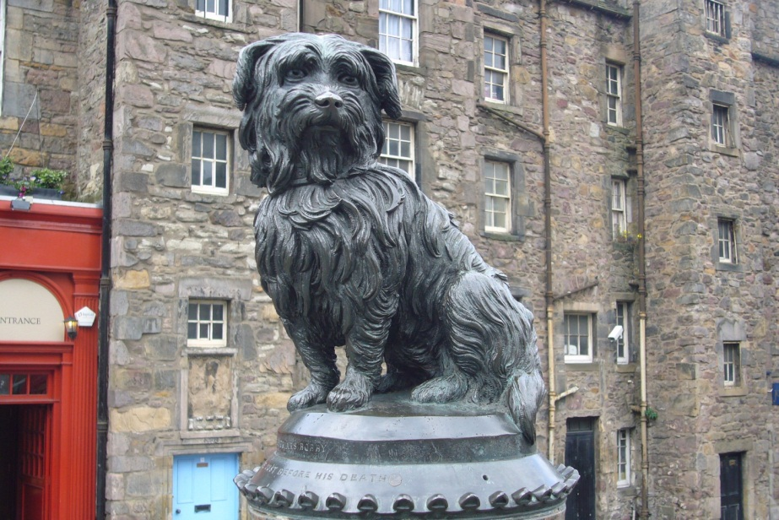
GUESS…

Who was Bobby?

Where did he live?

What happened?

Why did they build a statue of Bobby?

Now listen to Bobby’s story.

Task B - Correct the mistakes
M7
Task B

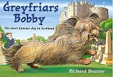
Somebody hasn’t been listening carefully here.

Read the story of Greyfriars Bobby

and correct the mistakes.

Greyfriars Bobby is the most famous dog who ever lived in America. He was so famous that a statue was put up to him in New York. We know that Bobby belonged to an Edinburgh teacher named John Gray. He was a Skye Terrier and his job was to help catch thieves. Bobby was very bad at that.

But one bitterly cold summer day John Gray fell ill with a terrible fever. Bobby snuggled close to him to keep him warm. He stayed beside his master even when John Gray died.
He followed the funeral procession to Greyfriars churchyard.

After the funeral Bobby stayed at his master’s house. He stood there and howled. He was very happy. The days came and went, and still Bobby did not leave his master’s house.

Dogs were not allowed in the churchyard, but James Brown, the grave-digger felt sorry for Bobby and let him stay. On cold nights he even invited him into his house and gave him some food.

When spring came, Bobby chased away all the birds in the churchyard. Mr. Brown was pleased, he didn’t like the birds in the churchyard.

Bobby soon made lots of friends. Many people brought him books and pencils. The waiters of the restaurants nearby gave him leftovers to eat. Lonely old ladies sang to him when they came to the graveyard.

Bobby became very famous. The story of the happy and faithful dog was reported in all the newspapers. Soon the churchyard was crowded with sightseers, painters and photographers. Now there is even a bronze statue of Bobby outside Greyfriars churchyard and Walt Disney made a song about him.

Bobby spent fourteen years close to his master’s grave. When he died, he was buried in a flowerpot in front of Greyfriars church. A hundred years later, a stone was put up to mark the spot. You can go to Greyfriars churchyard and see John Gray’s and Bobby’s graves.

Task C: Telling stories in the past
M7
Task C

Read the story summary of Greyfriars Bobby again and highlight
all the verbs (Zeitwörter, Tunwörter) in the past. Look at them carefully.
Some of the verbs have a regular past tense form (regelmäßig).
Write them here:

CHALLENGE: Find a rule: How do you build the past tense form of a verb?

Some of the words have an irregular past tense form (unregelmäßig).
Write them here: 

Task D - Past tense forms: Find the past tense forms in the text or on your irregular verbs sheet and write them into column two.
M7
Task D
Base form (present) | Past tense form
to be (Bobby is famous)
to be (The nights are cold.)
he lives in Scotland
he belongs to
he falls ill
he snuggles close to his master
he stays with his master
he stands there and waits
he howls unhappily
he comes back
I go
I do / he does
he invites him into the house
they give him food
he chases the cats away
he makes friends
They bring him food
I sing a song
He becomes famous
They make a film
He spends a lot of time there.

Task E - Sum up Bobby’s story in this story pie. Write in pencil or use an erasable pen. Show your page to your teacher.
M7
Task E

Travel with GRAN TOURS
- Gran’s cool Travel Agency.
- Go to the best places.
- Meet the coolest creatures.
- See the strangest things.
- Eat the most delicious foods.
- Do the craziest things.


M7
ME-book task

Write your own story about an exciting trip with Gran’s travel agency.
Step 1: Plan your story – Take notes!
Where did you go? | A place on Earth? The jungle, the ocean, a snowy mountain?  To the Moon? To another star?
Who came with you? | Take a friend or a family member with you.
How did you travel? | Did you go by airplane, by train, by car, by bus, by bike,  Or did you take a spaceship, a magic broom, a time capsule…
What did you see?  What was the place like? | Did you go to a village, a town, a large city, a forest, a mountain, a beach, a playground, a garden. Were there trees, flowers, houses, streets….
Who else was there? | What were the people, animals and other creatures like? Were they friendly / dangerous / weird / cool…?
What did you eat there?
What did you do? What happened?
How did you feel about it? |         Was it fun, scary, boring, exciting, exhausting …  This Photo by Unknown Author is licensed under CC BY-SA  This Photo by Unknown Author is licensed under CC BY-SA


Step 2: Write a first draft on a piece of paper in your spiral notebook.

Step 3: Discuss your story with your teacher. Then ask a friend for more ideas.
Step 4: Revise your story. Add more details to make your story interesting.

Step 5: Write your story into an origami storybook and draw pictures. Make a real masterpiece and put your booklet into your Me-book. Ask your teacher for an envelope.

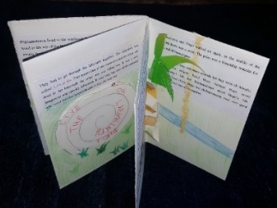
Nessie, The Loch Ness Monster
M7 Task F

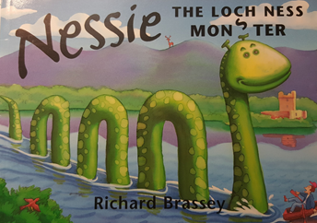

1. Read the book with a partner. Read it at least 2 times. The pictures will help you understand the information.

2. Work with your partner and answer the questions about the Loch Ness monster.

3. Look at the Loch Ness photos online:


4. Then make an information flyer about the Loch Ness monster. The flyer will help tourists who go to the lake to see the monster. You can use the design on the next page or create your own.

What does LOCH NESS mean?
What else could fit into Loch Ness? Find one answer from the text and come up with an idea from your life (e.g. house, PMS, Uhrturm)
When was the Noch Ness Monster first seen?
Who wrote down all the sightings of the monster?
Write down 3 (three) ways people tried to catch Nessie and what happened to them
If you were Nessie, would you have stayed in Loch Ness or gone away with your friends?
In 1933 people built the first roads to Loch Ness. Do you think Nessie liked that? Yes, because…./ No, because…
Why did so many people come to the lake?
How did people describe the monster?
Who made the monster footprints around the lake?
Have they found Nessie?

