For Experts: Mary, Queen of Scots
M7 Scotland
Task F
Task 1: Past tense forms that we find in the story Mary, Queen of Scots – Escape from Loch Leven
In the left column, you can see the base form (present) of the verbs. Read the examples carefully and fill in the right column with past tense forms. Tell us if the past tense form is regular (R) or irregular (IR). Tick one of the two boxes. The first example is already done for you!

Base form (present) | Past tense form | R | IR
Mary goes to France. | Mary went to France.
She speaks Scots and French.
She likes music and horse riding.
She becomes Queen of Scotland.
Mary returns to Scotland.
She marries her cousin.
She has a baby.
Rebel lords take her to an island.
She is not allowed to see her baby.
Mary is sad.
George promises to help Mary.
“Don’t worry,” Lady Seton says.
They walk in the courtyard.
The bird flies up the castle wall.
Mary helps Will.
Mary wants to be free.
The ladies go for a walk.
Mary misses her family.
She eats her supper.
Will sends a signal.
Mary sits down.
Mary finds a handkerchief.
Will steals the keys.
Will runs away quickly.
Mary’s army loses many battles.
Mary asks her cousin for help.
Elizabeth does not help Mary.
Mary, Queen of Scots
M7 Scotland
Reading Diary
Task 2: Design 2 beautiful pages in your reading diary.
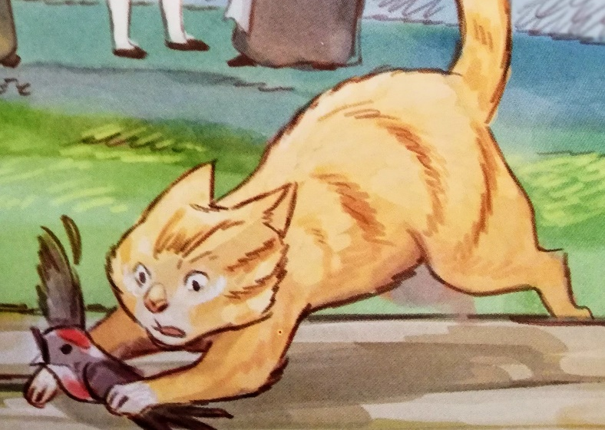
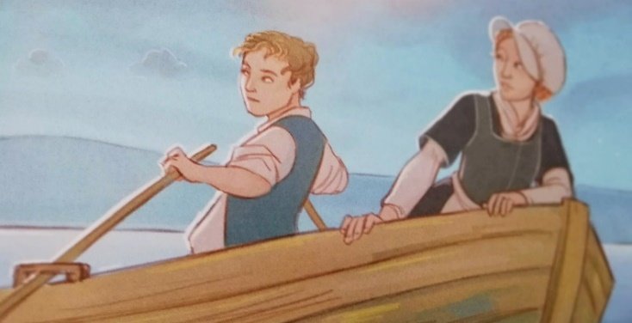
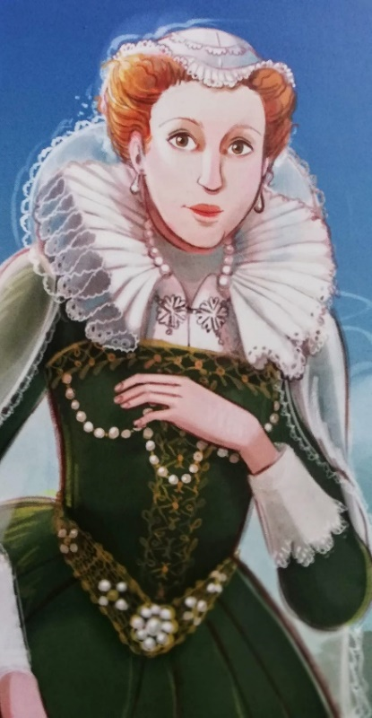

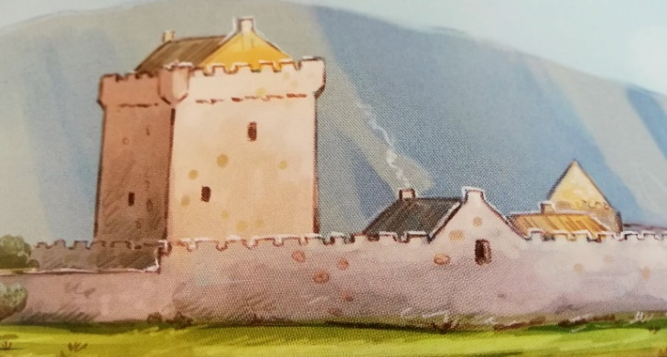

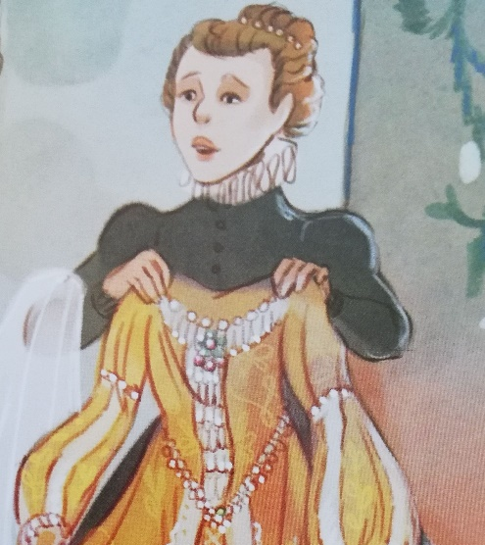

For the 2nd page in your reading diary, cut out the following questions. Glue the questions into your reading diary and answer them in whole sentences. Show your reading diary pages to your teachers!
- Who was Mary? What can you remember about her?
- Mary lived in different countries. Can you remember where she lived?
- What can you remember about her story?
- How did she escape Lochleven Castle?

