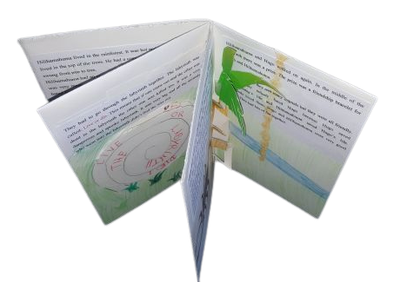
Our First Storywriting Project

Create your own origami storybook

Listen to the story "The Trouble with Gran".
Then travel to a cool place with Gran's travel agency and write a story about your adventure.
Use the story-planning worksheet on the next page and follow all the steps.
Start your story like this:
You won't believe what happened to me last week. I went on a trip with "Gran Tours"….






Travel with GRAN TOURS
- Gran’s cool Travel Agency.
- Go to the best places.
- Meet the coolest creatures.
- See the strangest things.
- Eat the most delicious foods.
- Do the craziest things.

Write your own story about an exciting trip with Gran’s travel agency.
Step 1: Plan your story – Take notes!
Where did you go? | A place on Earth? The jungle, the ocean, a snowy mountain?  To the Moon? To another star?
Who came with you? | Take a friend or a family member with you.
How did you travel? | Did you go by airplane, by train, by car, by bus, by bike,  Or did you take a spaceship, a magic broom, a time capsule…
What did you see?  What was the place like? | Did you go to a village, a town, a large city, a forest, a mountain, a beach, a playground, a garden. Were there trees, flowers, houses, streets….
Who else was there? | What were the people, animals and other creatures like? Were they friendly / dangerous / weird / cool…?
What did you eat there?
What did you do? What happened?
How did you feel about it? |         Was it fun, scary, boring, exciting, exhausting …  This Photo by Unknown Author is licensed under CC BY-SA  This Photo by Unknown Author is licensed under CC BY-SA


Step 2: Write a first draft on a piece of paper in your spiral notebook.
Step 3: Discuss your story with your teacher. Then ask a friend for more ideas.

Step 4: Revise your story. Add more details to make your story interesting.
Step 5: Write your story into an origami storybook and draw pictures.
Make a real masterpiece. Find out how to fold your origami book from an A3 sheet.

