The Blind Man and the Snake (for reading test 1 in M7)
1
Once upon a time a blind man and a man who could see were travelling together. They were riding on their horses and the blind man’s horse was following the other man’s horse all day. This helped the blind man to find the right way. The man who could see always told his friend where they were going and what he could see around him. He described the streets and the people, and he warned him if there was any danger.
Which of these statements are correct? Choose ALL the correct answers.
- Two friends were travelling together.
- The blind man was riding in the front.
- The blind man knew where they were going.
- It was a very dangerous road.

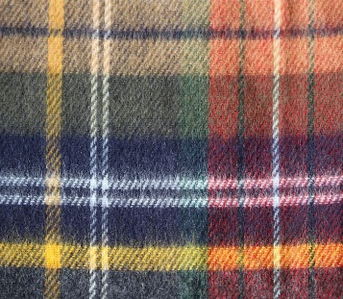
2
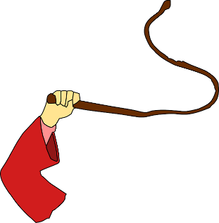
In the evening they lay down to sleep under a big tree. The grass was soft, and they made themselves soft beds of grass and leaves. When the sun rose in the morning, they woke up and got ready to leave again. The blind man searched for his whip in the grass next to him. By chance, a snake was lying next to him. It had crept under the blind man’s blanket during the night because it was cold outside.
Which of these statements are correct? Choose ALL the correct answers.
- The two men slept in soft beds in a guesthouse.
- The two men slept outside.
- Their beds were very hard and uncomfortable.
- Someone stole the blind man’s whip.
- The snake wanted to keep warm.
3
The blind man picked up the sleeping snake. It was stiff with the cold, but it felt soft in his hands.
The two men climbed on their horses and started to ride away. After a little while, the man who could see turned over and saw the snake in the blind man’s hand. He stopped his horse and said: “Oh my friend, quickly drop the snake in your hand. This is not your whip, it is a dangerous snake.”
But the blind man only laughed. “Why should I drop my good, soft whip? Do you want to steal it from me? My whip is much better than yours.”
Which of these statements are correct? Choose ALL the correct answers.
- The blind man’s whip was very soft.
- The man who could see wanted to steal the blind man’s whip.
- The man who could see wanted to help the blind man.
- The snake was soft and felt like a good whip.
- The blind man was happy and made a joke.
4
“My good friend,” answered the other man, “please believe me and throw away this snake. It is dangerous and will bite you.”
But the blind man did not drop the snake. He held it more tightly now. The warmth of the blind man’s hand woke up the snake. It opened its eyes and bit the blind man in his finger.
The blind man died quickly and painfully. Unfortunately, he had not believed his friend.
Multiple choice:
Why did the blind man not drop the snake?
- …because he wanted to keep the snake.
- …because he didn’t believe his friend.
- …because he thought that his friend was lying.
- …because he needed a whip to ride his horse.
- …because he was not afraid of snakes.

Adapted from: http://childrenstorybook.blogspot.com/2009/04/blind-man-and-snake.html

