Module SCOTLAND
M7 Scotland
Task A

Task A - Greyfriars Bobby - Guess the story

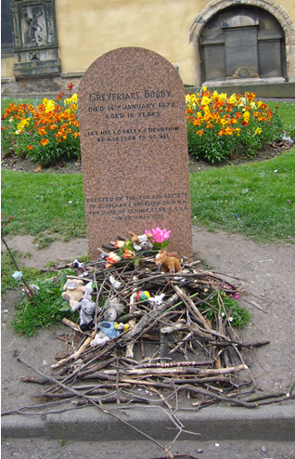
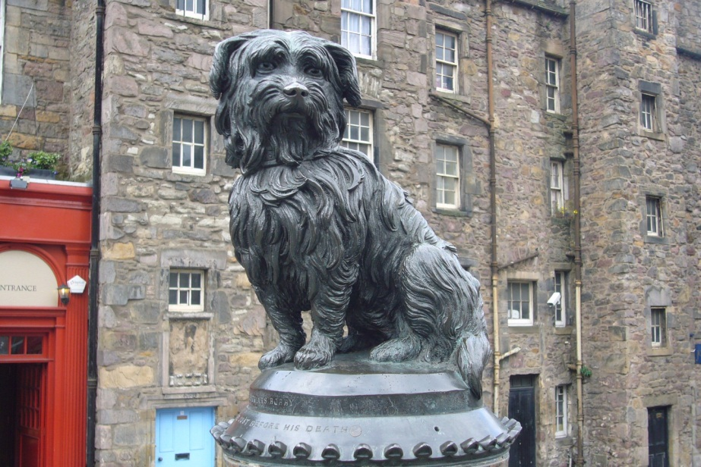
GUESS…

Who was Bobby?

Where did he live?

What happened?

Why did they build a statue of Bobby?

Now listen to Bobby’s story.

Task B - Correct the mistakes
M7 Scotland
Task B

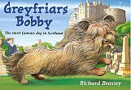
Somebody hasn’t been listening carefully here.

Read the story of Greyfriars Bobby

and correct the mistakes.

Greyfriars Bobby is the most famous dog who ever lived in America. He was so famous that a statue was put up to him in New York. We know that Bobby belonged to an Edinburgh teacher named John Gray. He was a Skye Terrier and his job was to help catch thieves. Bobby was very bad at that.

But one bitterly cold summer day John Gray fell ill with a terrible fever. Bobby snuggled close to him to keep him warm. He stayed beside his master even when John Gray died.
He followed the funeral procession to Greyfriars churchyard.

After the funeral Bobby stayed at his master’s house. He stood there and howled. He was very happy. The days came and went, and still Bobby did not leave his master’s house.

Dogs were not allowed in the churchyard, but James Brown, the grave-digger felt sorry for Bobby and let him stay. On cold nights he even invited him into his house and gave him some food.

When spring came, Bobby chased away all the birds in the churchyard. Mr. Brown was pleased, he didn’t like the birds in the churchyard.

Bobby soon made lots of friends. Many people brought him books and pencils. The waiters of the restaurants nearby gave him leftovers to eat. Lonely old ladies sang to him when they came to the graveyard.

Bobby became very famous. The story of the happy and faithful dog was reported in all the newspapers. Soon the churchyard was crowded with sightseers, painters and photographers. Now there is even a bronze statue of Bobby outside Greyfriars churchyard and Walt Disney made a song about him.

Bobby spent fourteen years close to his master’s grave. When he died, he was buried in a flowerpot in front of Greyfriars church. A hundred years later, a stone was put up to mark the spot. You can go to Greyfriars churchyard and see John Gray’s and Bobby’s graves.

Task C - Telling stories in the past
M7 Scotland
Task C

Read the story summary of Greyfriars Bobby again and highlight
all the verbs (Zeitwörter, Tunwörter) in the past. Look at them carefully.
Some of the verbs have a regular past tense form (regelmäßig).
Write them here:

CHALLENGE: Find a rule: How do you build the past tense form of a verb?

Some of the words have an irregular past tense form (unregelmäßig).
Write them here: 

Task D - Past tense forms: Find the past tense forms in the text and write them into column two.
M7 Scotland
Task D
Base form (present) | Past tense form
to be (Bobby is famous)
to be (The nights are cold.)
he lives in Scotland
We know
he belongs to
he falls ill
he snuggles close to his master
he stays with his master
he stands there and waits
he howls unhappily
he comes back
I go
I do / he does
he invites him into the house
they give him food
he chases the cats away
he makes friends
They bring him food
I sing a song
He becomes famous
They make a film
He spends a lot of time there.

Task E - Sum up Bobby’s story in this story pie. Write in pencil or use an erasable pen. Show your page to your teacher.
M7 Scotland
Task E

Then cut out the circle and glue it into your reading diary. Design a nice page for the story “Greyfriars Bobby”.

What else can you write about?

Irregular Verb Forms 2

There are about 185 irregular verbs in English. You will need only need these 90. Study them carefully

Base form | Past form | Last form |  | Base form | Past form | Last form
All forms different |  |  |  | Past form and last form end in [d]
be (is/was) | was / were | been |  | find | found | found
become | became | become |  | have | had | had
come | came | come |  | hear | heard | heard
do | did | done |  | hold | held | held
go | went | gone |  | lay | laid | laid
run | ran | run |  | make | made | made
see | saw | seen |  | pay | paid | paid
show | showed | shown |  | read [ri:d] | read [red] | read [red]
 |  |  |  | say | said | said
All forms the same |  |  |  | sell | sold | sold
cost | cost | cost |  | stand | stood | stood
cut | cut | cut |  | understand | understood | understood
hit | hit | hit |  | tell | told | told
hurt | hurt | hurt
let | let | let |  | Same sound patterns
put | put | put |  | bring | brought | brought
set | set | set |  | buy | bought | bought
shut | shut | shut |  | fight | fought | fought
 |  |  |  | think | thought | thought
Past form and last form the same |  |  |  | catch | caught | caught
dig | dug | dug |  | teach | taught | taught
win | won | won
 |  |  |  | sing | sang | sung
Past form and last form end in [t] |  |  |  | swim | swam | swum
build | built | built |  | begin | began | begun
burn | burnt | burnt |  | drink | drank | drunk
creep | crept | crept |  | ring | rang | rung
feel | felt | felt
keep | kept | kept |  | freeze | froze | frozen
leave | left | left |  | steal | stole | stolen
light | lit | lit |  | break | broke | broken
lend | lent | lent |  | wake | woke | woken
mean | meant | meant |  | choose | chose | chosen
meet | met | met |  | drive | drove | driven
send | sent | sent |  | write | wrote | written
shoot | shot | shot
sleep | slept | slept |  | beat | beat | beaten
smell | smelt | smelt |  | bite | bit | bitten
spend | spent | spent |  | eat | ate | eaten
spill | spilt | spilt |  | fall | fell | fallen
spoil | spoilt | spoilt |  | forget | forgot | forgotten
get | got | got |  | fogive | forgave | forgiven
lose | lost | lost |  | give | gave | given
sit | sat | sat |  | hide | hid | hidden
sweep | swept | swept |  | shake | shook | shaken
 |  |  |  | take | took | taken
Same sound pattern |  |  |  | tear | tore | torn
grow | grew | grown |  | wear | wore | worn
fly | flew | flown
know | knew | known
throw | threw | thrown

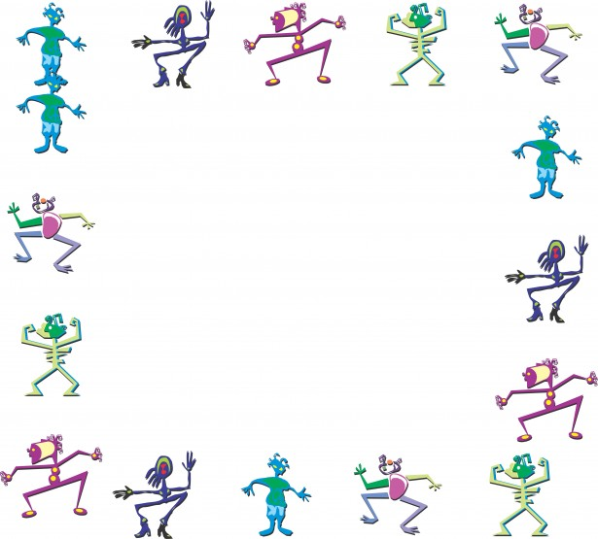
M7 Scotland
Reading Diary
Travel with GRAN TOURS
- Gran’s cool Travel Agency.
- Go to the best places.
- Meet the coolest creatures.
- See the strangest things.
- Eat the most delicious foods.
- Do the craziest things.

Write your own story about an exciting trip with Gran’s travel agency.
Step 1: Plan your story – Take notes!
Where did you go? | A place on Earth? The jungle, the ocean, a snowy mountain?  To the Moon? To another star?
Who came with you? | Take a friend or a family member with you.
How did you travel? | Did you go by airplane, by train, by car, by bus, by bike,  Or did you take a spaceship, a magic broom, a time capsule…
What did you see?  What was the place like? | Did you go to a village, a town, a large city, a forest, a mountain, a beach, a playground, a garden. Were there trees, flowers, houses, streets….
Who else was there? | What were the people, animals and other creatures like? Were they friendly / dangerous / weird / cool…?
What did you eat there?
What did you do? What happened?
How did you feel about it? |         Was it fun, scary, boring, exciting, exhausting …  This Photo by Unknown Author is licensed under CC BY-SA  This Photo by Unknown Author is licensed under CC BY-SA

Step 2: Write a first draft on a piece of paper in your spiral notebook.
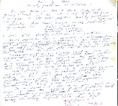
Step 3: Discuss your story with your teacher.
Then ask a friend for more ideas.
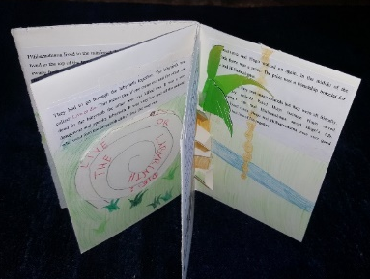
Step 4: Revise your story. Add more details to make your story interesting.

Step 5: Write your story into an origami storybook and draw pictures. Make a real masterpiece.

For Experts: Mary, Queen of Scots
M7 Scotland
Task F
Task 1: Past tense forms that we find in the story Mary, Queen of Scots – Escape from Loch Leven
In the left column, you can see the base form (present) of the verbs. Read the examples carefully and fill in the right column with past tense forms. Tell us if the past tense form is regular (R) or irregular (IR). Tick one of the two boxes. The first example is already done for you!

Base form (present) | Past tense form | R | IR
Mary goes to France. | Mary went to France.
She speaks Scots and French.
She likes music and horse riding.
She becomes Queen of Scotland.
Mary returns to Scotland.
She marries her cousin.
She has a baby.
Rebel lords take her to an island.
She is not allowed to see her baby.
Mary is sad.
George promises to help Mary.
“Don’t worry,” Lady Seton says.
They walk in the courtyard.
The bird flies up the castle wall.
Mary helps Will.
Mary wants to be free.
The ladies go for a walk.
Mary misses her family.
She eats her supper.
Will sends a signal.
Mary sits down.
Mary finds a handkerchief.
Will steals the keys.
Will runs away quickly.
Mary’s army loses many battles.
Mary asks her cousin for help.
Elizabeth does not help Mary.
Mary, Queen of Scots
M7 Scotland
Reading Diary
Task 2: Design 2 beautiful pages in your reading diary.
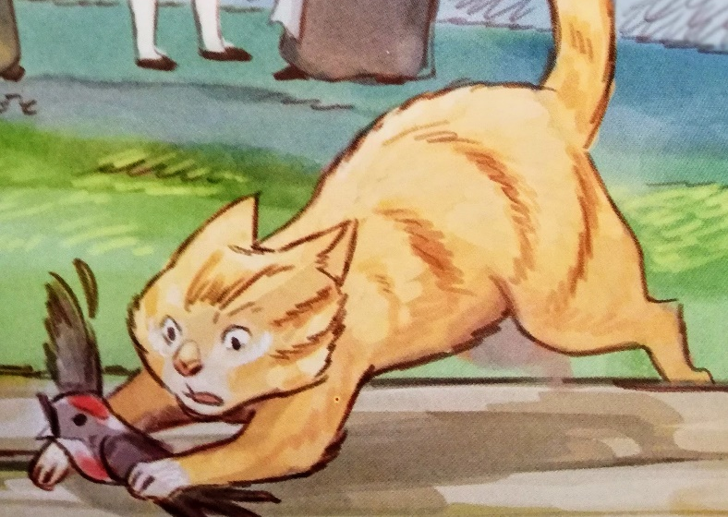
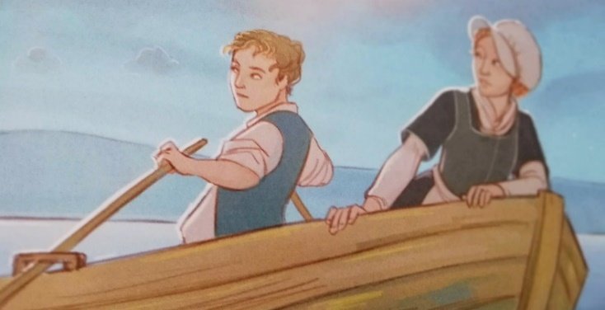
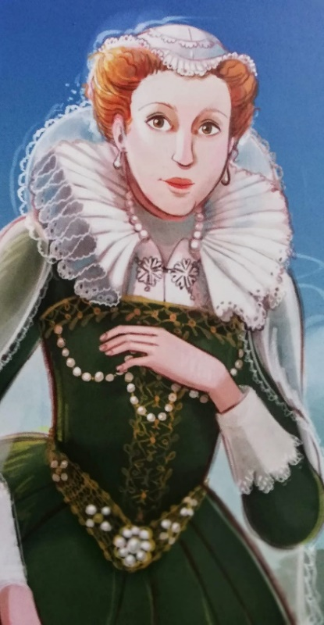

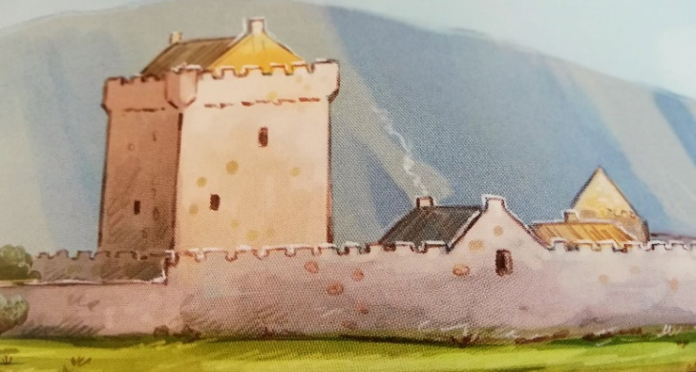

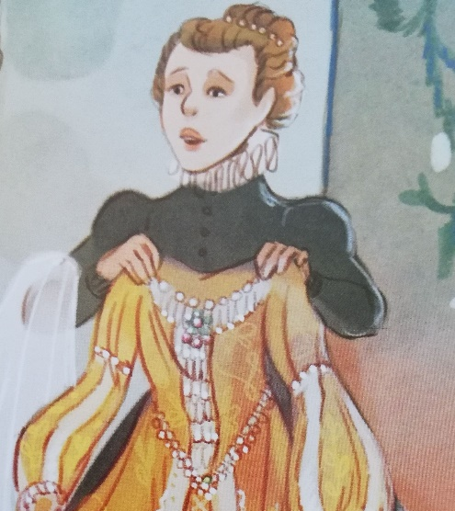

For the 2nd page in your reading diary, cut out the following questions. Glue the questions into your reading diary and answer them in whole sentences. Show your reading diary pages to your teachers!
- Who was Mary? What can you remember about her?
- Mary lived in different countries. Can you remember where she lived?
- What can you remember about her story?
- How did she escape Lochleven Castle?

