Stretch your Memory: Your teachers’ holiday stories
A visit to Edinburgh  In summer I went to Edinburgh. It was wonderful! We stayed in a little house with a garden. It was a 20 minute walk to the city centre.  There were lots of interesting shops on the way to the centre, so I really enjoyed the walk.  One day we visited the castle. It was fantastic! We had a great view of Edinburgh.  The next day we went to the Museum of Scotland. It was amazing! We spent five hours in the museum. Then we were really tired and hungry, so we went home quickly. | In the Highlands  I spent a week in the Scottish Highlands this summer. I really liked it. The best day was when we visited a farm with many sheep and a sheepdog. We watched the sheepdog at work. The dog could understand many different commands.  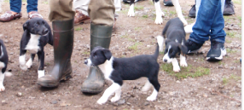  After that we fed the baby sheep with milk bottles and played with the young dogs. They were really sweet! | BBC Breakfast  One day we decided to go to the BBC breakfast show. It started at 6am so we got up at half past five in the morning. We got dressed and went to the show.  When we arrived we got seats in the first row. We could see everything and of course we were on TV! After the show we sat on the red couch and took a picture.    The show ended at 9am and then we had breakfast in a famous restaurant – the elephant house. In this restaurant J.K.Rowling wrote Harry Potter! | Dolphins and Whales  One day it was really sunny and warm, so we went to the beach. It was wonderful. We had a nice picnic and then we watched the sea. Suddenly I saw something. We took a picture and saw that it was a dolphin.  We were very excited! Then we saw another dolphin and another. I think there were six or seven dolphins!  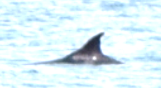  Then my husband saw something - it was far away and it was black. We took a picture and zoomed in. Then we saw that it was an orca – a killer whale!
My holidays in Greece  I spent my summer holidays in Greece. We stayed in a little house close to the beach. Every morning I went jogging in the cool morning air. When I came back we all had breakfast on the terrace. We enjoyed the beautiful view of the blue sea. We went swimming every day. The water was nice and warm and there were no clouds in the sky. It was very hot, but I like hot weather. I read lots of great books in the shade of a big olive tree and I often met friends and neighbors and talked for hours. | A Walk in the River  One day we made an excursion to Acheron Springs. It was a really beautiful day with bright sunshine. We walked in the ice-cold water of the Acheron river. We walked along the river for an hour, then the water got so deep that we had to swim. The current (Strömung) was very strong. It was hard to swim to the other side. Then we continued our walk in the river until we came to a beautiful old stone bridge. There we sat on the rocks to warm up in the sun, because we were all freezing.  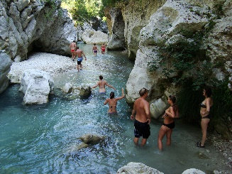 | Camping in the garden  In August my daughter Anna came to visit us in Greece. She brought five friends, so our house was too small for all the guests. They put up their tents in the garden. We had a lot of fun and spent a lot of time chatting and talking. Anna’s friends love cooking. They spent many hours in the kitchen and they cooked us some delicious dinners. We ate the wonderful meals on our terrace and watched the beautiful sunsets.  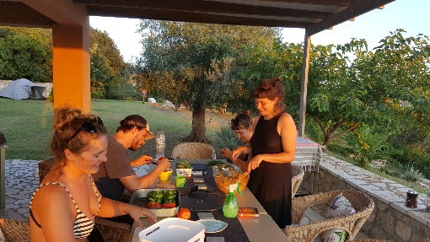 | A Greek wedding  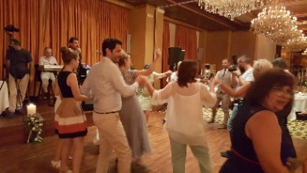  On August 26th our friend Thanasis got married and we were invited to his wedding. The wedding started at 5 o’clock. All the guests met in front of the church. Then we waited for the bride to arrive. When she came everybody took pictures. She was very pretty in her long white dress. The church service was quite long. It was very different from our church at home. Then we all went to a fancy hotel for the wedding reception. There was a delicious buffet for the 300 guests and we all ate a lot and talked to friends. Then a group of musicians came and played traditional Greek music. All the people started to dance. It was a great experience.

