MODULE 8: Personal Time Planner
Week 1 |  | Week 2 |  | Week 3 |  | Week 4 |  | Week5
Date: ________ |  | Date: ________ |  | Date: ________ |  | Date: ____ |  | Date: ___
Week 6 |  | Week 7 |  | Week 8 |  | Week 9
Date: ________ |  | Date: ________ |  | Date: ____ |  | Date: ____
 |  |  |  |  |  |  |  | 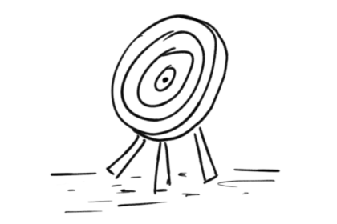
normaler Zeitplan: (2 Jahre) Zeitplan für 3 Jahre:
Start: Anfang Dezember Start: Ende April 2. Jahr
Abschluss: Ende Jänner Abschluss: Ende Juni, 2. Jahr

Animals
8 A

Let’s discuss:
My pet or
The pet that I would like to have

Do you have a pet? What is it? Tell us about it.
If you do not have a pet, what animal would you like to have?
Why? What do you like about this animal?

Your teacher will read you the book. Listen carefully and do all the little tasks.

The Snagglegrollop
Listen and draw the snagglegrollop
Parents don’t want pets because…

The Quibblesnuff:
What does the snagglegrollop eat? How many things can you remember?

What else do you have to do if you have a snagglegrollop?

The quibblesnuff: Color the quibblesnuff according to the info below.
Your quibblesnuff's body is light blue. Your quibblesnuff's lips are bright red and the tip of her trunk is also red. Her eyes are orange. Your quibblesnuff's wings are pink and her ears are green. Your quibblesnuff's hands and fingers are purple. The curls on top of her head are black. She is holding a yellow handbag. She is wearing grey boots with a bit of pink fur on top.
Now compare your quibblesnuff with the quibblesnuff in the book. Is it the same? What are the differences?
Write them here in the box below:

In the book, the quibblesnuff’s body is……..

Be an animal expert
8 B
Work with a partner. Find the info cards 8.1 about interesting pets in Erik. Choose an animal and read the information about it carefully. Take notes in the animal info card below. Just write keywords.
Then tell your partner how to care for “your” pet and find out how to care for the other pet.
They need… (a large tank)
You should…
Can I take them for walks?
What do they eat?

You must …

How often do I have to clean the cage?
You have to…
Do they need a cage?
You shouldn’t…

Type of animal: | Appearance and general info | How do they move?
Home: | Food: | Other information

Type of animal: | Appearance and general info | How do they move?
Home: | Food: | Other information

8 C
Fantasy animal: Pet Info
What you need to know about horsotigopigchicks.

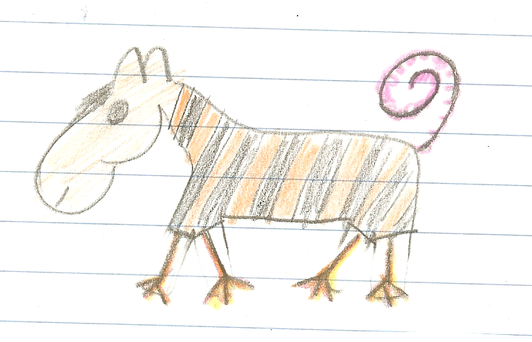
Appearance:
Horsotigopigchicks are really great pets.

These animals have the head of a horse, the body of a tiger, the tail of a pig and the legs of a chicken.
They have short hair and a short black mane. The tail of the horsotigopigchick is pink and very thin. It does not have any hair. Horsotigopigchicks are the size of a dog and they weigh about 15 to 20 kilograms.
Home:
Hortotigopigchicks can live in your house or they can live outside in the garden. They need a doghouse to keep them warm and to spend the night.
In the winter, when it is very cold, you should keep them inside during the night.

How do they move?

Horsotigopigchicks can walk. They do not run very fast because their legs are short and weak. This is great because they do not need a big garden.

.

What do they eat?
Horsotigopigchicks eat almost everything. Their favorite foods are spaghetti, pizza, bread and sweets. They also like fruits and they eat grass and leaves in the garden. The only thing these animals do not like is hot and spicy food like pepperoni or chili.

Other information:
Hortotigopigchicks are very shy animals. They get along well with children, but they are scared of loud noises and big dogs. You can take them for short walks, but you have to walk slowly and you must keep them on a leash. You should not take them to places with lots of people or cars.

Now it’s your turn to describe your animal in detail. Write a pet-info brochure like this one. Show it to your teacher. This is a graded task – so do it carefully.
Then correct your text and make a really nice pet-info brochure. You will need your brochure for the final speaking task on flipgrid and for your Me-book.
The words and ideas on the next page will help you.

Useful words and ideas to describe your animal:

The animal’s name
Make up a new name for your animal. For example:
a mousodogobird has the head of a mouse, the body of a dog and it has the wings of a bird.

What body parts?
giraffes have long, thin legs, monkeys have strong arms, birds have wings, giraffes have very long necks, hippos have big heads, mice have small ears and eyes, squirrels have bushy tails, pigs have a fat bodies, monkeys have fingers and toes, cats have claws, fish have fins, male lions have manes, dogs have strong teeth.

Appearance: skin and hair
rabbit have soft, fluffy fur and smooth skin, dragons and fish have scales, an elephant’s skin has folds and wrinkles, some dogs have long hair, others have short hair, horses and lions have a mane

How does it move?
cats can walk and climb on trees, frogs jump, birds fly, mice run very fast, ants and caterpillars crawl, fish swim.

What does it eat?
horses eat grass, cats eat meat, some insects drink blood, pigs eat everything (they are omnivores – Allesfresser), sheep eat grass and leaves, (they are herbivores –Pflanzenfresser)

Home:
Does your animal need a cage? Does it live outside? Does it need a dog house or a big stable?
Can it live in your room?
Do you have to walk it on a leash?

Is it a good family pet?
Does it like children? Is it dangerous? Does it bite?
Do you need a leash to walk it outside? Does it sleep during the day or at night? Does it need any toys to be happy?
How does your animal get along with other animals? Does it fight? Does it like other animals?
What is it afraid of?

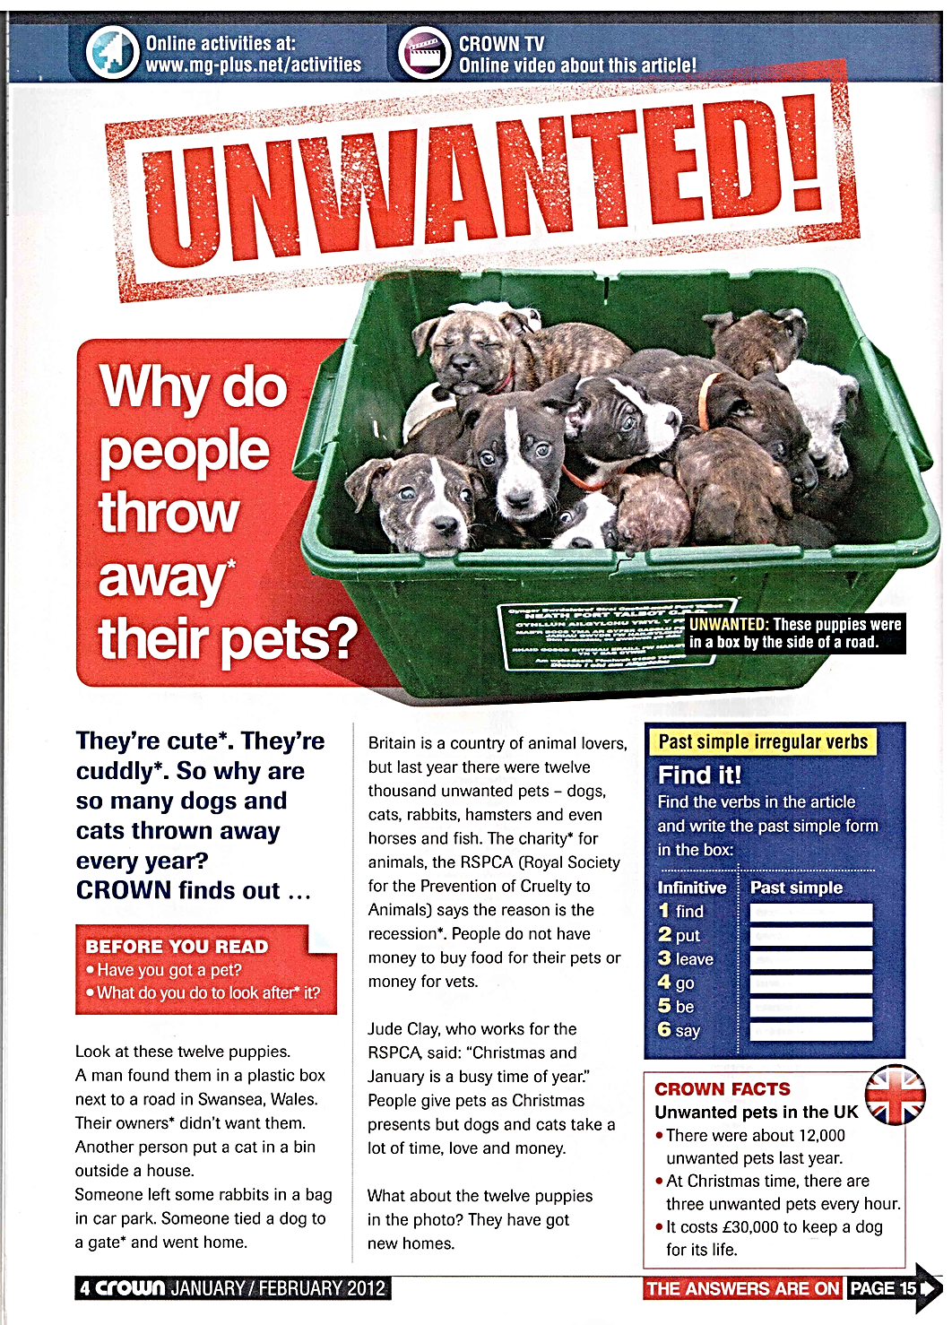
READING:
8 D

*to thorw away = wegwerfen | *cute = süss | *cuddly = kuschelig | * to look after = sich kümmern um | * owner = Besitzer | *gate = Tor | *charity = Wohlfahrtsorganisation | *recession = Rezession

Where were these animals left? (A: Direct careful reading, scanning)
12 puppies
cat
rabbits
dog

Do the dogs in the pictures have new homes already? yes no

Put the events in the right order: (Inferred Meaning, logical organisation of the text – not really but trains logic skills)  - The child gets bored  - It’s Christmas  - The RSPCA has got the animal  - A child wants a pet  - Someone buys a pet as a present  - The child is happy  - The pet is given or thrown away | What is the text about? (choose the BEST answer) (Expeditious Reading ,differentiating between main message and detail(s)  Britain – a country of animal lovers  the RSPCA – a royal society  pets that nobody wants  Christmas, a busy time  - How many unwanted pets are there in the UK every year? ___________________________  - How much does a dog cost in his whole life?  - _____________________________________  - What is the RSPCA?  - _____________________________________  - Where does Jude Clay work?  - _____________________________________
Why is Christmas time busy for Jude Clay, who works at the RSPCA? Inferred meaning

What happens to many people, when there is a recession? Inferred meaning
