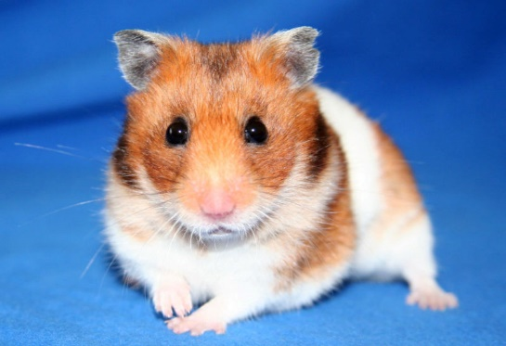  This Photo by Unknown Author is licensed under CC BY-ND | 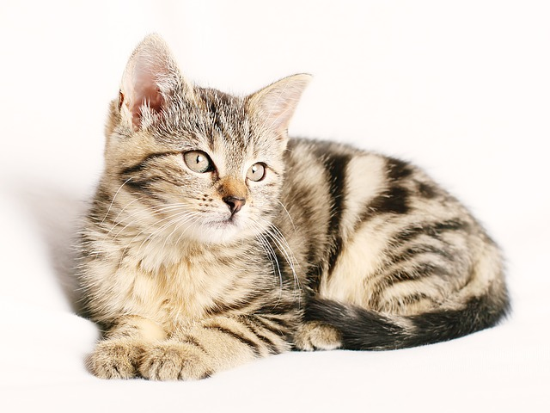 |  | 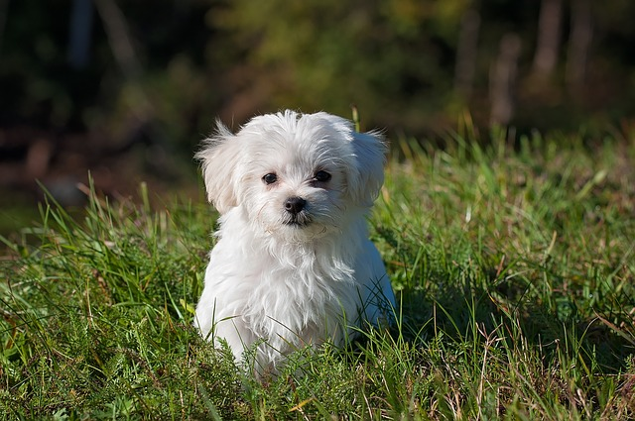
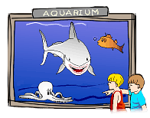 | 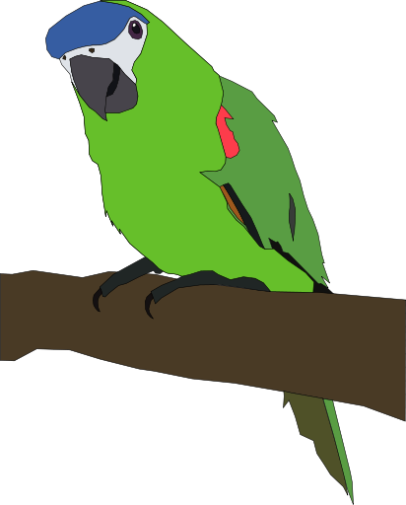 |  | 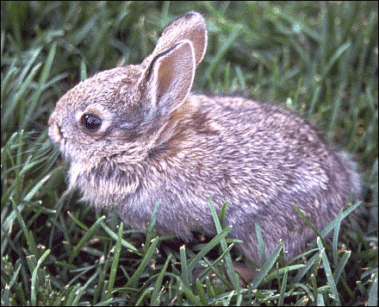
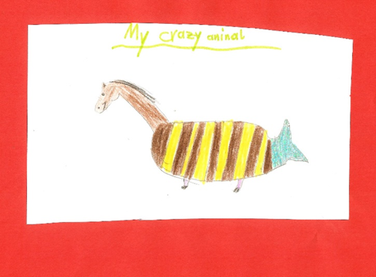 |  | 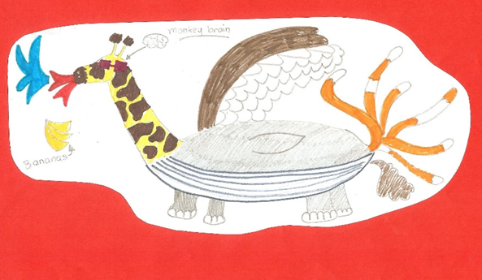
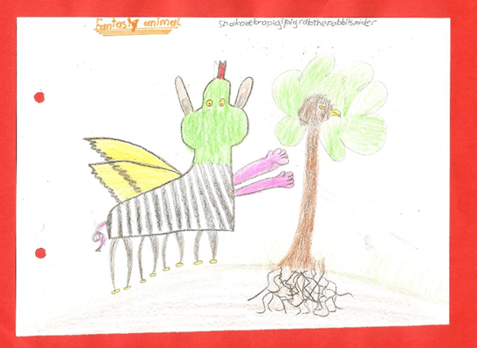 |  | 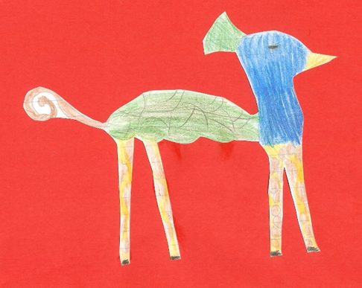
Writing test
Draw two animals from your teacher’s collection: one real pet and one fantasy pet.
Write guidelines for a pet info page.
Write about
- Looks
- Home
- Food
- Other information
Tell your readers what you should and shouldn’t do with your pet
and
what you must or must not do with your pet.

