Challenge: Comparing exotic animals
LR book
Read the descriptions of these exotic animals and highlight all the comparisons (Vergleiche). Then match them with the pictures. Draw lines.
Tigohorsophin
The tigohorsophin is a lovely animal. It has the head and neck of a horse, the body of a fat tiger and the tail and fin of a dolphin. It has the smallest. shortest legs of all the exotic animals. Normally it doesn’t walk but it can swim. The tigohorsophin is the heaviest of the exotic animals and it is even slower than the horsotigopigchick but it is the most intelligent of all the exotic animals.
Crocosharkopeacock
The crocosharkopeacock is a very strange animal. It has a crocodile’s head, the body of a shark and the tail and feathers of a peacock. Its legs are as short as a crocodile’s and it cannot run very fast, but the crocosharkopeacock can fly faster than any other bird. It is the fastest animal in the world. It has very sharp teeth and it is one of the most dangerous animals in the world.
Horsotigopigchick
The horsotoigopigchick has the body of a tiger, the head of a horse, the tail of a pig and the feet of a chicken. Its head is bigger than a tiger’s head and a lot heavier. The horsotigopigchick’s legs are much thinner than a tiger’s legs and it much slower than a tiger. It has a think pink tail and it is a very peaceful animal. It is the friendliest of these animals and makes a perfect pet.

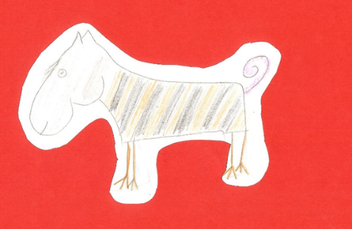
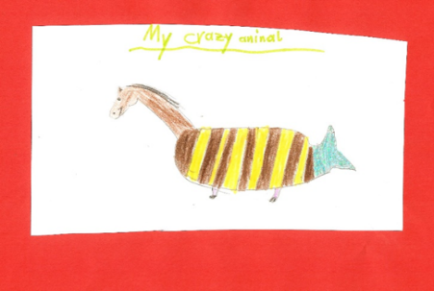
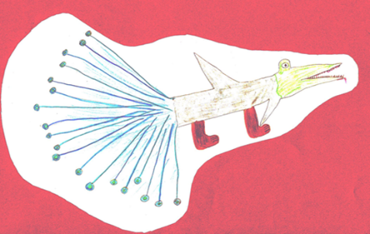

Are these sentences true or false? Tick the correct ones and correct the false ones.
Horsotigopigchicks are as fast as tigers.
Challenge:
Find the rule.
How do we compare adjectives?
How would you explain this to your mom?
Tigohorsophins are the heaviest and slowest animals. in this group.
Tigohorsophins are the most intelligent of the exotic animals.
The crocosharkopeacock has the shortest legs of the three animals.
The horsotigopigchick is the most dangerous animal in this group.
Challenge
1. Show that you can do this.
thin
kind
cold
intelligent
beautiful
interesting

2. Explain it!

