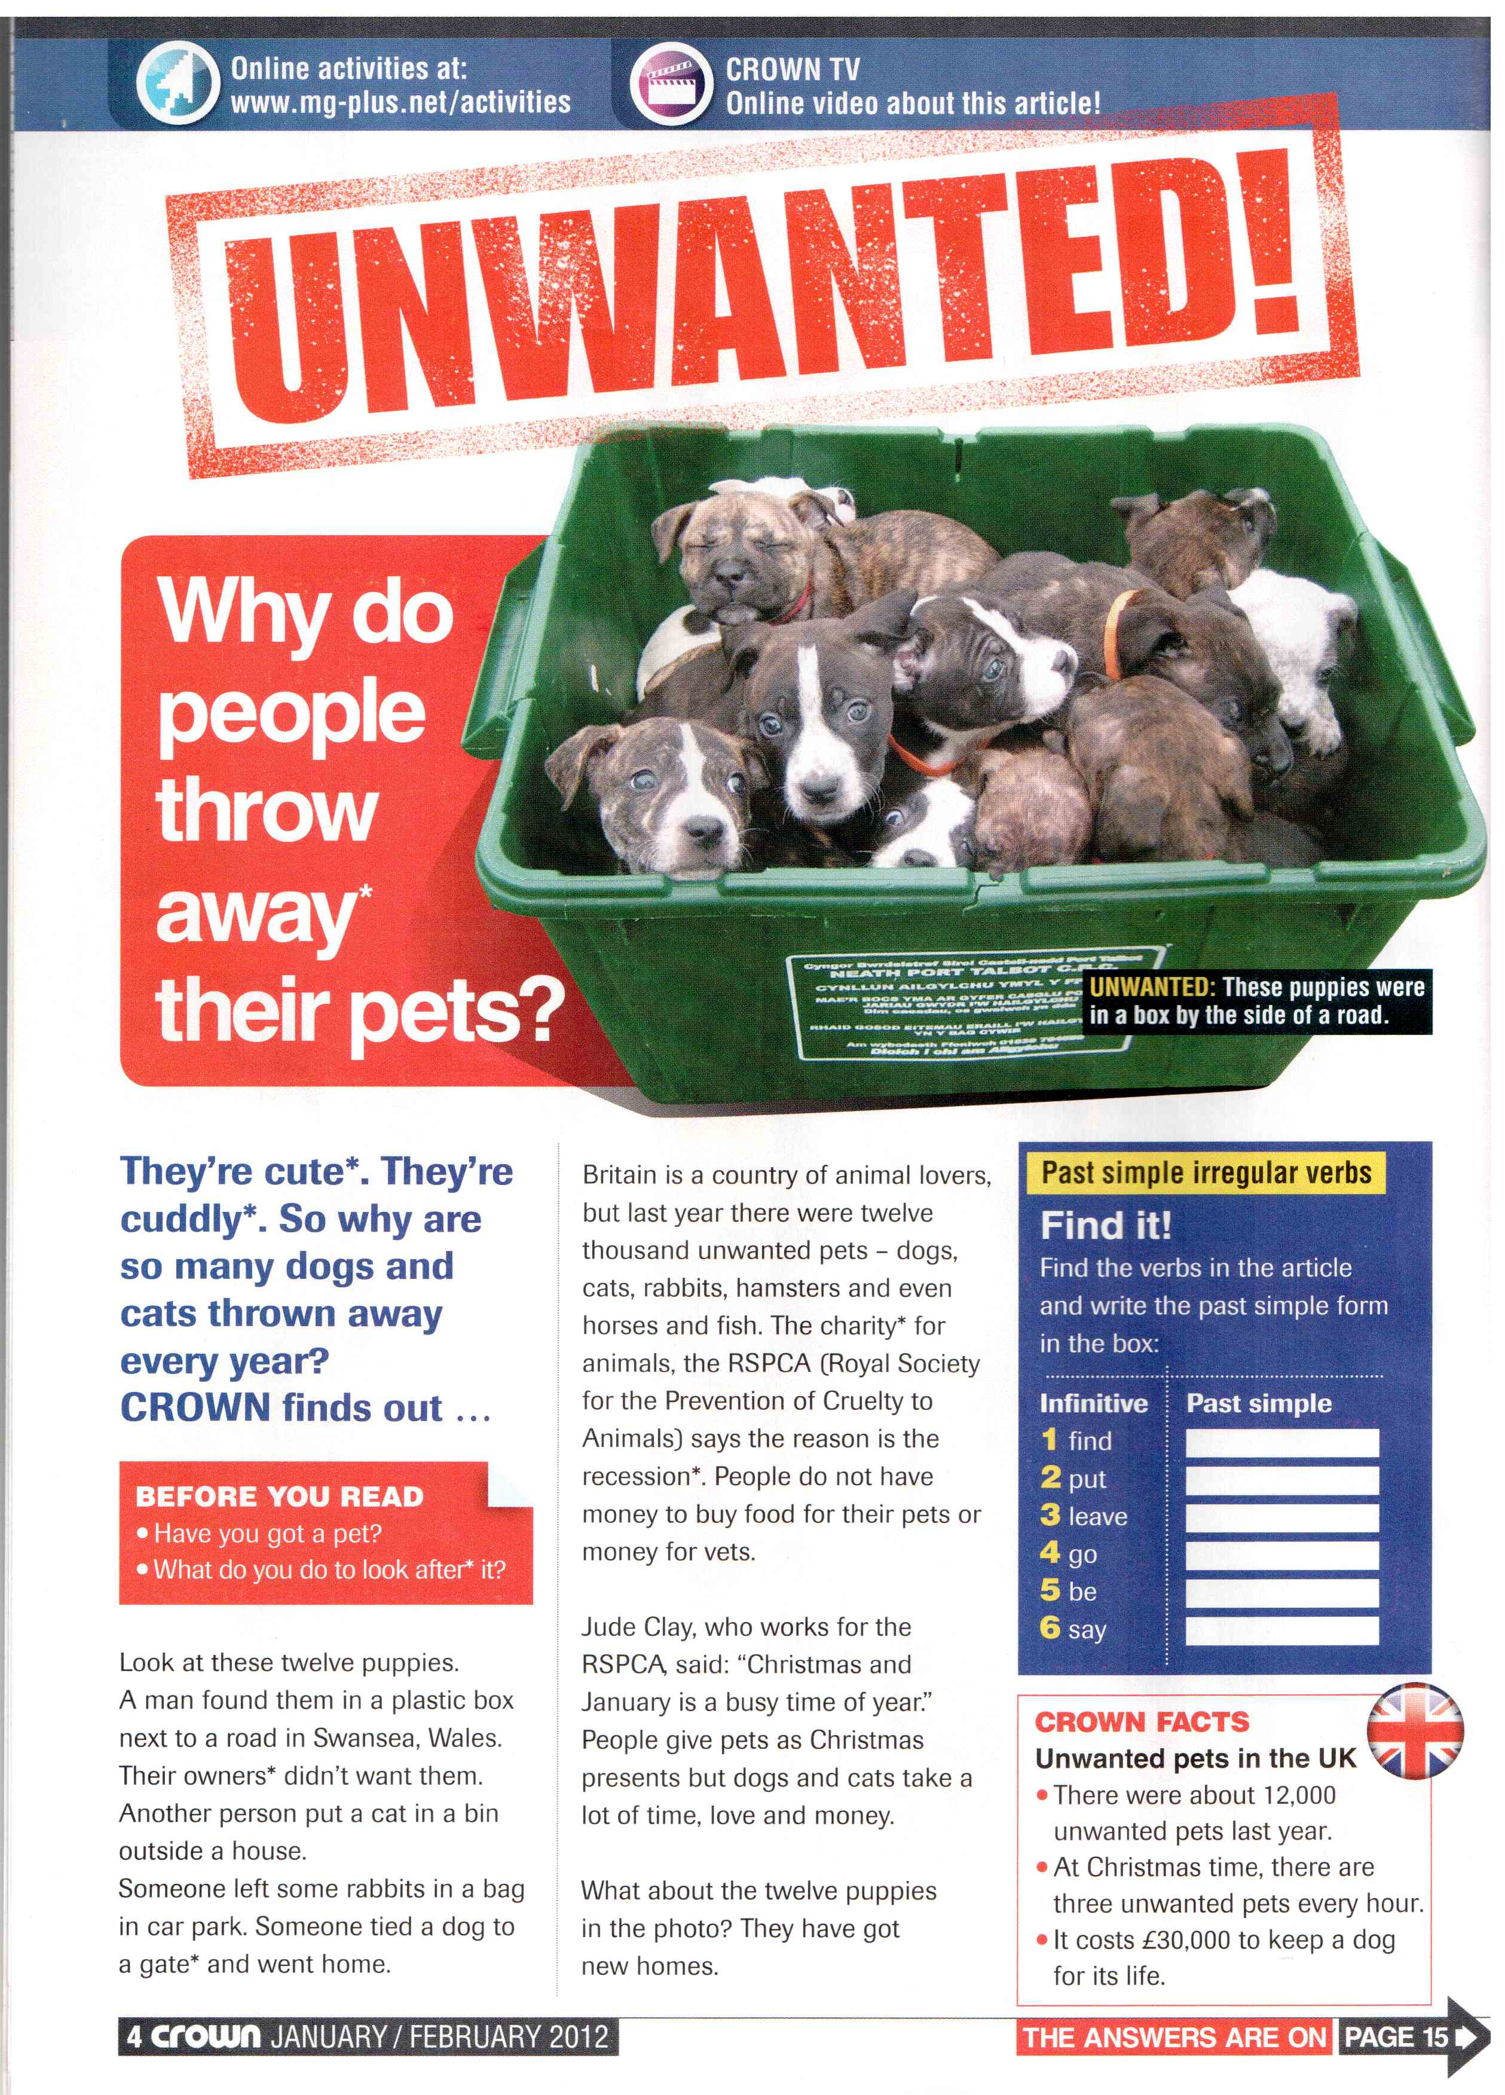
*to thorw away = wegwerfen | *cute = süss | *cuddly = kuschelig | * to look after = sich kümmern um | * owner = Besitzer | *gate = Tor | *charity = Wohlfahrtsorganisation | *recession = Rezession
Direct Careful

1. Where were these animals left? (scanning)
a) 12 puppies
b) cat
c) rabbits
d) dog

2. Do the dogs in the pictures have new homes already? yes no

Inferred Meaning

i. Put the events in the right order: (logical organisation of the text – not really but trains logic skills)
The child gets bored
It’s Christmas
The RSPCA has got the animal
A child wants a pet
Someone buys a pet as a present
The child is happy
The pet is given or thrown away

Expeditious Reading

A) What is the text about? (choose the BEST answer) differentiating between main message and detail(s)
Britain – a country of animal lovers
the RSPCA – a royal society
pets that nobody wants
Christmas, a busy time

B) How many unwanted pets are there in the UK every year? ______________________
C) How much does a dog cost in his whole life?
_____________________________________
D) What is the RSPCA?
_____________________________________
E) Where does Jude Clay work?
_____________________________________

ii) Why is Christmas time busy for Jude Clay, who works at the RSPCA? Inferred meaning

ii) What happens to many people, when there is a recession? Inferred meaning

