Comparing animal facts
Watch the two videos about animals in the zoo, then complete the sentences below.
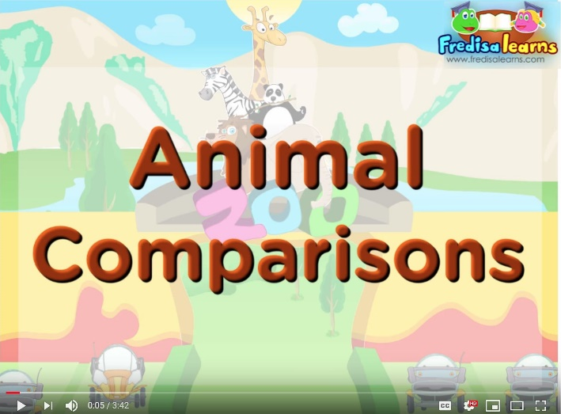 | 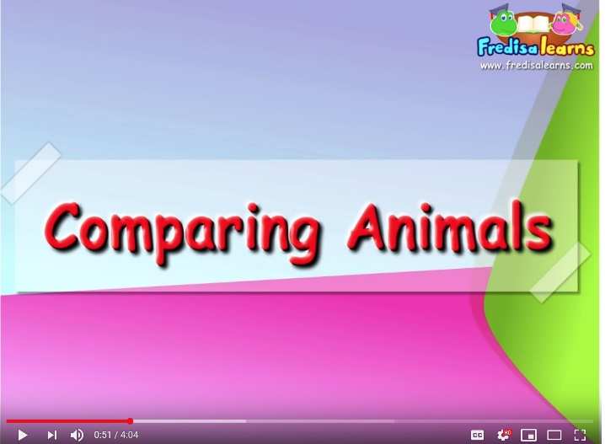
https://www.youtube.com/watch?v=V_8CvvwT-Gg https://www.youtube.com/watch?v=kQHVhvwASYY
Otters are swimmers than turtles.  Otters are than turtles.  The girl thinks that otters are than turtles.  Zebras are than elephants.  Elephants are zebras.  Lions are zebras.  The elephants are animals in the zoo.  The animal in the zoo is the angelfish. It is tiny.  The sailfish is swimmer in the world.  Monkeys are animals in the zoo. | bigger than  not as big as  faster  more playful than  cuter  the fastest  the biggest  the most playful  smallest  smaller
No write your own sentences about zoo animals. Write them on a sheet of paper and show them to your teacher. Use these words.
polar bears
monkeys
sharks
giraffes
dolphins
dangerous
heavy
hairy
strong
intelligent

