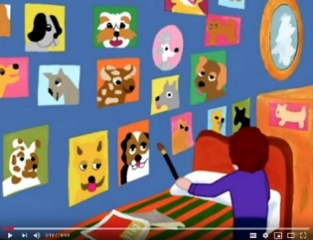
May wants a dog
Watch the video. Then put the text pieces in the right order.
1 | May’s biggest wish was to have a dog. She loved dogs more than anything else. She dreamed about dogs, she thought about dogs and she painted lots of pictures of dogs. The walls of her room were full of pictures of dogs.
2 | So May tried again.
3 | But May said: Yes, I’ll do it. I’ll feed the dog, I’ll walk the dog, I’ll take it to the vet and I’ll teach the dog to obey. Then May had an idea: She made her own fantasy dog from an old roller skate.
4 | May’s parents saw that she could really take good care of a pet. They were impressed. May’s friends also liked the idea. They all took their roller-skate pets for a walk on a leash.
5 | She made a leash and she walked her roller skate dog every day. Every day May practiced taking good care of her fantasy pet.
6 | Unfortunately, her parents did not allow her to have a dog. Every time May asked her parents if she could have a dog, they just said NO! But May did not give up. She remembered an important tip that her father had given her. “When you don’t succeed, try, try again.
7 | She bought a baby dog for her mother’s birthday. But her mom did not want the dog. May had to take it back to the pet store. May’s parents explained why they did not want a dog. They said:
8 | First, May’s friends laughed at her and thought this was funny. But May did not give up. She took her roller skate dog everywhere.
9 | - Dogs need a lot of care. Dogs must learn to obey.  - You have to walk them every morning and every night, even when it rains or snows.  - You have to take them to the vet for shots.
10 | Now her parents said: May has practiced so much. She is really ready to take good care of a dog. For May’s next birthday they gave her a puppy. May was soooo happy.
Continue the story: Think of the following questions: What name did May give her new dog? Tell us all the things she and the dog did every day. What did the dog eat? Where did it sleep? Write your text on a sheet of paper and show it to your teacher.

