Pet Info
8.1
a
What you need to know about Ball Pythons.

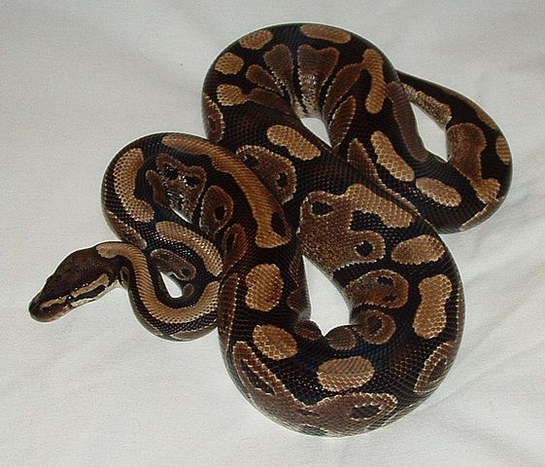
Appearance and
general info
Ball pythons are not easy to take care of.
They can become quite large (up to 150cm long) and weigh up to 3kg. They are black and brown and have dry skin.
Ball pythons live for 20-30 years.
Pythons look dangerous, but they are not poisonous and do not normally attack people.

Mokele at English Wikipedia [CC BY-SA 3.0 (https://creativecommons.org/licenses/by-sa/3.0) from Wikimedia Commons
Home:
Ball pythons need a large glass tank (about 140 litres). The tank should have a good lid. Cover the bottom of the tank with newspaper.
There should be a place to hide (e.g. a box) in the tank.
How do they move?
Ball pythons love to climb, so you should give your python something to climb on. A big branch is perfect.

.

What do they eat?
Ball pythons eat dead mice or small rats. You should only feed your snake every week or two.
Your snake needs fresh water, so you should change the water in its water bowl daily.

Other information:
Keep your ball python warm. The temperature should be 27°C-32°C.
You can hold your snake when it is small, but you shouldn’t hold it too often. Keep it away from small children.

Read this info sheet carefully and take notes (keywords) in your handout (task 8.B)
Then tell your partner about pythons.

