Pet Info
8.1
What you need to know about Potbellied Pigs.
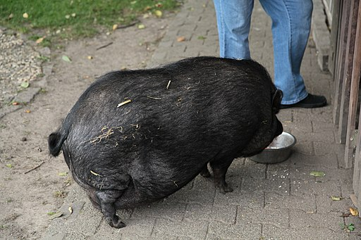
Appearance:

Even miniature potbellied pigs can get quite large and weigh up to 30 kg. (Normal potbellied pigs can weigh up to 100kg)
They live for 12-18 years.
By Frank Vincentz [GFDL (http://www.gnu.org/copyleft/fdl.html) or CC BY-SA 3.0 (https://creativecommons.org/licenses/by-sa/3.0)], from Wikimedia Commons

Home:
Potbellied pigs can live inside the house. They only need a basket and a blanket.
You shouldn’t keep your pig indoors all the time. Let your pig play in the garden regularly!
How do they move?
Pigs love to run around and explore. They can run quite fast, so keep your pig on a lead if you walk outside.
They also like to dig. You should provide a place for them to dig – e.g. a sandbox

.

What do they eat?
Potbellied pigs can eat anything: meat, potatoes, apples… But be careful! Pigs get very fat very quickly and they can learn to open the fridge door to look for food.
You should feed your pig fruit, vegetables and special pig food.

Other information:
Potbellied pigs are very intelligent. They can learn tricks! But they can get bored so you should play with your pig and it should have a lot of interesting toys.
You should train your pig to use a cat litter box.

Read this info sheet carefully and take notes (keywords) in your handout (task 8.B)
Then tell your partner about potbellied pigs.

