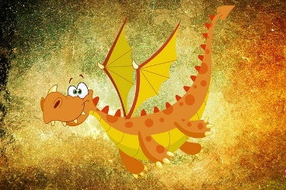
Is it easy to keep?
How large / heavy / long can it become?
What color is it?
How old can it become?
Is it dangerous?
Does it bite? Does it sting?
How can you keep it at home?
Does it need a cage?
What does it need for a good life?
What does it eat?
What does it drink?
What temperature is perfect for it?
Can you hold / cuddle / hug it?
What else does it need?
What does it like doing?
What else should I know about this animal?
Can I take it for walks outside?

