
M9: Writing Task 1:
What are you going to do next weekend? Do you have any PLANS or VAGUE IDEAS?
Write them on this sheet. Use words and grammar to show us how fixed your plans are.






Task 2: What will the weather be like in the next 5 days?

Mon | Write whole sentences for each day of the week.
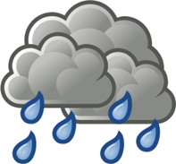
Tue

Wed.
5cm
- 10 degrees
Thu

Fri

+ 10 degrees

