MODULE 9: Personal Time Planner
Week 1 |  | Week 2 |  | Week 3 |  | Week 4 |  | Week5
Date: ________ |  | Date: ________ |  | Date: ________ |  | Date: ____ |  | Date: ___
Date: ________ |  | Date: ________ |  | Date: ________ |  | Date: ____ |  | Date: ____
Date: ________ |  | Date: ________ |  | Date: ________ |  | Date: ____ |  | Date: ____
Week 6 |  | Week 7 |  | Week 8 |  | Week 9
Date: ________ |  | Date: ________ |  | Date: ____ |  | Date: ____
Date: ________ |  | Date: ________ |  | Date: ____ |  | Date: ____
 |  |  |  |  |  |  |  | 
Date: ________ |  | Date: ________ |  | Date: ____
What are your plans?
9A
- Step 1: Write down 10 things you are planning to do this upcoming weekend (or in the next holidays).
Ask:
Are you going to …

- Step 2: Then ask your classmates about their plans. Find one name for each of your plans.
Ask: Are you going to … or Are you planning to…
Write your plans here: | your friends‘ names:
I am going to…
I am planning to…
I am going to…
Now ask one friend more details about the things he or she is going to do on the weekend (or in the next holidays). Is your friend planning any cool, interesting, fun or boring things? Write down the 3 most interesting things that your friend is going to do.
………………….. is going to …………
………………….. is going to………….

Horoscopes
9B
  Aries March 21-April 20  This year will be very successful for you! You will travel and meet a lot of new friends. Maybe you will even meet the love of your life! |   Libra September 23-October 22  This year won’t have a very good start.. Perhaps you will have problems with friends. Things will get better in the summer, but the winter will be the best!
  Taurus April 21-May 20  This will be a tough year. You will have problems in the beginning, but because you are such a hardworking student, things will work out in the end! |   Scorpio October 23-November 21  Hungry for adventure? This will be your year! The stars will help you in your troubles, but try to listen to your brain, too.
Gemini May 21-June 21    This year will be complicated. You will lose some friends, but your real friends will stand by you! Winter will be dangerous for your health. | Sagittarius November 22-December 21    This year will bring happiness to your life. Problems that made you sad last year will end and you will feel much better and free!
  Cancer June 22-July 22  Parents, parents, parents! This year they will try to control your life more than ever. This will make you angry, but try to listen to them. Perhaps you will benefit from their advice. | Capricorn December 22-January 19    This year won’t bring you much luck. There will be some small problems in school and the teachers won’t be very patient with you, so be careful! Try to work harder, if you can!
Leo July 23-August 22    This year will bring love to your life. You will fall in love madly. Be careful! Summer will be critical. You will need money this year, so try to find some kind of job. |   Aquarius January 20-February 18  This will be a fun year! You’ll meet interesting people, you’ll visit interes-ting places and you’ll have enough money. Love will also find you, but you’ll have to wait until the end of the year!
  Virgo August –September 22  This year, the stars will help you at school. You will think fast and everything will seem easy. If you study, you will be the best student in the class! | Pisces February 19-March 20    Chaos! This year, you will sometimes wonder why all problems seem to find you. Don’t worry, and trust your instincts. You will always find the right way. This year will also bring some romance!

What does the horoscope say about you?
Find out your friends’ and your family members’ signs of the zodiac and tell them what’s in for them this coming year.
Then find your teacher’s sign of the zodiac and tell her what will happen to her this coming year.
Do you believe in horoscopes? Do you ever read them in the newspaper?

Good Fortunes: Tulips
9C
Step 1: Draw a name-card from the box on your teacher’s desk. Write 4 good fortunes for the person on your card. If you do not know the person very well, ask his/her friends (secretly) and find out what would make them happy.
Step 2: Produce a few “tulips fortunes” or a “good fortunes boat” for your classmate and write the 4 good fortunes onto it. Don’t forget to start all your fortunes with: “You will….”
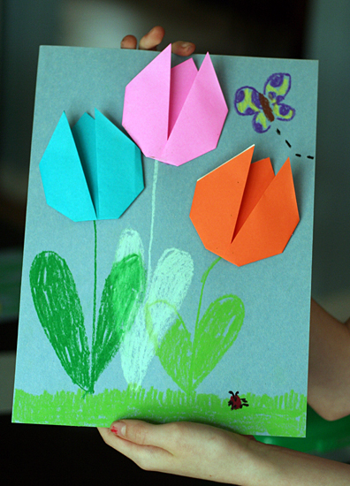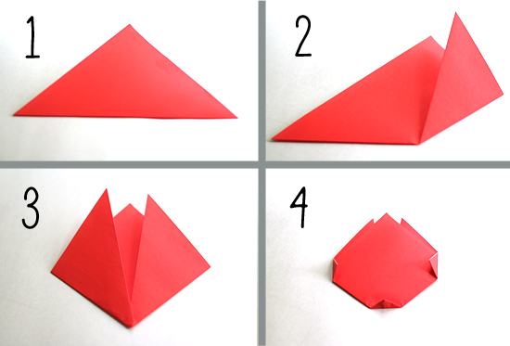
For each step, press each fold well with your fingers.
Step 1: With the colored side facing down, fold your paper on the diagonal to make a triangle.
Step 2: Bring the bottom right corner up and to the right of the center point.
Step 3: Repeat with the left corner, bringing it up and to the left of the center point.
Step 4: Flip the paper over. Fold the side and bottom points in just a bit, to create a more rounded tulip shape.
Flip it back over and check out your finished tulip! So cute and easy, right? I showed my girls how to make one, and they proceeded to whip out a whole pile in minutes.
Write a good fortune into each tulip, then glue the tulips on a colored card and draw the stems.

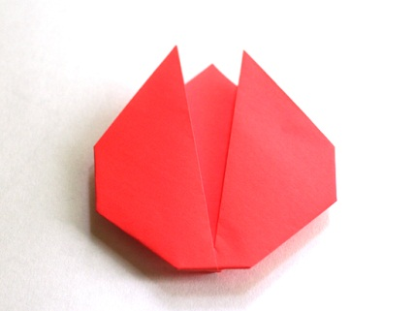

Good Fortunes: Where will the future take you?
9D
Write a good fortune for your friend on each side of the boat – inside and outside.

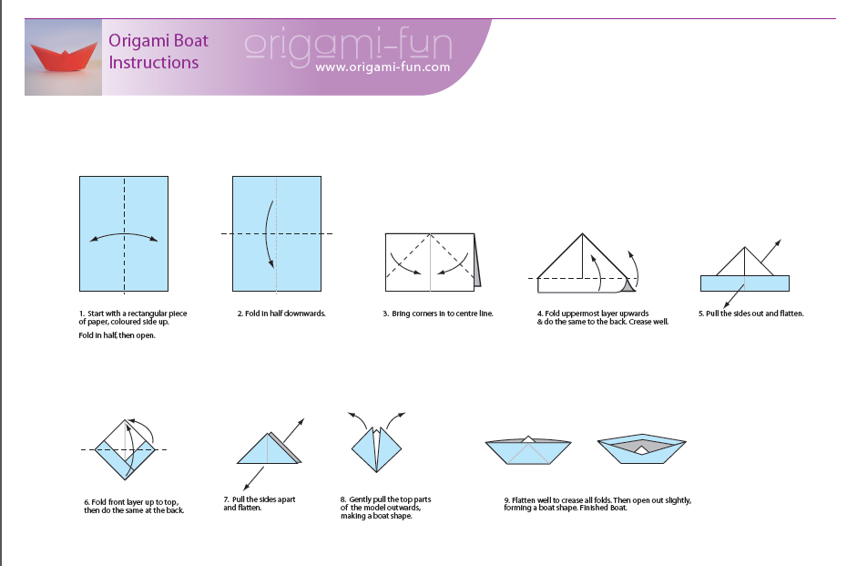

Fortune Tellers

You will…….
Fold your personal paper fortune teller and write in 8 good fortunes that you think will happen to your friends.
Then talk to 3-4 of your friends and tell them what’s in store for them in the future.
To fold your paper fortune teller follow these instructions:
Start with a square.  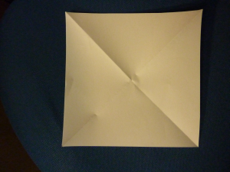 | 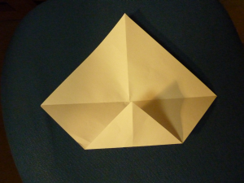 | 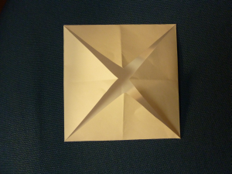 | Now turn it over.
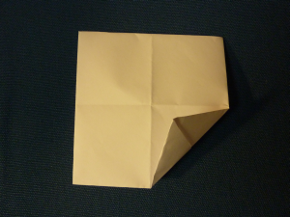 | 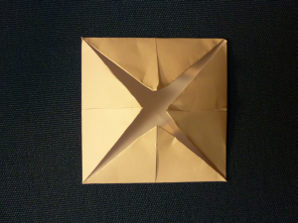 | 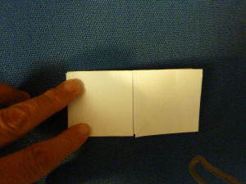 | Push together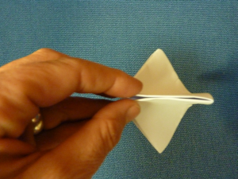
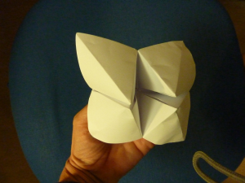 | Open up your fortune teller and write in eight good fortunes.  You will….  You will…  You will… | 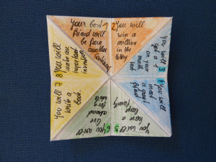 | Add numbers 1-8  and  choose 4 colors to decorate your fortune teller.  Optional: Decorate the outside of your fortune teller.
To play:  Ask your friend to choose a number between 1 and 10.  Open and close your fortune teller counting up to the chosen number. | Ask your friend to choose a color.  Open your fortune teller so you see the chosen color.  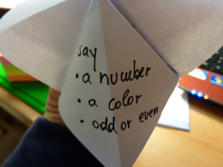 | Ask your friend to choose odd (ungerade) or even (gerade).  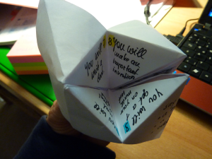 | Read out your friend’s fortune and wish him/her good luck.


Predicting the weather: How good is the weather forecast?
9F
Are they always right?
Let’s look at the weather forecast for next week. Let’s see if they are right.
Go to THE WEATHER CHANNEL and find out what the weather will be like in the next two weeks.
Write it into the table below. Then let’s check whether they were right.
Write the dates and the weather into the calendar.
Use handout task 9G (Weather) to help you find the correct words.

Example: On Monday the 12th it will be very cold. There will be rain or snow.
Monday | Tuesday | Wednesday | Thursday | Friday | Saturday | Sunday
Monday | Tuesday | Wednesday | Thursday | Friday | Saturday | Sunday


9G
Weather report for the next five days
You are the TV weather lady / weather man. Use the weather forecast from task 9 F. Then draw 5 nice weather symbols on A4 paper. Practice announcing the weather for the next five days. Use your drawings. Put them on the blackboard with magnets and tell your viewers what the weather will be like.
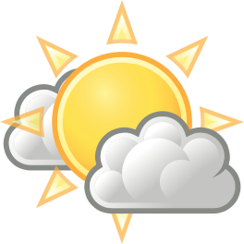 | - It will be sunny with a few clouds (in the afternoon). | 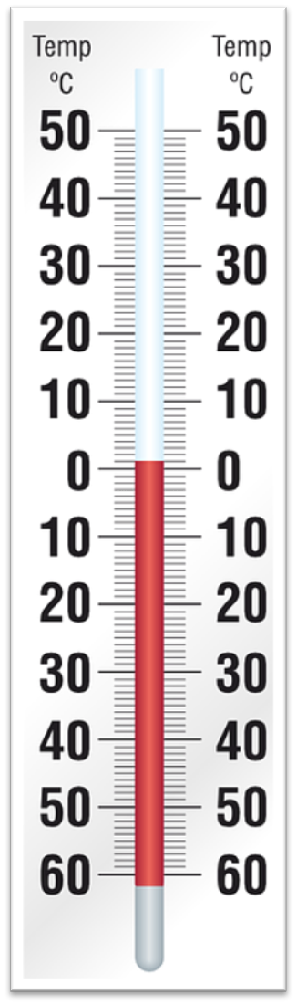  cool  warm  extremely hot  (very )cold  freezing cold
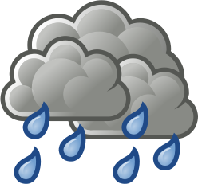 | - It will be rainy.  - It will rain all day.  - There will be a lot of rain in the morning.
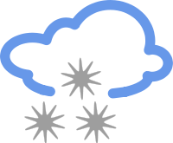 | - It will snow all day.  - There will be one to two centimeters of snow.
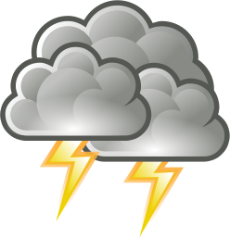 | - There will be thunderstorms during the night.
 | - It will be cloudy with a few showers in the morning.
 | - It will be windy.



What will the future be like on Earth?
9H

Work with a partner. Collect your ideas about the future on Earth in the table below.
Then act out a dialog: One of you is a scientist who knows a lot about the future. The other one is a TV journalist. Ask a third student to film you on Flipgrid.
TIP: Ask your teacher for some props: a lab coat and glasses for the scientist, make some drawings of the things that you are going to talk about. Show them to your viewers.
Start your show like this:
- Hello and welcome to our science show. Today we are going to talk about the future. This is Mr./Mrs. xxx. He/she is a specialist who knows a lot about the future of our planet Earth. I am going to ask him/her lots of questions. Let’s get started….
Practice your TV show, then ask a friend to film you on Flipgrid..

The TV Journalist  Ask your guest scientist lots of questions about the future. | The Scientist
Write your questions here: | Write your answers here.
End your show with: Thank you Mr/Mrs. XXX. . I am sure our viewers have learned many things about the future of our planet.
You are welcome. Good bye/ Good bye.

