Palm-reading
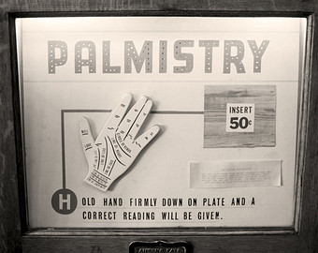
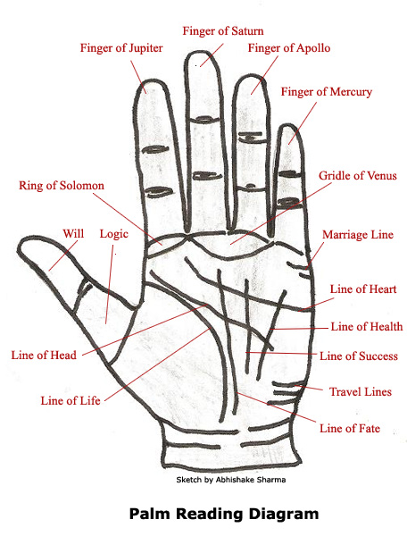
http://www.buzzle.com/articles/palm-reading-learn-how-to-read-palms.html (04.02.2014)
