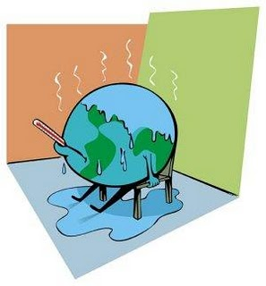
The Future of our Planet
Have you heard about GLOBAL WARMING? It means that the temperature on our planet Earth is getting higher and higher. This has serious consequences for all of us. Scientists tell us that if we don’t act quickly, terrible things will happen:
wikimedia.org

The ice caps on the North Pole and the glaciers in the mountains are melting. Therefore, the sea level will rise and many places near the sea will be under water. Many people will lose their homes due to flooding. | 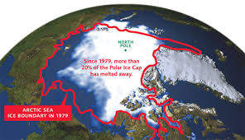  enviromatters.wikispaces.com  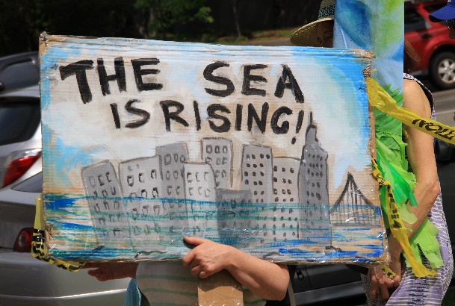  By Dcpeopleandeventsof2017 - CC BY-SA 4.0, https://commons.wikimedia.org/w/index.php?curid=58573258
Polar bears will die out because they won’t find enough food. | 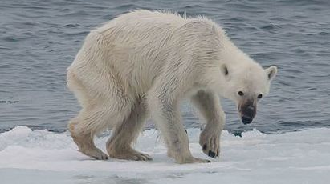  by AWeith. CC BY-SA 4.0 via Wikimedia Commons.
If the temperature keeps rising, the summers will be very hot and dry and there will be terrible forest fires. People will lose their homes and many people and thousands of animals will die every year. | 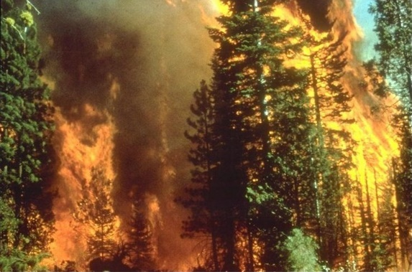  commons.wikimedia.org
In Africa the summers will be extremely hot and dry. People will not be able to grow any food for themselves and their animals. Therefore, they will have to leave their home towns and move away into large cities or to other continents. Many people will die of hunger. | 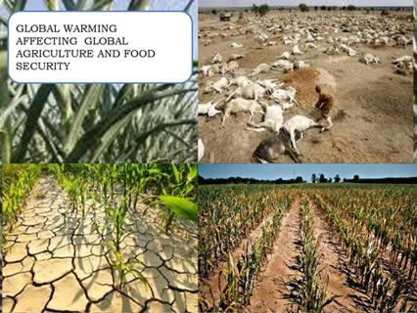  Asamoah Francis [CC BY-SA 3.0  https://creativecommons.org/licenses/by-sa/3.0)], from Wikimedia Commons

If we want to save our planet, we must act now.
- We should make electricity with solar power. That is electric power from the sun.
- We should go by tram, by train or by bus and shouldn’t drive our own cars as much.
- We should walk short distances or take our bikes.
- We should eat more vegetables and less meat.
- We should use less energy for heating and cooling our homes.
- We should turn off our lights, our computers and our TVs when we do not use them.

