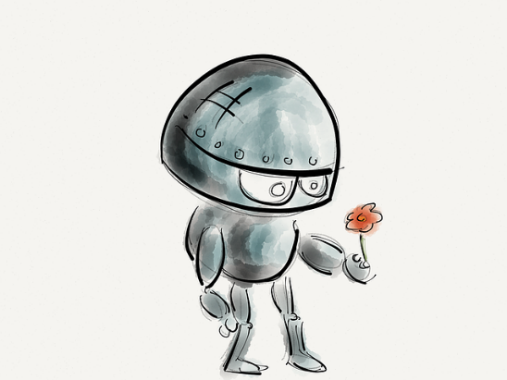
Time Capsule:
What will my life
be like in 2040?

Written in the year ……………..
Imagine yourself when you are all grown up. What will your life be like? Where will you be living? Who will be with you? What will you be doing? What will the world be like?
Draw a portrait of yourself here.


1. Things I’ll do or not do
When I am all grown up, I think I will do these things.
Tick all the things that you’ll do – and cross out the things you won’t do when you are grown up.
- I’ll stay up late at night.
- I’ll have a garden.
- I’ll live in a big house with a pool.
- I’ll have a pet.
- I’ll be married.
- I’ll have children.
- I’ll work from 9 to 5 every day.
- I’ll go camping in the holidays.
- I’ll spend my holidays in a 5 star hotel.
- I’ll eat lots of sweets.
- I’ll go to lots of concerts.
- I’ll watch every football or soccer game on TV.
- I’ll watch the TV news every evening.
- I’ll work in a large company.
- I’ll be my own boss.
- I’ll sing in a choir.
- I’ll play a musical instrument.
- I’ll play in a band.
- I’ll have a car of my own.
- I’ll have friends in other countries.
- I’ll speak at least three languages.




3. My Daily Routine

In the year 2040, when I am grown up, I will…

2. What will your home be like when you are grown-up?
Make a drawing.



Describe your future home in detail.

When I am grown up, I will live in….

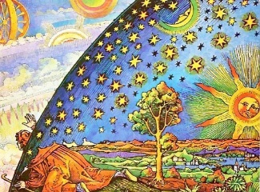
4. The World in 2040

What will you eat in the year 2040?

How will you travel and go to work?

What will the world be like when you are grown up?

What else will be different?

