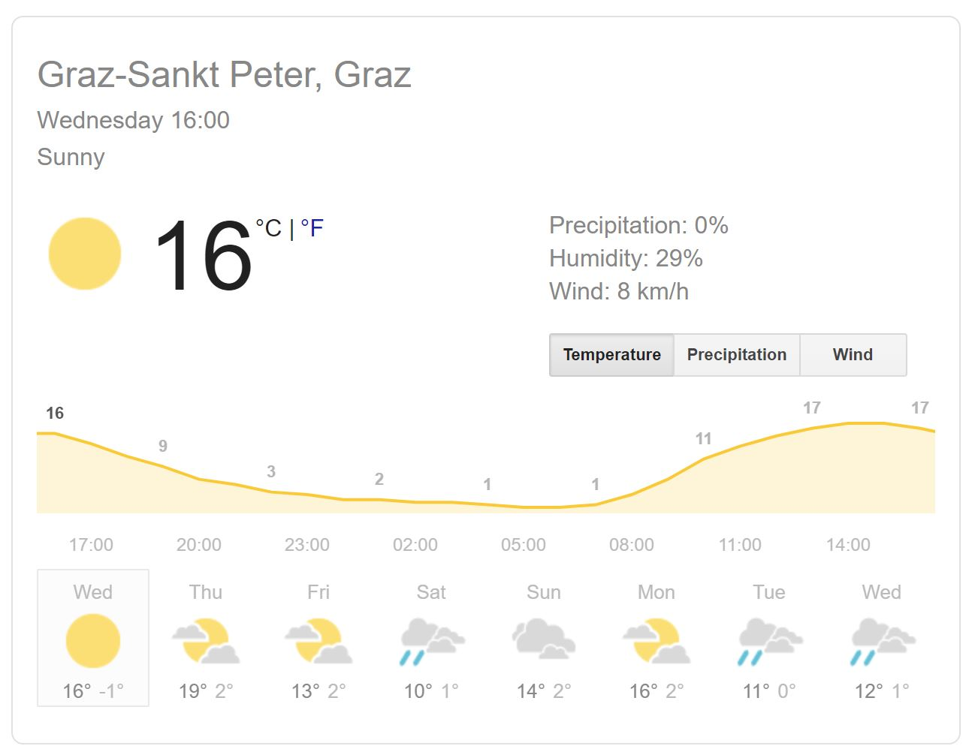
Next week it will be…

Next week there will be…

