Our holiday plans
M A
Task A

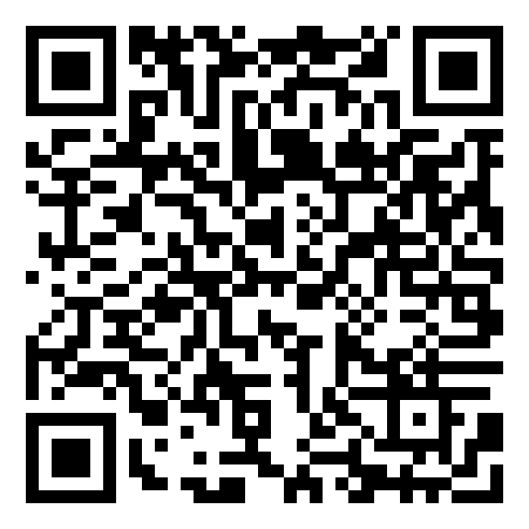
https://learningapps.org/5289086
Step 1: Work with a partner. Do the learning app activity “Talking about holiday plans”.
For each matching pair, ask your partner if he/she is going to do this as well.


Step 2: Look at the pictures again. Guess what your English teachers are going to do in the summer holidays. You can use the pictures in the learning app, or you can use the picture card MA 1 in Erik.

Write sentences like these:
I think Mrs. …is going to…
I am pretty sure Mrs … is going
I know that Mrs. …. is going to…
Mrs. Pölzleitner’s plans for the summer | Mrs. Bergmann’s plans for the summer

Step 3: Talk to your teachers and check if your guesses are correct.

What are you going to do in the summer holidays?
MA
Task B

Do you have any plans?
What are you planning to do in the holidays?
What are you going to do in the holidays?c

- Write down 10 things that you are planning to do.
I am going to
- read lots of books
- eat lots of ice-cream
- go to Turkey to visit my grandparents
- Interview your classmates about their plans and note them in your table.
- Who is your perfect match? Who do you share most plans with?
Write your classmates‘ names here.

What are you going to do in the holidays?
Write your friends’ names or initials into the first line.
Then tick off which of your plans they share with you.
I am going to…



ME-Book: My holiday plans

Design a beautiful page for your Me-book. The title of your page is “My holiday plans”
Show your best!
Check all the pages in your Me-book. Add pictures, drawings and decorate the pages beautifully.

LR Book:

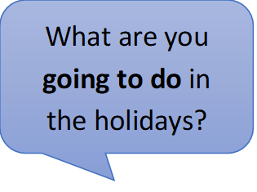
Talking about plans: GOING TO
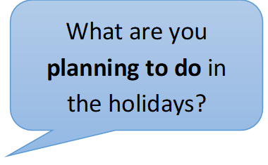
Write 3 sentences about your holiday plans
and
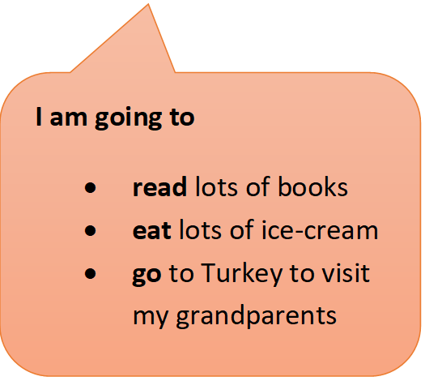
three sentences about your friends’ holiday plans
and
three sentences about your teachers’ holiday plans.

Show your sentences to your teacher.
Then copy them on your blue LR book sheet for this topic.

Before the holidays
1. Hand in your Me-book and your LR book to your English teachers before the holidays. You will get them back in September.
2. Install Quizlet and Duolingo on your mobile phone and create an account (if you have not yet done it). This will help you to study English vocabulary in the summer, even if you do not have your vocab cards.
3. Install Flipgrid on your mobile phone so we can keep in touch.
4. Install e-mail on your mobile phone so you can get our messages.
5. Make sure your vocab box and your vocab practice book are with you. We will need them again in September.

In the summer holidays

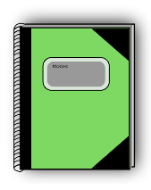
Enjoy your summer holidays. Do lots of fun, cool things. Meet your friends, go swimming, enjoy the sun, go hiking in the woods, eat lots of ice-cream, read cool books, listen to music, dance and sing. Travel with your family, visit your grandparents and your aunts, uncles and cousins in Austria and abroad. Ride your bike, bake potatoes in a fire, write some postcards, play soccer or basketball, play fun games, laugh about good jokes AND study English vocabulary and stretch your memory.
Wherever you go, you’ll need your vocab box (or Quizlet on your phone) and a small A5 notebook (vocab practice book). Show it to us in September.
Challenge: Who can fill a whole notebook and become a real PRO in English next year?

Let’s keep in touch with Flipgrid video message
In the summer holidays, let’s keep in touch and share a few cool video messages on Flipgrid. Tell us what you are doing and what you like about it. Your messages can be very short, just a few sentences. Only your classmates and English teachers can see them.
For example:
Hello, right now I am at the beach. The sun is shining, and I am playing with my brothers and sisters. It’s great fun here. We are eating a watermelon.
Good Bye. Enjoy your holidays.

Achtung: Wenn du andere Personen (Freunde, Familie) in deinem Flipgrid video mitfilmst, mussts du sie zuerst fragen ob sie einverstanden sind.
Challenge: How many cool, short video messages can you make? Win a prize in September.

