MODULE B: After the holidays

Personal Time Planner
Week 1 |  | Week 2 |  | Week 3 |  | Week 4
Date: ________ |  | Date: ________ |  | Date: ________
Date: ________ |  | Date: ________ |  | Date: ________
Date: ________ |  | Date: ________ |  | Date: ________



What's wrong with this letter?
Task 1: Read Mrs. Weinzettls letter to Maureen. Do you think all the information is true?
Ask her lots of questions, then correct the letter. What did Mrs. Weinzettl really do in the holidays?
easy questions

Did you really…
stay in Austria?
hard questions
Is it true that you…
stayed in Austria?
Did you really go dancing a lot?
Is it true that you went dancing a lot?

Graz, September 10th
Dear Maureen,
Thank you very much for your postcard from Brighton. You must have had a wonderful holiday. My holidays were great, too. This summer I stayed in Austria. Right at the end of term I went to the Salzkammergut by bus. I did a lot of climbing in the mountains and enjoyed the view over the impressive landscape. I sailed across the wonderful lakes and also went swimming there. The water was really nice and warm. I even took a ride on a donkey to the top of a high mountain. The weather was not perfect, it was sometimes snowing, partly very hot, but I always did something nice. When I came back to Graz I had a lot of work organizing my school things. I also read many books, started to learn Japanese, and went horse-riding again. And I went dancing a lot. I’ll tell you all the details and I’ll show you some photos when we meet in November!
Yours,
Béatrice
Check the solutions on Moodle.

What's wrong with this letter?
Task 2: Read Mrs. Bergmann’s letter to Jeremy. Do you think all the information is true?
Ask her lots of questions, then correct the letter. What did Mrs. Bergmann really do in the holidays?
Did you really…
go to Germany?
easy questions

Is it true that you…
went to Germany?
hard questions

Did you really take an airplane?
Is it true that you took an airplane?

Graz, September 10th
Dear Jeremy,
Thank you very much for your postcard from Edinburgh. You must have had a wonderful holiday. My holidays were great too.
I spent the first three weeks in Austria. Unfortunately I got sick - I had Corona. Then I spent a lot of time preparing for the new school year. My brother came to visit us and we met in the garden (because of Corona).
In August I went to England. We took an airplane and flew to London. We stayed on a boat for four days and then we went to the sea by car.
In London did a lot of sightseeing. We had a great time and bought lots of things. The weather was not ideal, it was rainy – but we enjoyed the city and went out for dinner twice.
Then we went to Ireland. It was fantastic. We slept in a church and took a boat trip. I saw dolphins and a whale. I did not see any seals though. .
I'll tell you all the details and I'll show you some photos when we meet in November!
Yours,
Laura
Check the solutions on Moodle.

Task 3: Now it’s your turn
Find 5 examples of REGULAR past tense verbs in your teachers’ holiday letters. (There are 7)
Highlight them in the text. The next page will help you.

Past tense: Regular Verbs 1
Usually, .. |  | Yesterday … / In summer...
I | visit my grandparents every Saturday. | I | visited my aunt.
I | play soccer in the afternoon. | I | played soccer in the morning.
We | stay in a hotel. | We | stayed with friends.
I | watch TV in the evening. | I | watched TV all day long.

Past tense: Irregular Verbs
Usually, .. |  | Yesterday …/In summer...
I | am happy. | I | was sad.
We | are happy. | We | were sad.
I | do my homework. | I | did my math exercises.
I | go to school by bus. | I | went to school by bike.
I | spend 6 hours in school. | I | spent 7 hours in school.
I | have breakfast with my mom. | I | had breakfast with my dad.
I | fly to America in summer. | I | flew to England.
I | take a shower. | I | took a bath.
I | come home at 5 o’clock. | I | came home at 7 o’clock.
I | read a book in bed. | I | read a newspaper.
I | speak with my friends. | I | spoke with my sister.
I | drink water. | I | drank Coke.
I | get up at 6 o’clock. | I | got up at 7 o’clock.
We | drive to my grandmother’s house. | We | drove to my aunt’s house.
I | say funny things. | I | said sad things.
I | eat dinner with my family. | I | ate dinner at my grandmother’s.
We | stand up when a teacher comes in. | We | stood up when Frau Wagner came in.
We | buy our food at SPAR. | We | bought our food at BILLA.

Find someone who…
Task 4: Talk to your classmates (old and new!) and find at least one name for each question. Use each name only once (1x).
No, I didn’t.
Yes, I did.
Ask your classmates | Names:
Did you go to Croatia this summer?
Did you read more than three books this summer?
Did you go hiking in the mountains this summer?
Did you speak English during the holidays?
Did you visit your grandparents in the holidays?
Write your own questions:
Did you…
Did you…
Did you…
Did you…
Did you…

Task 5:
Challenge: What do you notice in these examples?
I went to Turkey. | I did not go to America.
I ate lots of ice-cream. | I did not eat any Sauerkraut.
I bought a new t-shirt. | I did not buy any souvenirs.
I took a bus and a train. | I did not take an airplane.
I played soccer with my friends. | I did not play chess.

Now it’s your turn:

Write 10 sentences about your holidays. Tell us what you did and did not do. Write in pencil.
Show your sentences to your teacher. Then correct them carefully.
Examples:
I did not go to Greece this summer, but I went to Turkey.
I did not read many books this summer, but I watched lots of movies.

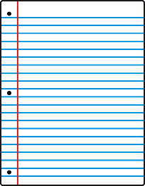
Task 6: A Letter
Write a similar letter to your teacher. Write two or three things that aren't true. Write a first draft on your spiral block. Hand your text in to your teacher.
Talk to your teacher. Your teacher will then guess what is wrong in your letter.
Then write your 2nd draft (your corrected text) on this page.



These are my lies:
I didn’t …………………………………………………………………………….. but I ……………………………………………………………………….
I didn’t …………………………………………………………………………….. but I ……………………………………………………………………….
I didn’t …………………………………………………………………………….. but I ……………………………………………………………………….

1 Put the adjectives under the headings for pleasant () and unpleasant () weather.

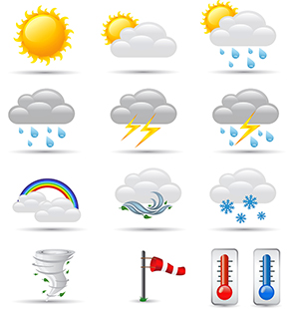
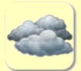

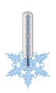
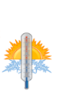
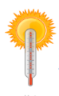
nice hot warm cold dry wet stormy partly cloudy cloudy/overcast
wet
freezing sunny foggy rainy chilly windy snowy
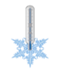
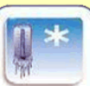
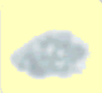

nice | freezing
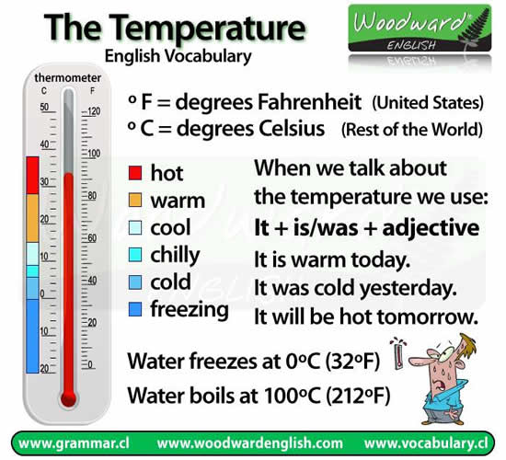

2 What was the weather like in the holidays
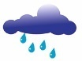  I was in Scotland |  | I was in … |  | I was in …. |  | Graz: Today it is

Scotland: I was in Scotland. It was rainy and windy.
___________: ____________________________________
___________: ____________________________________
Graz: Today it is ________________________________

