MODULE B: After the holidays

Personal Time Planner
Week 1 |  | Week 2 |  | Week 3 |  | Week 4
Date: ________ |  | Date: ________ |  | Date: ________
Date: ________ |  | Date: ________ |  | Date: ________
Date: ________ |  | Date: ________ |  | Date: ________

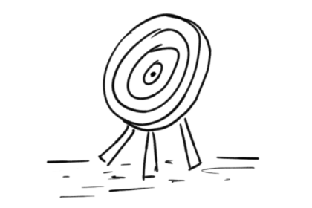

What's wrong with this letter?
Task 1: Read Mrs. Pölzleitner’s letter to Mary. Do you think all the information is true?
Ask her lots of questions, then correct the letter. What did Mrs. Pölzleitner really do in the holidays?
easy questions

Did you really…
go to Italy?
hard questions
Is it true that you…
went to Italy?
Did you really take an airplane?
Is it true that you took an airplane?
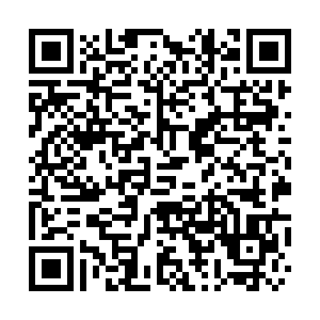
Graz, September 10th
Dear Mary,
Thank you very much for your postcard from Spain. You must have had a wonderful holiday. My holidays were good too.
I spent the first three weeks at home, organizing and cleaning up my school things and preparing for the new school year. Then I went to Italy with Peter. We took the airplane and flew to Rome. We stayed in a luxury hotel for two weeks. The weather was very nice and hot, and I watched lots of movies.
We enjoyed the good food in the nice ‘tavernas’ and had a lot of fun with our friends who came to visit us for a week. Anna also came for two weeks and we had a great time together as a family.
I'll tell you all the details and I'll show you our photos next week!
Yours
Lis
Check the solutions on Moodle.

What's wrong with this letter?
Task 2: Read Mrs. Bergmann’s letter to Jeremy. Do you think all the information is true?
Ask her lots of questions, then correct the letter. What did Mrs. Bergmann really do in the holidays?
Did you really…
go to Italy?
easy questions

Is it true that you…
went to Italy?
hard questions

Did you really take an airplane?
Is it true that you took an airplane?

Graz, September 10th
Dear Jeremy,
Thank you very much for your postcard from Florida. You must have had a wonderful holiday. My holidays were fantastic too.
I spent the first three weeks in Austria. I had a lot of work - preparing for the new school year. We also did some work in our flat – my daughter Martina moved to our bedroom and we now sleep in her old room.
In August we all went to England. We took an airplane and flew to London. We stayed with friends for two weeks and then we went to Scotland by car.
In Edinburgh we did a lot of sightseeing and visited the Fringe festival. We had a great time together as a family. The weather was very nice and warm – we enjoyed the beach and swam in the sea.
Then we went to the Highlands. There it was rainy, so we read lots of books. I did not see Nessie, the monster of Loch Ness .
I'll tell you all the details and I'll show you some photos when we meet in November!
Yours,
Laura
Check the solutions on Moodle or scan the QR code.
Task 3: Now it’s your turn
Find 5 examples of REGULAR past tense verbs in your teachers’ holiday letters.
Highlight them in the text. The next page will help you.

Past tense: Regular Verbs 1
Usually, .. |  | Yesterday … / In summer...
I | visit my grandparents every Saturday. | I | visited my aunt.
I | play soccer in the afternoon. | I | played soccer in the morning.
We | stay in a hotel. | We | stayed with friends.
I | watch TV in the evening. | I | watched TV all day long.

Past tense: Irregular Verbs
Usually, .. |  | Yesterday …
I | am happy. | I | was sad.
We | are happy. | We | were sad.
I | do my homework. | I | did my math exercises.
I | go to school by bus. | I | went to school by bike.
I | spend 6 hours in school. | I | spent 7 hours in school.
I | have breakfast with my mom. | I | had breakfast with my dad.
I | fly to America. | I | flew to England.
I | take a shower. | I | took a bath.
I | come home at 5 o’clock. | I | came home at 7 o’clock.
I | read a book in bed. | I | read a newspaper.
I | speak with my friends. | I | spoke with my sister.
I | drink water. | I | drank Coke.
I | get up at 6 o’clock. | I | got up at 7 o’clock.
We | drive to my grandmother’s house. | We | drove to my aunt’s house.
I | say funny things. | I | said sad things.
I | eat dinner with my family. | I | ate dinner at my grandmother’s.
We | stand up when a teacher comes in. | We | stood up when Frau Wagner came in.
We | buy our food at SPAR. | We | bought our food at BILLA.

Find someone who…
Task 4: Talk to your classmates (old and new!) and find at least one name for each question. Use each name only once (1x).
No, I didn’t.
Yes, I did.
Ask your classmates | Names:
Did you go to Greece this summer?
Did you read more than three books this summer?
Did you go hiking in the mountains this summer?
Did you speak English during the holidays?
Did you visit your grandparents in the holidays?
Write your own questions:
Did you…
Did you…
Did you…
Did you…
Did you…

Task 5:
Challenge: What do you notice in these examples?
I went to Turkey. | I did not go to America.
I ate lots of ice-cream. | I did not eat any Sauerkraut.
I bought a new t-shirt. | I did not buy any souvenirs.
I took a bus and a train. | I did not take an airplane.
I played soccer with my friends. | I did not play chess.

Now it’s your turn:

Write 10 sentences about your holidays. Tell us what you did and did not do. Write in pencil.
Show your sentences to your teacher. Then correct them carefully.
Examples:
I did not go to Greece this summer, but I went to Turkey.
I did not read many books this summer, but I watched lots of movies.

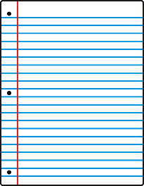
Task 6: ME BOOK:
Write a similar letter to your teacher. Write two or three things that aren't true. Write the solutions on the back of the sheet. Hand your text in to your teacher.
Talk to your teacher. Your teacher will then guess what is wrong in your letter.
ME-Book: Then write your correct text on a nice sheet, put it into an envelope and glue it into your Me-book.



