Days of the week and months
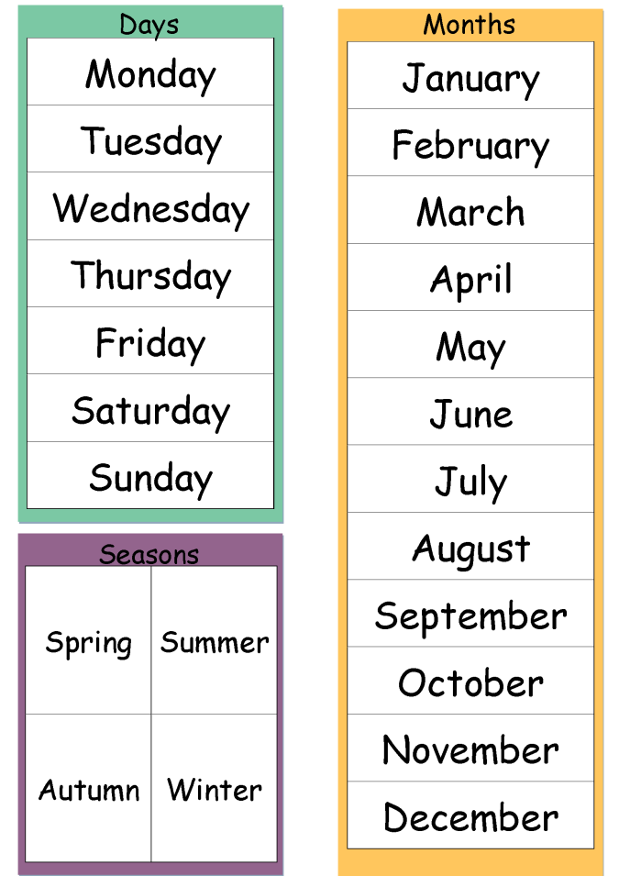
Write your answers on an extra sheet and put it into your LR book, next to this page.
What is your favorite season?
What is your favorite month? Tell us why?

In which months do you go swimming?
In which months do you wear short sleeves?
What is your favorite day 😊 of the week? Tell us why.
What is your least favorite ☹ day of the week? Tell us why.

Ordinal Numbers
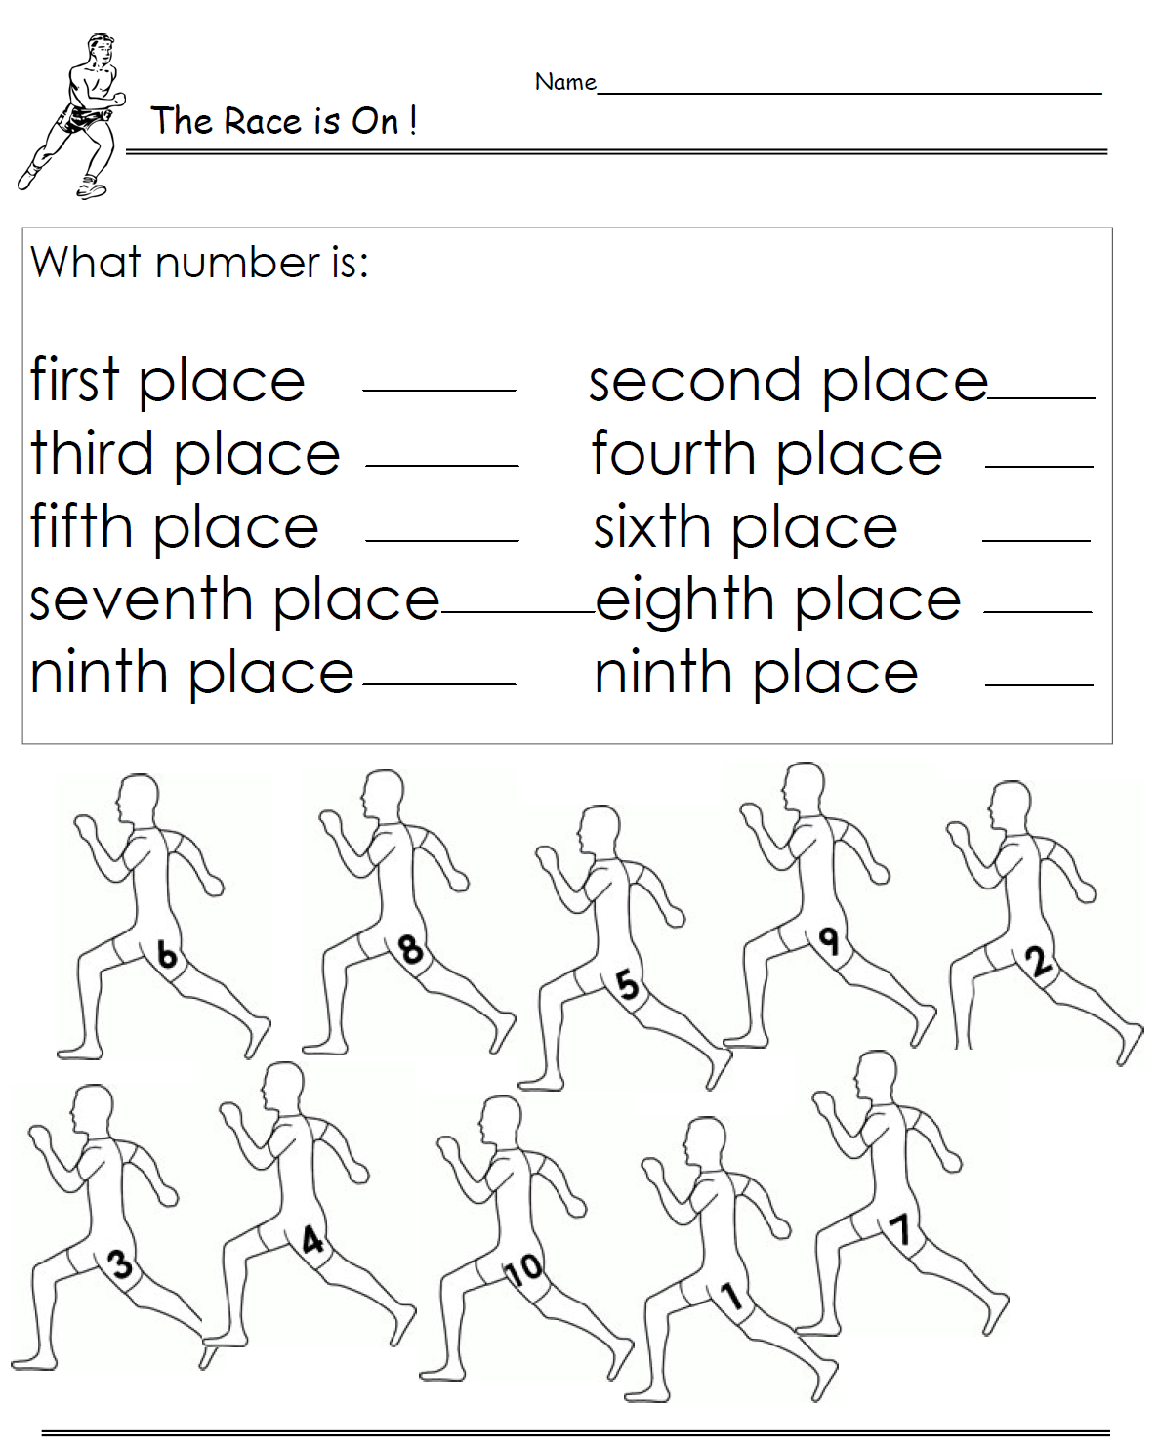
first 1st
second 2nd
third 3rd
fourth 4th
fifth 5th
sixth 6th
seventh 7th
eighth 8th
ninth 9th
tenth 10th
eleventh 11th
…
twenty-first 21st
twenty-second 22nd
thirty-third 33rd
forty-fourth 44th
…
www.worksheetplace.com

Now it’s your turn:
GIVING THE DATE
British:
1st October 2018
2nd November 2018
American:
December 3rd, 2018
January 4th, 2019
February 5th, 2019
When is your birthday?
It’s on ______________________________
What is today’s date?
It’s the _______________________________
On what floor is your English teachers’ office?
It’s on the ____________________________
On what day is Christmas?
It’s o_ _______________________________
When does Ramadan start this year?
It’s _ _ _____________________________

