1 Go to the moodle course E5-Flexi-Nachprüfung

Do the FOF exercises online

2 Writing: Daily Routines

Write about your mother’s typical day. Tell us lots of details from getting up to going to bed.
When does she get up?
Breakfast?
When? What?
Who makes it?
Shower? Teeth? Get dressed?

WHEN?
Does she go to work? What time?
Lunch? Where? When?
After lunch?

When does her work start / end?

Hobbies?

Afternoon?

After dinner?
Dinner? Who? When? What?
Evening?

If you have more time and want to show us more good work, you can do these module checks as well.

Johannes: Reading
Daniel:Listening, Reading
Lukas: Listening, Reading
Melina: Reading
When does she go to bed?
TV? Reading?
When do you go to sleep?

Help card!

first,
then.
after that
after breakfast/lunch/ dinner
5 minutes/an hour later
and
but (aber)
because (weil)
always
usually
often
sometimes
never

Make it interesting!

Explain WHY your mum does things: My mum usually doesn’t have breakfast because she likes to sleep a bit longer.

FOR THE TEACHER
 | not yet | poor | ok | good |  | excellent
Task achievement/organisation
Range of vocab and structures
Accuracy
Comment

- Listening (online) | - Reading (online) | - Focus on Form (online) | - Writing | - Speaking
- Gesamtnote:
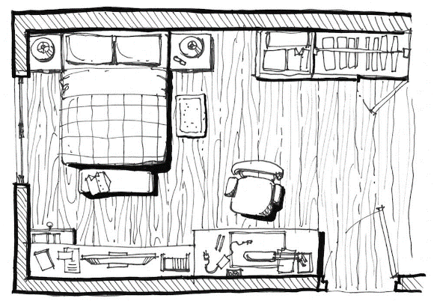
Speaking: My fantasy dream-room
Cool loft bed with sofa underneath
Shelf with books, TV and gaming station
Slide from bed to pool
My private garden with monkey cage
Swimming pool

Draw a quick plan of your dream-room on a piece of paper.
Be creative – you can have everything you want!
Plan your little presentation:
General impression of your room (light, dark, cosy, big, small…)

When you enter the room you ….

Describe all the pieces of furniture in detail and tell us where they are. Beschreibe alle Möbelstücke und erkläre wo sie sind.
Tell us what they look like, whether you like them, what you use them for… Erkläre wie sie aussehen, ob du sie magst, wofür du sie benützt.
Make a list of the furniture here and add a few keywords. Do NOT write whole sentences. Mache eine Liste der Möbelstücke und schreibe ein paar Stichwörter auf – keine ganzen Sätze!

Tipp: Your teacher should be able to draw your room from your description. Make sure they know where everything ist. Deine Lehrerin sollte den Raum nach deiner Beschreibung richtig zeichnen können. Stelle sicher, dass sie wissen, wo was ist.

WENN ohne nicht möglich, dann ausgeben und schauen ob es damit geht….

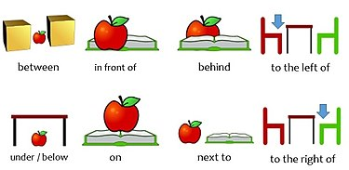




Tipp: Your teacher should be able to draw your room from your description. Make sure they know where everything ist. Dein Lehrer/Deine Lehrerin sollte den Raum nach deiner Beschreibung richtig zeichnen können. Stelle sicher, dass sie wissen, wo was ist.
above
opposite
Helpcard

How do you feel about your presentation?


FOR THE TEACHER

 | not yet | poor | ok | good |  | excellent
Fluency
Range of vocab and structures
Accuracy
Comment

