EOS: English Outside of School

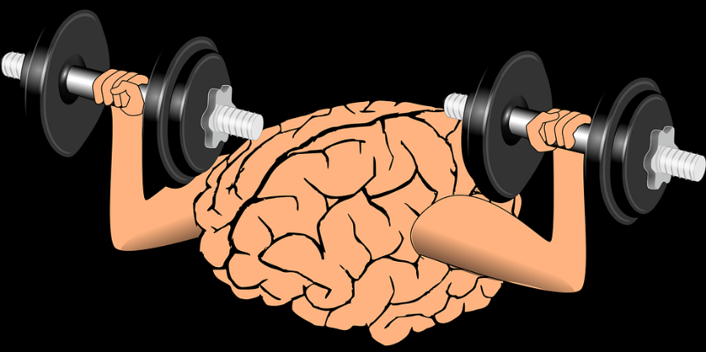


Add a little puzzle piece every day
Your brain is like a muscle


Take a picture

Write the words
or stick in the pictures.

Find English words in Graz

Cut out English words

What else can you do to become a real PRO?

Draw your own “stickers” into your EOS book (the back of your Me-book).
I have watched a you-tube video about … | I have read a text about … | I have played an English computer game. | I have practiced English with Duolingo.
I have listened to an English song. | I have watched an English movie. | I have read an English book. | I have talked to an English speaker.


pictures: pixabay: CC0

