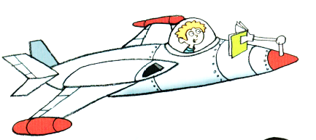
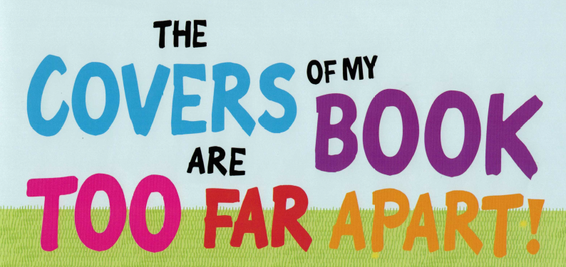
READING IS FUN

What does the boy say?
I __________________ stories.

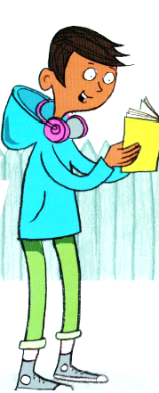
What books do YOU read? Do you LIKE the book?
__________________________________________________
__________________________________________________
__________________________________________________
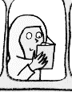
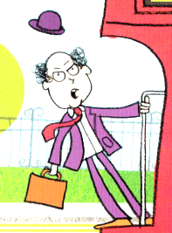
Does he read books? Does she read books?
yes no yes no

Where do they read books? Match the people and the places.
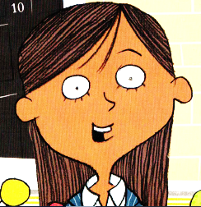
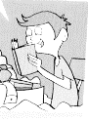

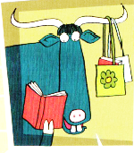
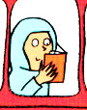

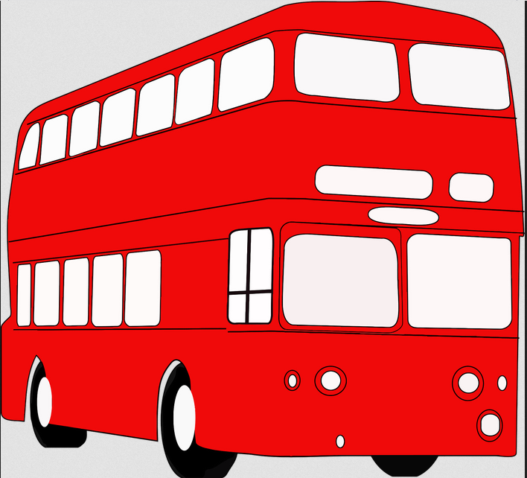

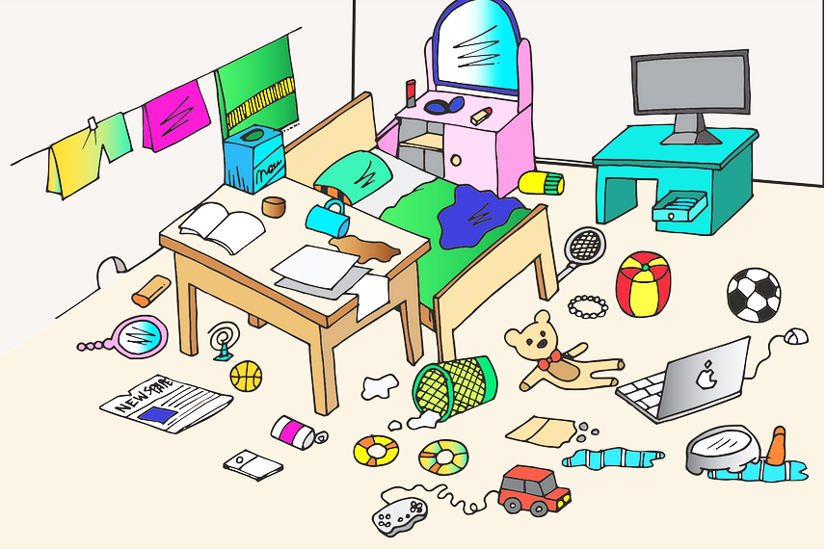
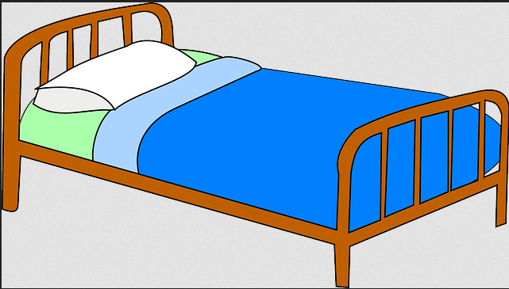
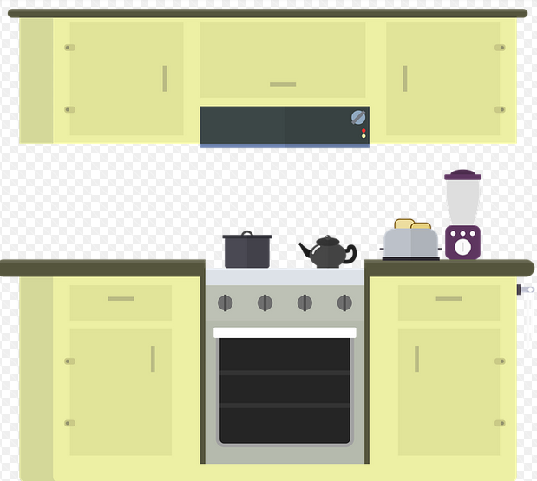
in bed in his room in the kitchen in a shop on the bus

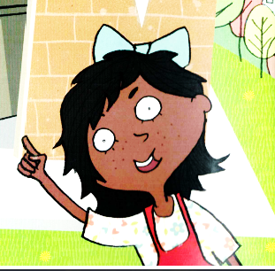
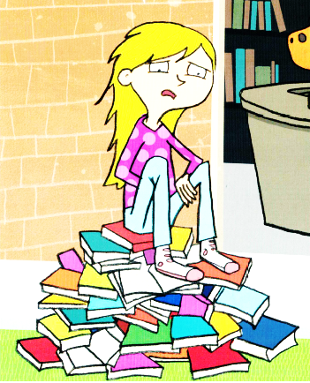
She can not find a book.
Ask your __________________what they are reading.

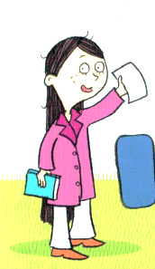
Fill in the numbers:
If you can read _____ page, you can read _______.

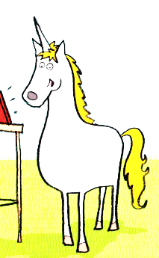
What does the unicorn say?
I ______________ eBooks.

Do you read eBooks?
yes no
Do you like big books?
yes no
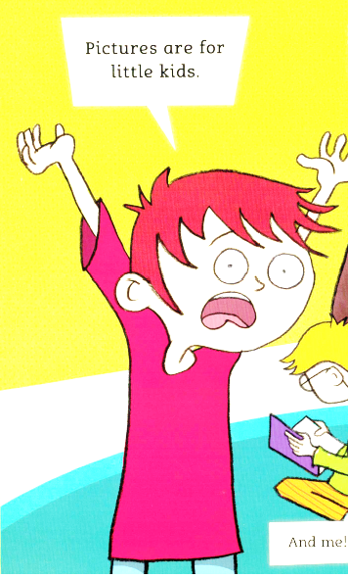
“Pictures are for little kids.”
yes (true) no (false)

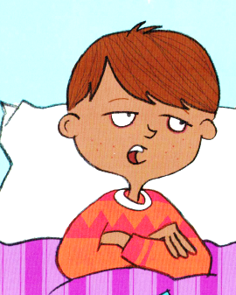
I’m too _________.for bedtime stories.

Do you like bedtime stories?
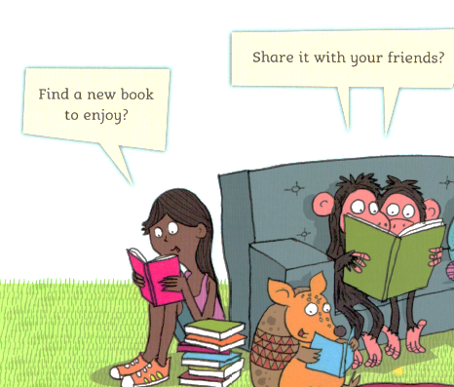
yes no

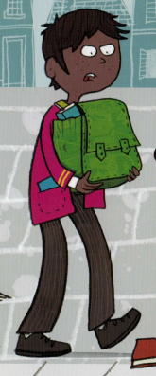
Where does he read?
at home
in school
on the bus

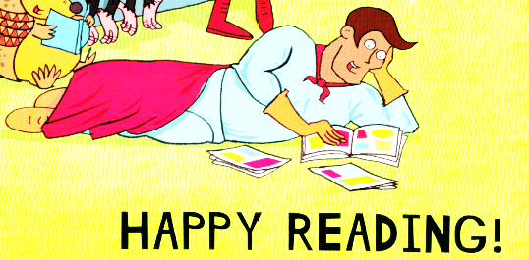
FIND AN INTERESTING ENGLISH BOOK TO READ in your teacher’s basket and start reading!

GLUE THIS WORKSHEET IN YOUR READING DIARY

READING IS FUN

Why does the boy love stories?

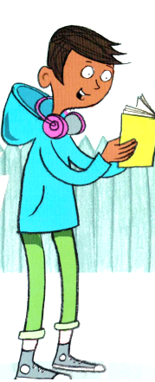
What books have YOU read? Did you LIKE the books?
__________________________________________________
__________________________________________________
__________________________________________________
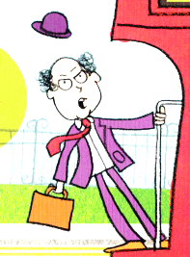
Why doesn’t he read books?
________________________________________________________________
What is YOUR excuse if you don’t read?

________________________________________________________________
Where does she read books? Where does he read books?
________________________________________________________________
Where do you read?

What is her problem? _______________________________________________
What can she do? __________________________________________________
_________________________________________________________________
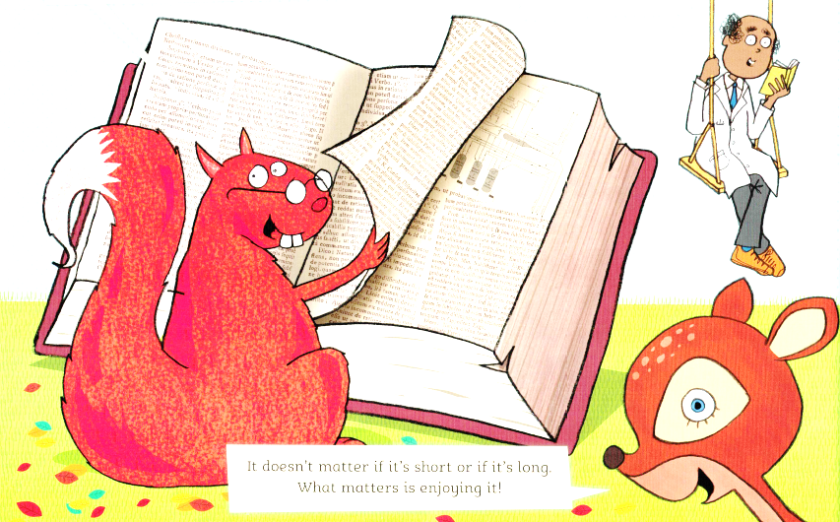
How do you find interesting books?
______________________________________
______________________________________
______________________________________
Do you like big books or short books?
big books short books both
“Pictures are for little kids.”
True or false? Why
_______________________________________________________________________
_______________________________________________________________________
What does he think? Is he right?
__________________________________________________________________
Do you read bedtime stories?
yes no
Do you like bedtime stories? Who reads them in your family?
______________________________________________________________________________
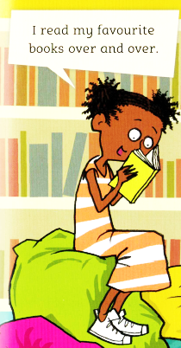
Do you read books ‘just for fun’? yes no
What is your favourite book?
___________________________________________________________________
How often have you read it?
__________________________________________________________________
Do you want to read it again?
__________________________________________________________________
FIND AN INTERESTING
ENGLISH BOOK TO READ
- in your teacher’s basket
- in the school library
- at home
- in a bookshop
- …..
and start reading!

GLUE THIS WORKSHEET IN YOUR READING DIARY

