Oxford Owl Free e-Books
You can read lots of good English stories at home.
Go to: https://www.oxfordowl.co.uk/
Then click on My class login
Your username is: xxxxxxx
Your password is: xxxxxxx
Then click: Log in
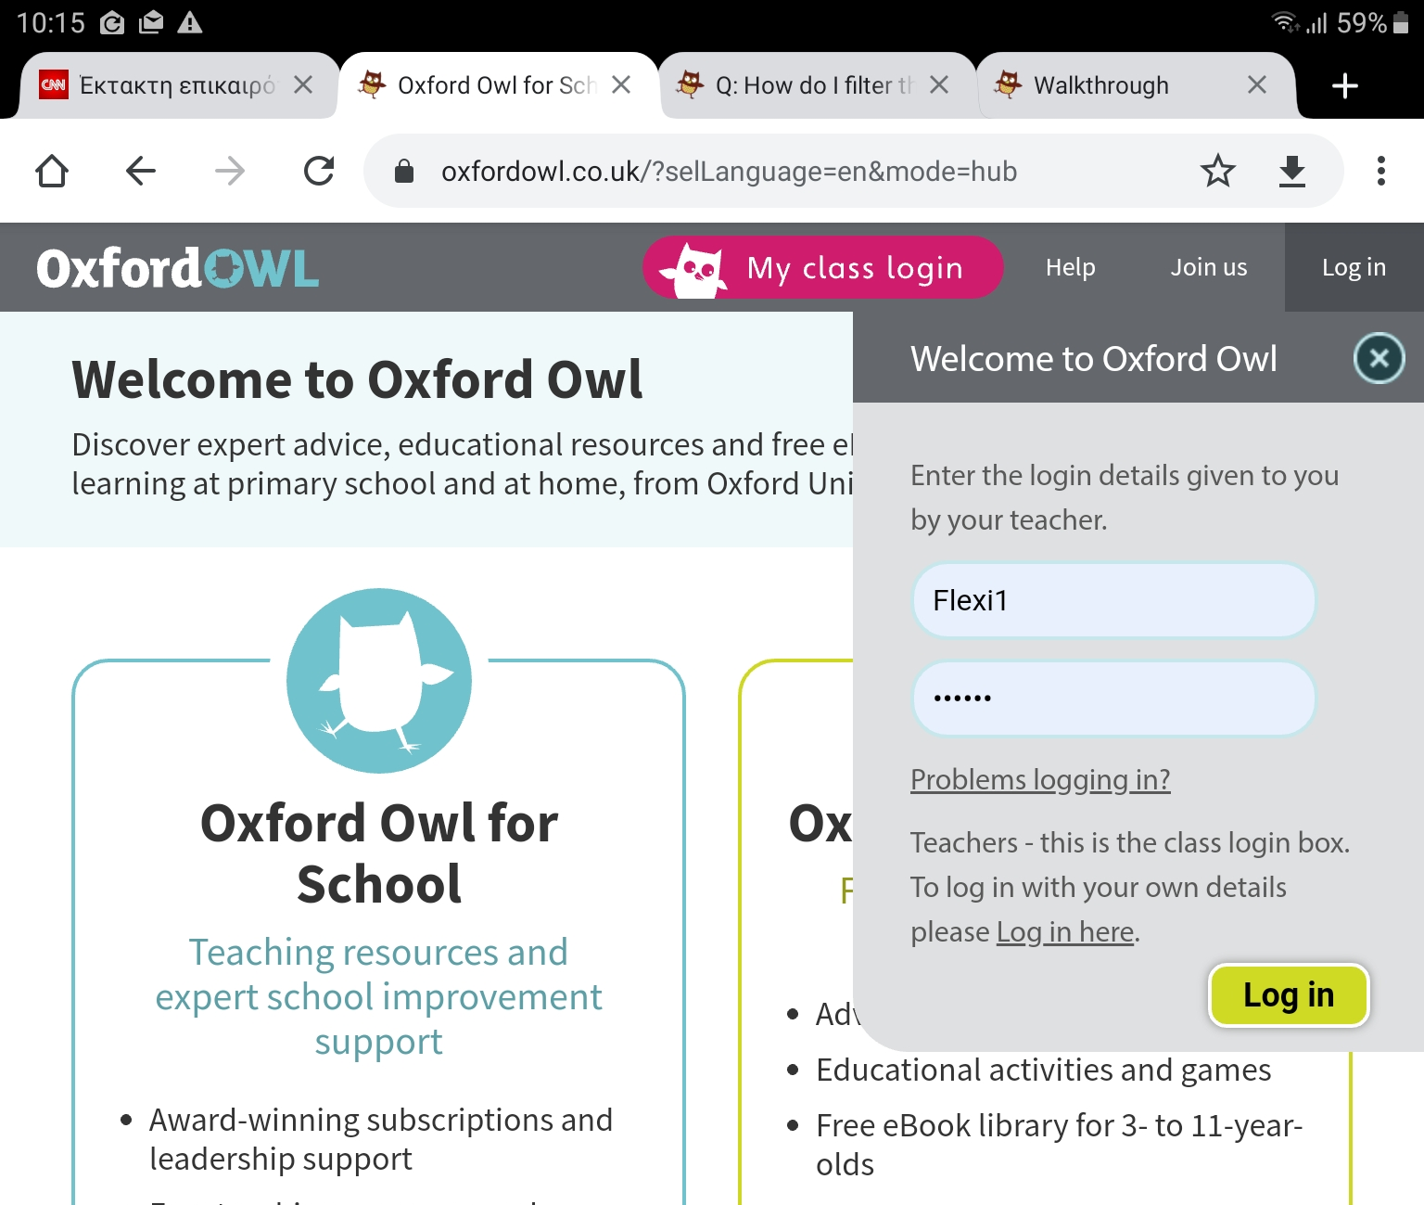
xxxx

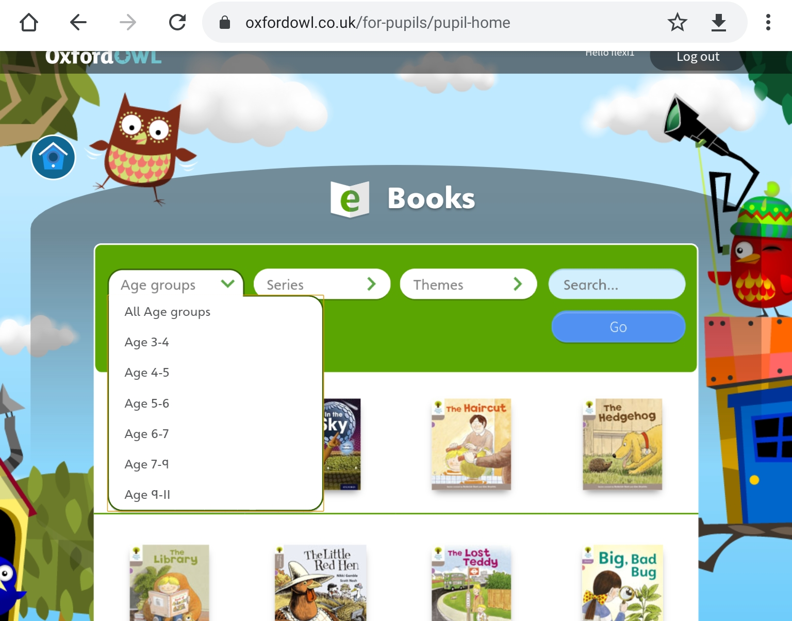
Then click on AGE groups and choose your READING age. Your READING age in English is below (under) your real age.
Then choose a book. You can read the book and you can also listen to many of the books.
Have fun.
You can then do a book-chat with your teacher and write a page in your reading diary.

