How to create class logins on Oxford Owl
1. Sign up as a teacher. Click on JOIN US, then fill in the form.
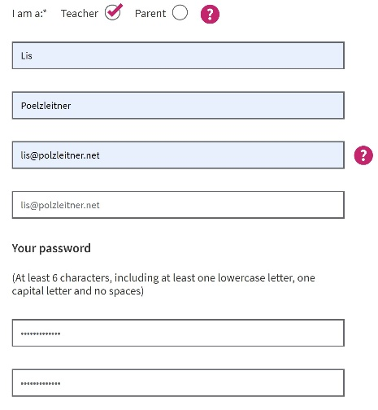
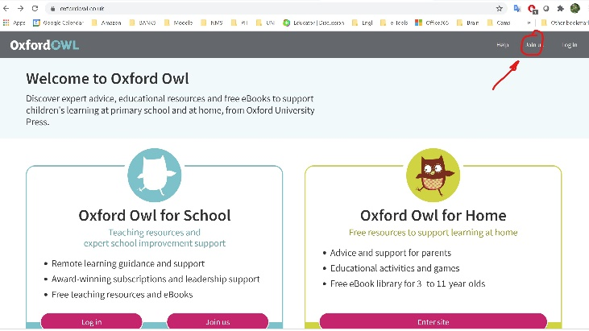

2. Then create class logins.
Open the dropdown menu by clicking the little arrow next to your username.
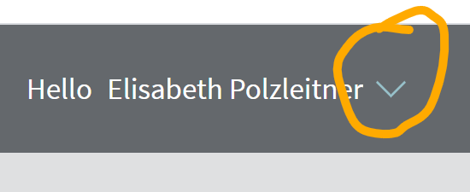 In the dropdown menu, choose CREATE CLASS LOGINS
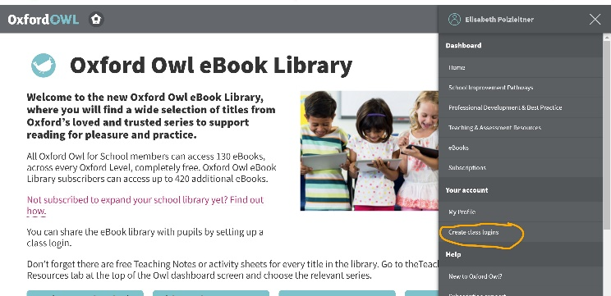

3. Use simple usernames and passwords for each class.
