Let’s talk about your book
TITLE: ___________________________________

Author: _________________________________

Ups and downs in life
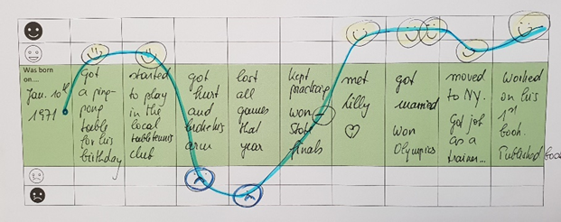
Choose about five to seven important moments in your main character’s life. Write short notes about these events into the gray area of the table. Then decide how the character was feeling at these moments and draw appropriate smileys.
Draw a line through all these smileys to show the character’s emotional ups and downs in life.






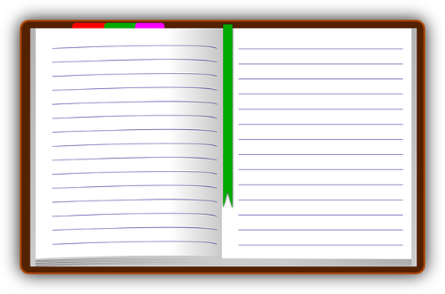
Diary
Choose one of the happiest or lowest moments in your character’s life and write your character’s diary entry for that day.
In the diary your character describes the situation he/she is in and his/her feelings about this situation. Maybe your character also writes about possible solutions to his/her problem.

Dear Diary,

Agree or Disagree?

In your story the characters had to take several decisions.
Do you agree with them?
What would you have done in these situations?
Explain why.
My character decided to ……… | Yes, I would have done the same.  Yes, I would also have ……………….  because ……………………………………..  No, I would have …………… instead, because ……………………………………..

