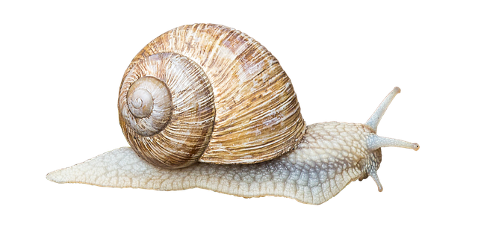
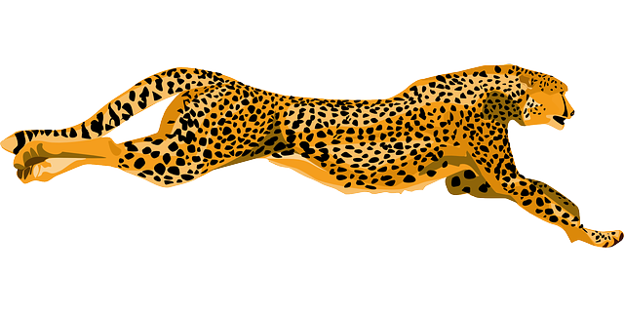
https://pixabay.com/de/pferd-freigestellt-braun-tier-3108994/ https://pixabay.com/de/pferd-freigestellt-braun-tier-3108994/ https://pixabay.com/de/gepard-wildkatze-schnell-40986/
SNAIL | 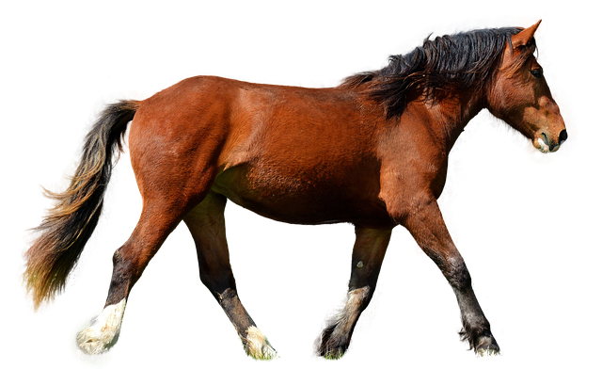  HORSE | CHEETAH

Azra | Selina P | Clemens | Robart | Tobias
Merit | Selina D | Luca | Haitham | Tim
Lea | Elisabeth | Lucas | Clyde
Michelle | Sidra | Sojjad | Elias
Angela |  | Ennio | Leon

