Dear student,
Please follow these instructions to sign up to our Moodle platform. You will have the role and rights of a teacher in the class where you are going to teach in this practicum. Please use your rights carefully and do not delete anything that we have created in the course.
You will be assigned ONE topic block where you can design tasks and activities for your teaching.
Within this block, feel free to try all kinds of tools that Moodle offers.

Step 1: Register for a new account on: eduvidual.at
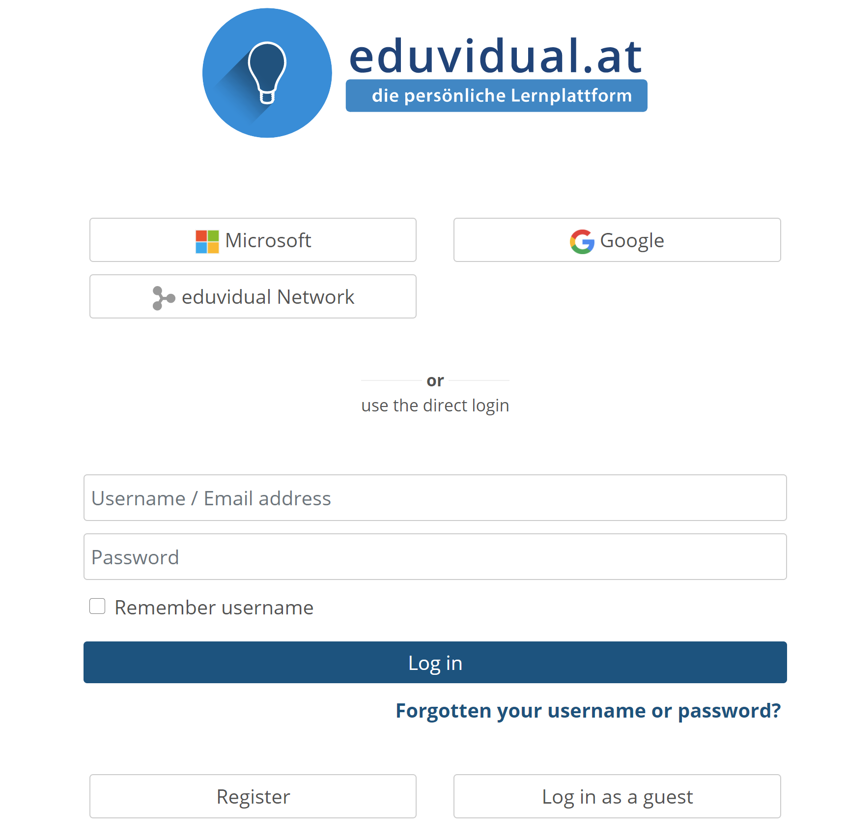
You will have to enter your age and place, then click PROCEED.
Then enter your e-mail address and a password of your choice. Please make sure you remember the password and fill in all the required fields on the page.

Use the newly created account to log in to the website. Then use the temporary access-code (link or QR code) that your mentor has sent you by e-mail to enroll in the course where you are going to teach.
Look around in the course and see what we have done already and how Moodle can help teachers present and organize materials and activities efficiently.
If you need any help with using Moodle, try the moodle doc pages first, then ask your mentors for help.
Good luck,
E. Pölzleitner

