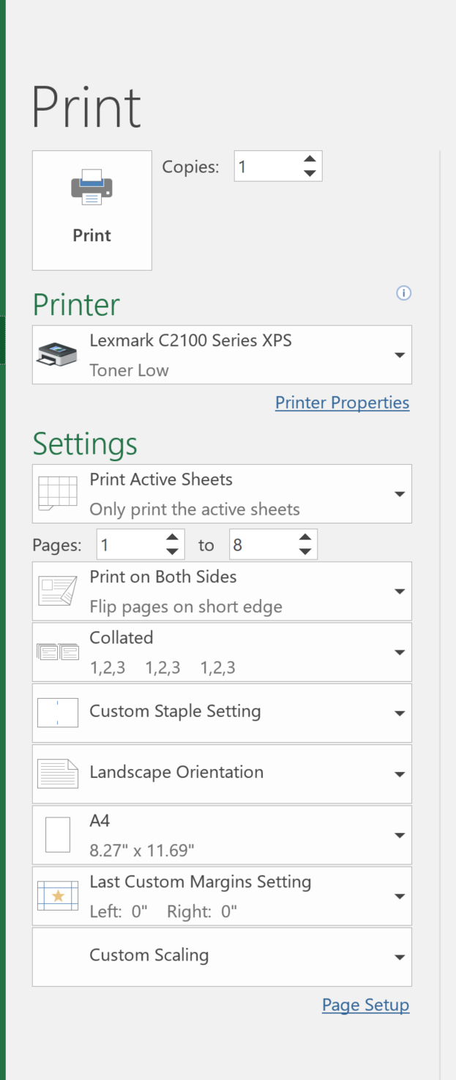
1. Number of cards should be a multiple of 16
2. Center all sentences in the input columns before proceeding to printing.
3. Printer setup see left.
