A Short Christmas Workshop

We Wish You A Merry Christmas
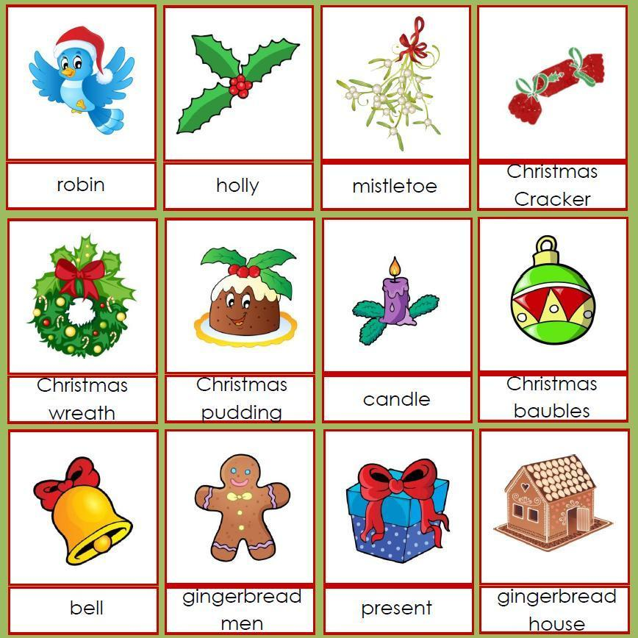
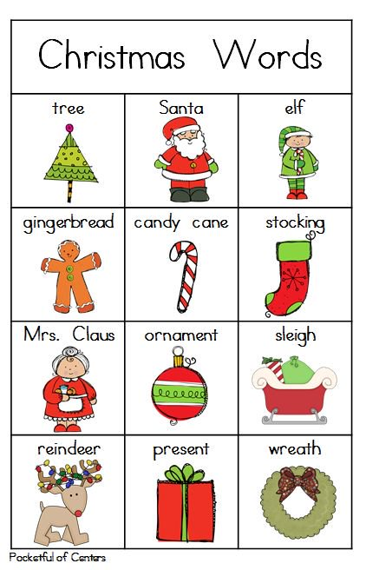
We wish you a Merry Christmas,
We wish you a Merry Christmas,
We _______you a Merry Christmas,
And a Happy New Year.
Good tidings to you,
And all of your kin,
Good tidings for Christmas,
And a Happy New ______.
We all know that Santa's coming,
We all know that Santa's coming,
We all know that ______'s coming,
And soon will be here.
Good tidings to you,
And all of your kin,
Good tidings for Christmas,
And a Happy _______ Year.
We wish you a ________ Christmas,
We wish you a _______ ______________,
We ________________________________,
And a ________ ______ _________

https://www.google.com/search?q=christmas+flashcards&tbm=isch&source=iu&ictx=1&fir=TaAqt8Ex05Z0sM%253A%252CtYMoCxENvF8x2M%252C_&usg=__3oQliucUkqyQ_Y3iyuEy_-cJ0So%3D&sa=X&ved=0ahUKEwiBsKDNzJHYAhUIIuwKHUhvCKYQ9QEIPDAG#imgrc=TBSFEn2h6w9eqM:

https://www.google.com/search?q=christmas+flashcards&tbm=isch&source=iu&ictx=1&fir=TaAqt8Ex05Z0sM%253A%252CtYMoCxENvF8x2M%252C_&usg=__3oQliucUkqyQ_Y3iyuEy_-cJ0So%3D&sa=X&ved=0ahUKEwiBsKDNzJHYAhUIIuwKHUhvCKYQ9QEIPDAG#imgdii=lZ2mo04Wq2fXTM:&imgrc=TBSFEn2h6w9eqM:

Play a Christmas word game    https://learnenglishkids.britishcouncil.org/en/word-games/christmas-1 | Another word game    https://learnenglishkids.britishcouncil.org/en/word-games/christmas-2
 | Santa, high in the skyhttps://learnenglishkids.britishcouncil.org/en/songs/santa-santa-high-the-sky
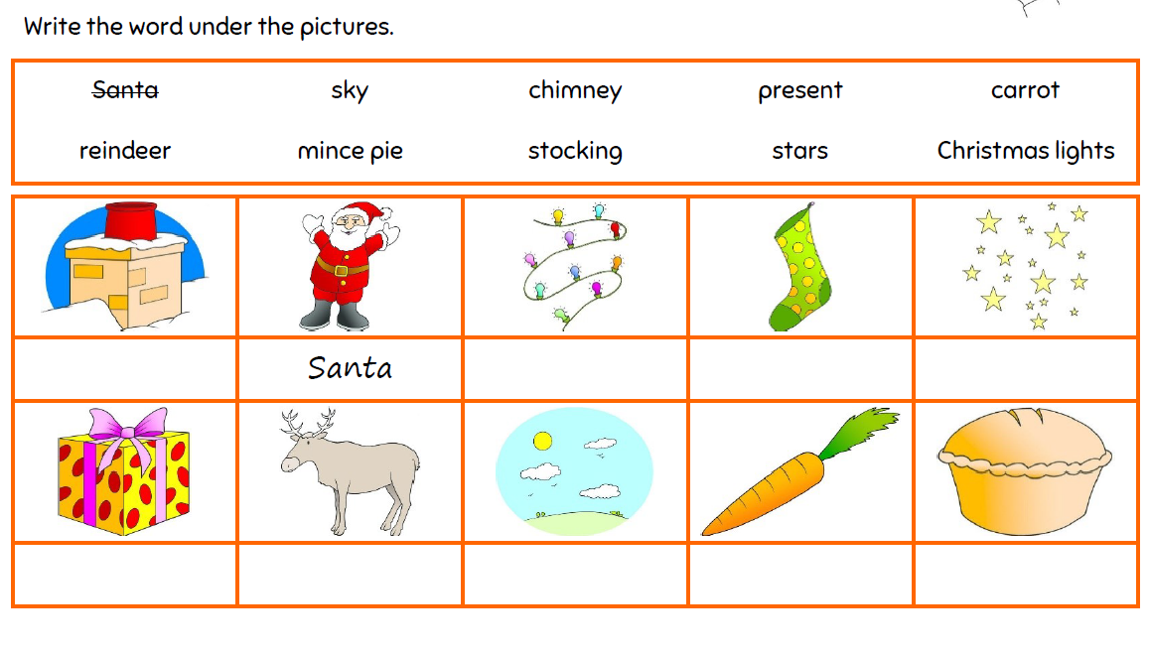

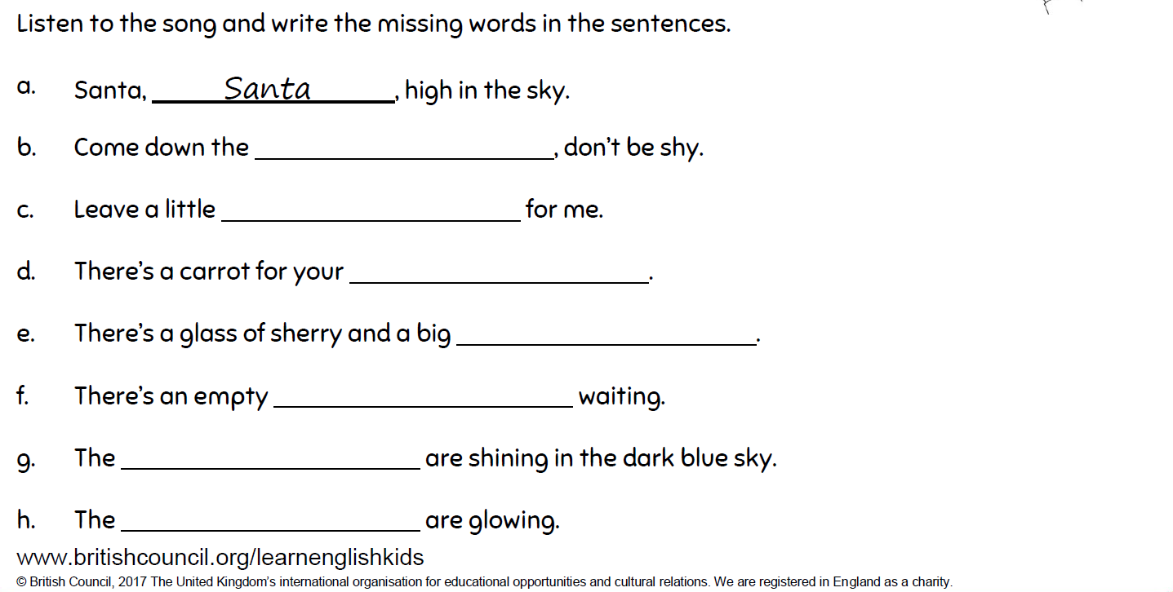
If you want more…
http://chagall-col.spip.ac-rouen.fr/IMG/didapages/christmas/index.html

Some of these will only work on the computer – not on your tablet

