

Note: In the next few weeks, I will be opening up a limited number of places in the LessonStream Membership. I would love to have you in. If you would like to join the waiting list, you can sign up here.
Hello lovely people,
Today, I have a picture-telling activity for you.
What did you do Rudolph?
Last Christmas, a friend of mine sent me a seasonal photograph and asked if I could use it in class.
This year, I am happy to oblige. (Thanks Phil!)
Note: I am not going to show you the photograph yet. I want you to imagine that I am standing at the front of the classroom, with the image in hand. You (my pretend students) cannot see the photograph but you know that it is there. I am now going to communicate the narrative of the image as a storyteller would. This is a technique that I refer to as picture-telling.

So, this is a Christmas image which went viral in 2017. People seemed to think that it was funny. They shared it on Facebook and other social media sites.
First of all, let’s give the photograph a title. Let’s call it:
Rudolph’s Revenge
Do you know who/what Rudolph is/was? What do you know about him?
Rudolph is the most famous of Santa Claus’s reindeer.
Rudolph, the Red-Nosed Reindeer is a well-known Christmas story. It is also a song that was number 1 in the USA at Christmas time in 1949. Can you identify the two missing words from this excerpt of the lyrics.
Rudolph, the red-nosed reindeer
Had a very shiny nose
And if you ever saw it
You would even say it __________ (1)
All of the other reindeer
Used to laugh and call him names
They never let poor Rudolph
Join in any reindeer __________ (2)
Answers:
(1) Glows
(2) Games
Click here to listen to the song on YouTube

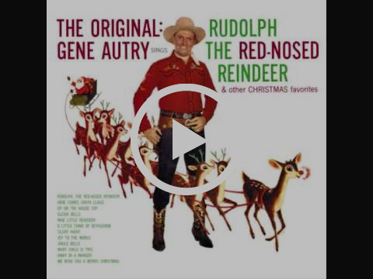

Back to the photograph ...
So, the photograph (which you have not seen yet) is titled Rudolph’s Revenge.
What do you think is happening in the photograph?
Let me describe it: Rudolph, the red-nosed reindeer, is in the foreground of the image. He is flying towards us. His nose is as red and shiny as ever.
He has left all of the other reindeer behind. They are lying on the floor in the background of the image. (Notice that I said floor and not ground.)
Where do you think this picture was taken?
So, all of the other reindeer are lying on the floor below. And things don't look good for them. They don’t look too well. In fact, they might even be dead.
Of dear.
Oh reindeer!
(Sorry)
So, this is Rudolph’s revenge.
One more thing – there are two men in the picture. They are standing above all of the other reindeer as if this were the scene of a crime. One of the men seems to be attending to one the reindeer.
So the questions are:
- Where was this picture taken?
- What's going on here?
Now, scroll down to see the image …
↓↓↓↓
↓
Just a little bit more ….
↓Almost there …
↓↓
Congratulations – you made it!
This photograph was taken in a Hull shopping center in 2017.

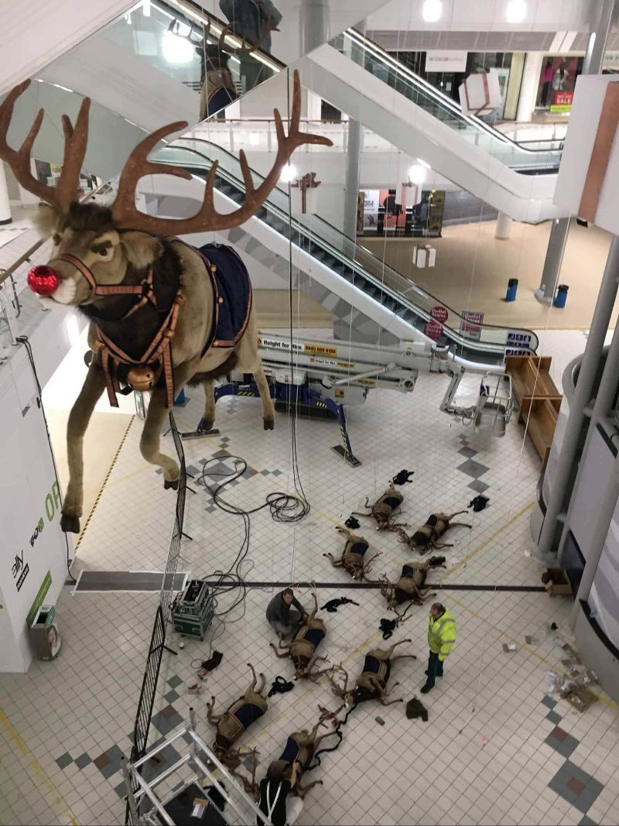

When the image was shared online, it was often accompanied by captions which referenced the song and spoke of Rudolph getting his revenge on all of the other reindeer. For example, this one was reported in the Hull Daily Mail.
From here, the story is just beginning. It's now up to your students to develop it.
- What did Rudolph do to get his revenge?
- Are the other reindeer really dead?
- What happened next?
Perhaps you could adapt this idea for your own classroom. If so, please let me know how you get on. And thank you to Phil Longwell for sending me the picture last year.
Enjoy the rest of your Sunday!
Jamie :)

