My Time Capsule
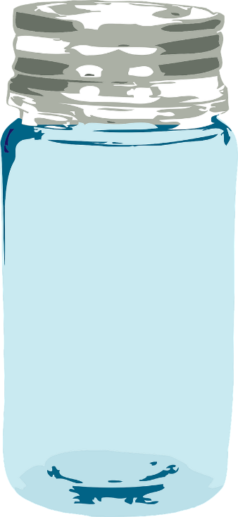

Year:
………………

Name:
………………

Ideas and inspirational sayings from the BIG LIFE JOURNAL for Kids, www.biglifejournal.com
All other images: creative commons from Pixabay and Microsoft

My memories of 2019: Describe the situations in a few sentences.
This Photo by Unknown Author is licensed under CC BY-SA
I laughed out loud when…

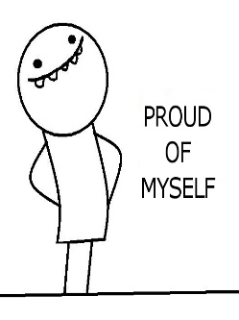
This Photo by Unknown Author is licensed under CC BY-NC
I was really proud when…

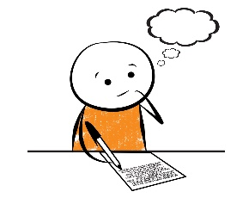
This Photo by Unknown Author is licensed under CC BY
This made me think:.

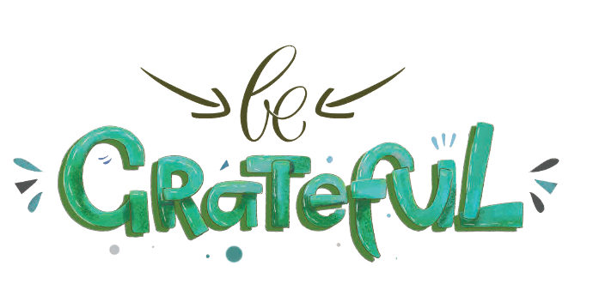
This made me grateful:
Find one thing with each letter of the word. You can also write a short sentence or phrase. Think of big and small things and everything in between..
G
R
A
T
E
F
U
L
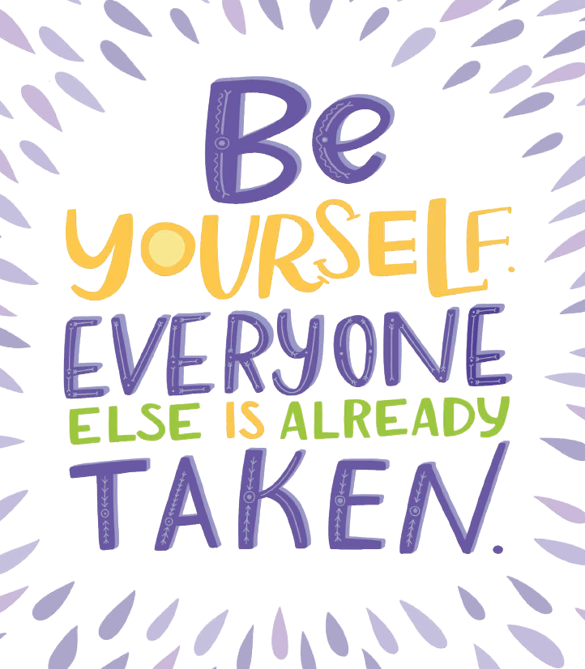
Draw yourself on this page and add all the things that make you unique.
If you need more ideas, ask your classmates what makes you unique.


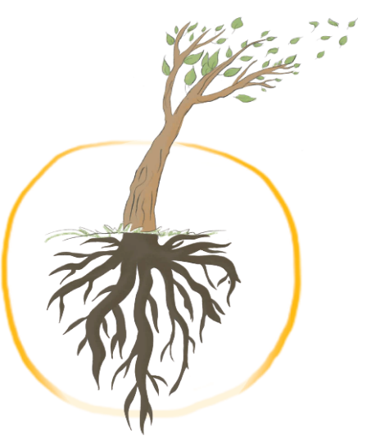
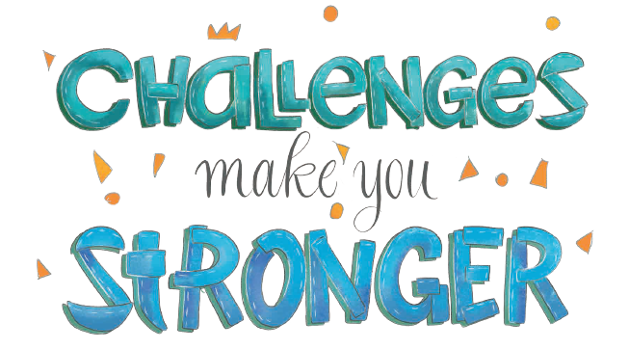

Our roots keep us standing strong:
We can think of our lives as trees. The loving adults, teachers, friends, our thoughts, values are roots which keep us standing strong. Challenges are like the wind in the trees. Trees sway in the wind and storm but keep standing tall and strong as long as their roots are deep.
Think of some challenging or difficult situations in the last year. Were you tired – sad – disappointed – scared – …
What happened?

How did you feel about it?

How did you solve the problem?

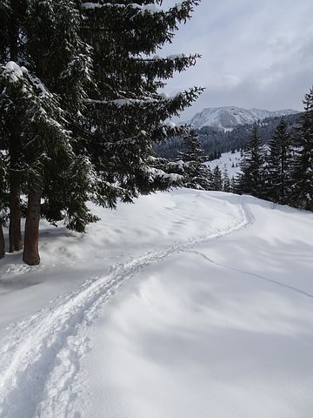
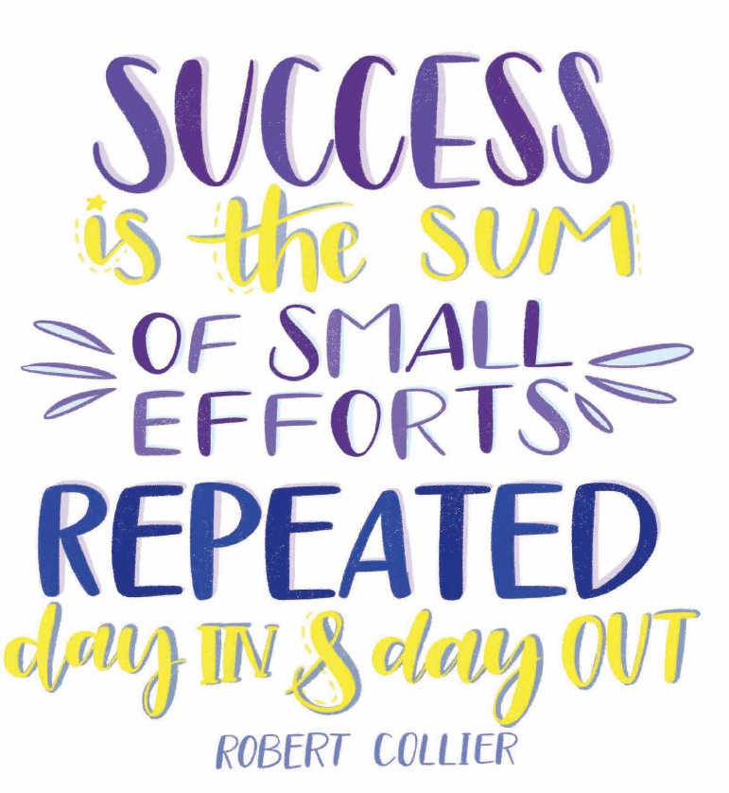
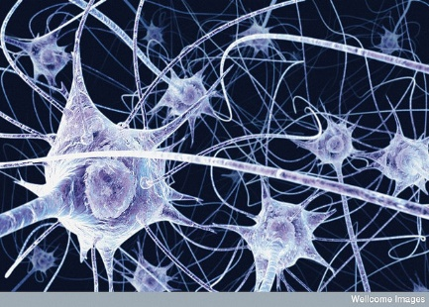
Imagine you are walking in the deep snow. The first time you walk the path, it is slow and difficult. When you walk the same path again, you walk in your own footsteps and it gets easier and easier.
The same happens in your brain. Every time you learn something new the cells in your brain create a new path. When you practice something the path in your brain gets faster and stronger.
Think of a few things that you can do well. How did you learn them?

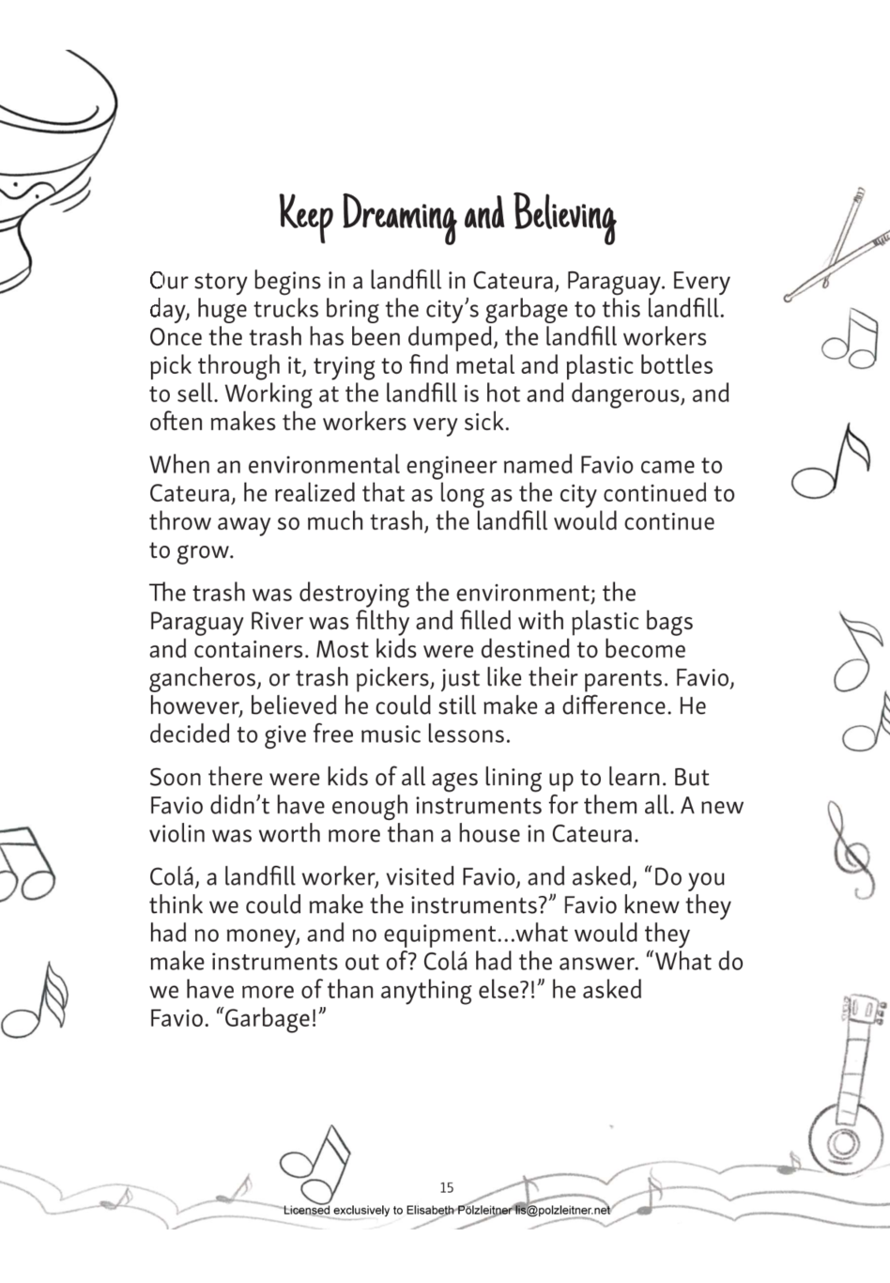
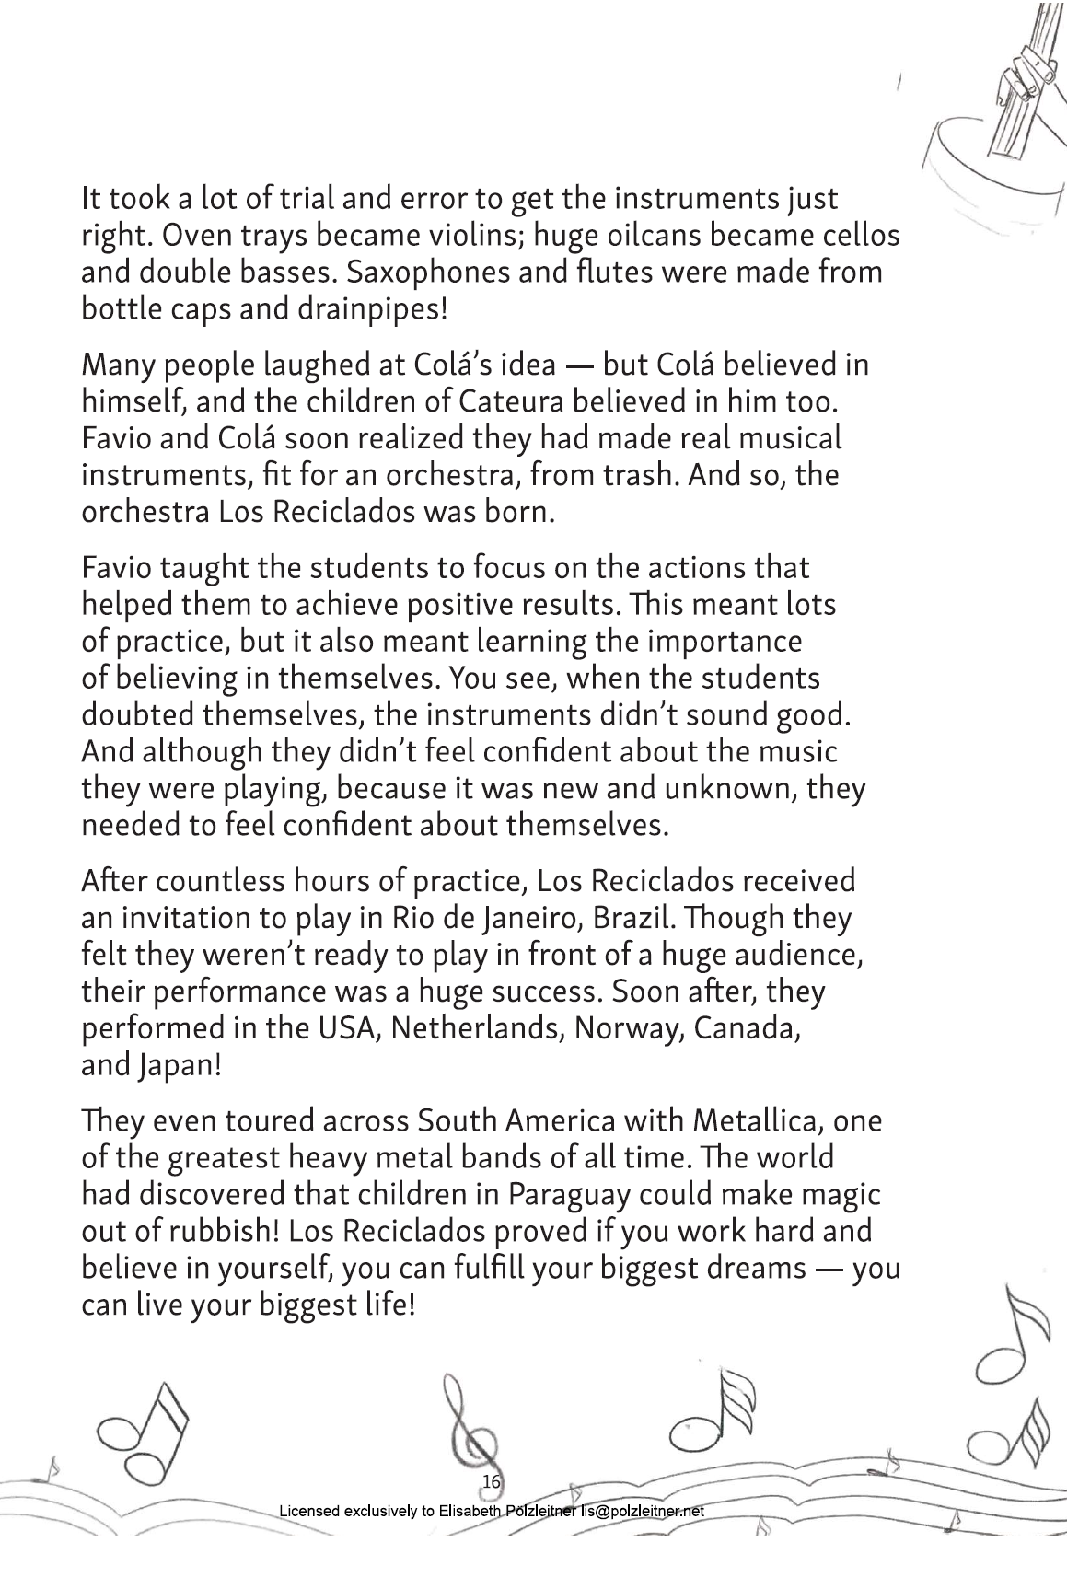

Now watch the short video about Los Reciclados.
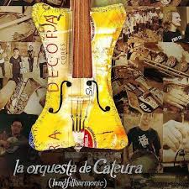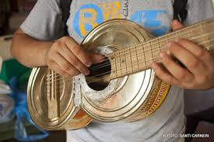
https://youtu.be/7AOnZb7ZlJI



Now it’s your turn:
Begin with the END IN MIND.
What is your big dream? What would you like to do in the next 10 years? Do you want to start a band? study at university? find an interesting job? move to a different place? volunteer?...
Collect your ideas. on the next page.

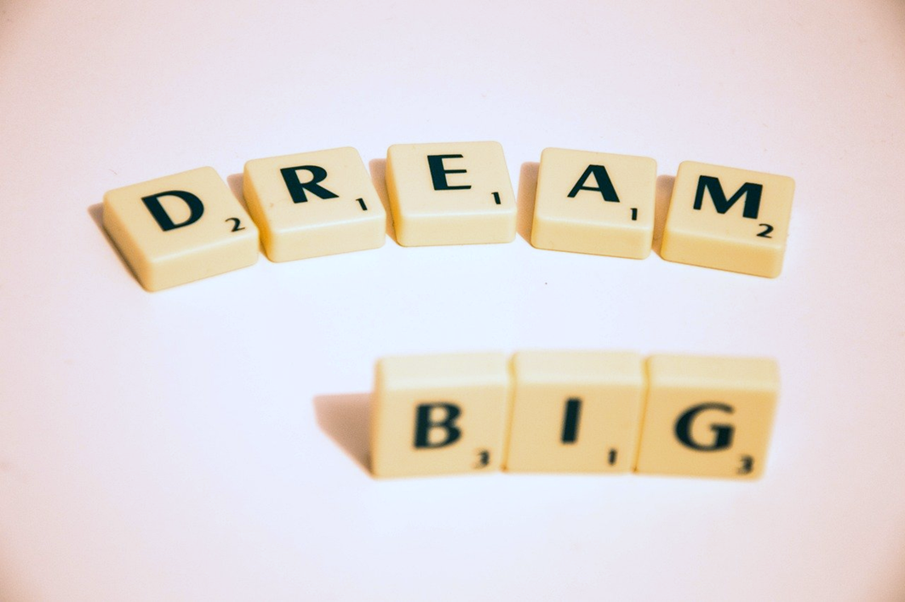

Things I want to do in the next 10 years.

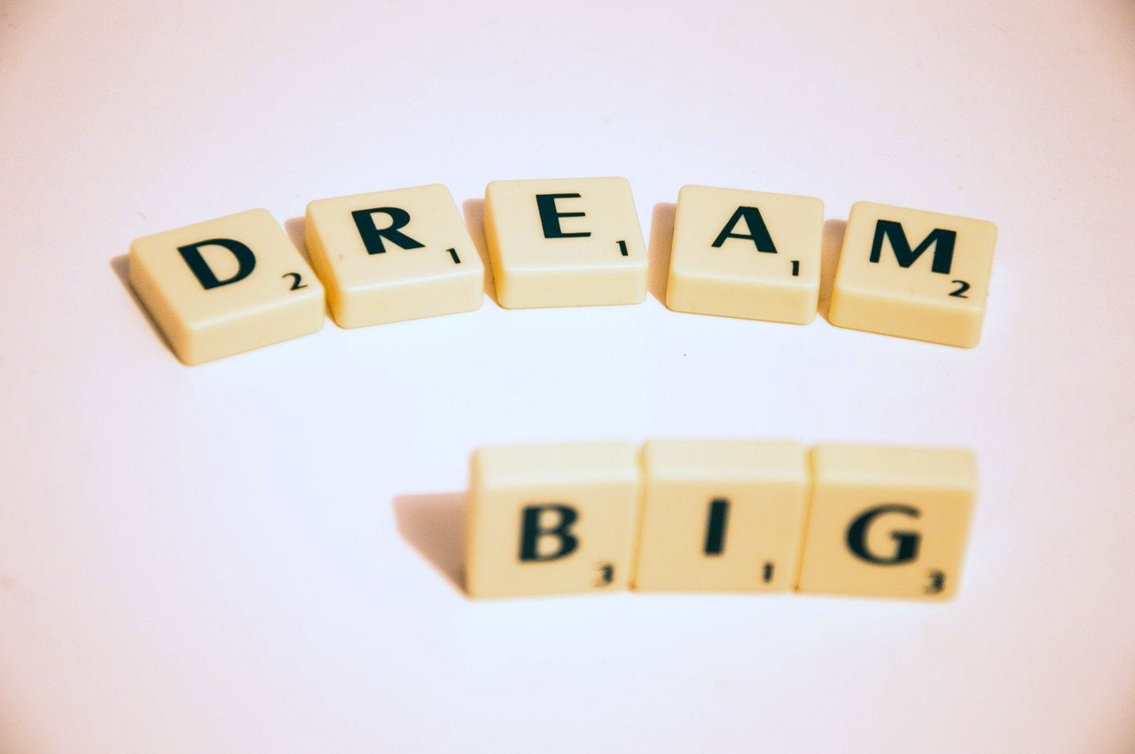

What will be your next steps?

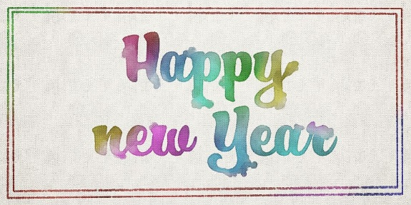
My New Year’s Resolutions!
My Goals | My Plans: What I am going to do to reach these goals.
This year I really want to: | In order to reach this goal, I am going to…
I want to be better at: | In order to reach this goal, I am …
I really need to: | In order to reach this goal, …
I want to learn how to: | In order to reach this goal, …
Me – others – our planet
My wishes and hopes for 2019 and beyond…
What are your wishes and hopes for the next year and for the future?. Think of your own wishes and of things you wish other people or our planet.
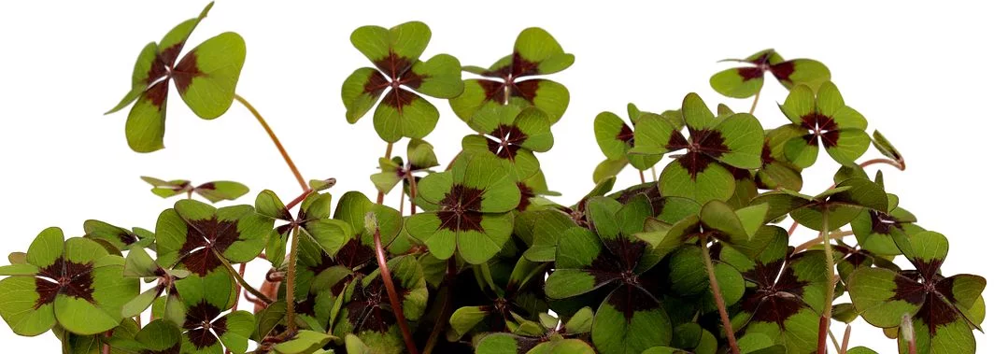
I hope that I will …
I hope that …

I hope that …

I hope that…

I hope that…

I hope that…

I hope that…

