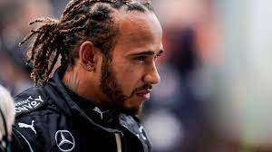
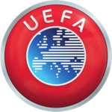
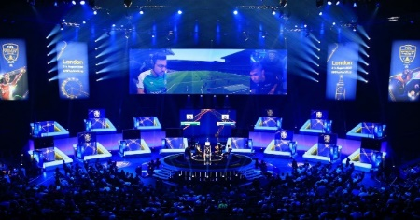
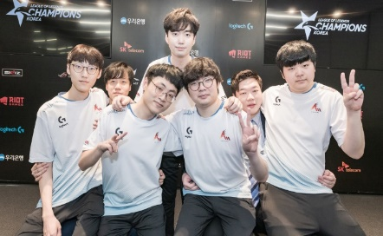
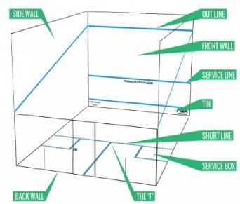
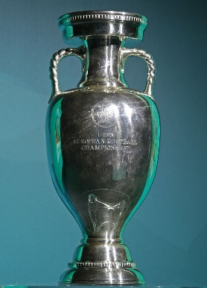

The Best

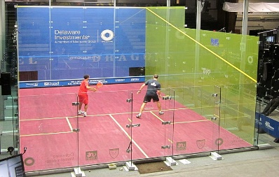

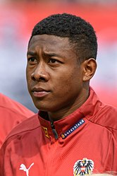
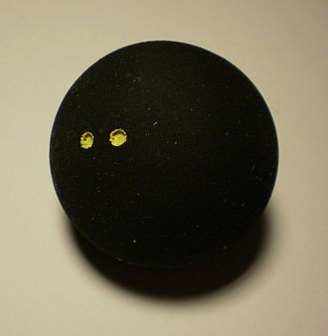




Table of Content
The best Netflix series 3
Why you should play squash 4
The EC 2020 5
Hopefully the winning team 6
The exciting title fight in the formula 1 7
The new evolution of sport 8
The best browser games 9
Chocolate cookies recipe 10
The best chocolate bars in town 11
Jokes to laugh out loud 12





The best Netflix series
Nowadays, there are already a lot of streaming services. With these dropped providers, you quickly lose track. Today I have chosen the streaming service Netflix. It may not be the best, but Netflix has a very wide range of series. So that you don't always have to search for hours, I have listed the best series on Netflix for you.
By Tim Kröpfl
Ranking | Name | Genre | Seasons | Actors
1 | Money Heist | Thriller | 4 Seasons | Alvaro Morte, Ursula Corbero, Alba Flores
2 | Prison Break | Drama | 5 Seasons | Wentworth Miller, Dominic Purcell, Sarah Wayne Callies
3 | Narcos | Krimi | 3 Seasons | Petro Pascal, Wagner Moura, Joanna Christie
4 | The Witcher | Fantasy | 1 Season | Henry Cavill, Anya Chalotra, Mimi Ndweni
5 | Suits | Drama | 9 Seasons | Meghan Markle, Rick Hoffman, Gabriel Macht
6 | Hous of Cards | Drama | 6 Seasons | Kevin Spacey, Robin Wright, Kate Mara
7 | Locke & Key | Drama | 1 Season | Darby Stanchfield, Jackson Robert Scott

Money Heist
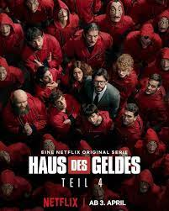
Money Heist is not the best series ever made, but on Netflix it’s hard to find a Better one. The series is made in Spain. It's about a team of bank robbers who break into a banknote printing house to print money for themselves. In the process, they also take some hostages. Therefore, it is very difficult for the police to storm the bank. In the 3th season they commit a second break-in in the Spanish bank to steal the gold, at the end of the 4th season they lose control. Therefore, in September we can expect an exciting final season of Money Heist.
Why you should play squash
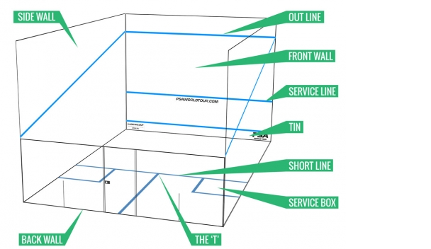
By Laura Friedl
While it doesn’t have quite the same status as tennis or badminton, squash is a great sport for fitness fanatics. It’s the healthiest sport in the world, according to Forbes and the health range from more accurate hand-eye coordination and improved agility to increased strength.

How does squash work?
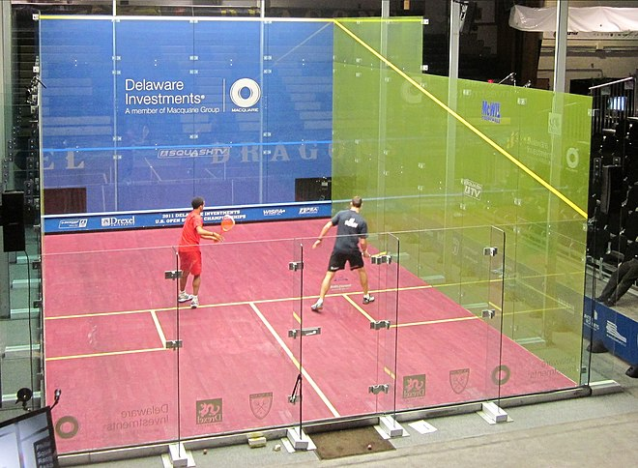
The basic principle of squash is to keep hitting the ball against the front wall until your opponent cannot successfully get it back. When serving, the ball must land above the service-line and in the opponent’s quarter. The ball must not touch the out, the tin or touch the floor twice. The ball cannot hit the floor before hitting the front wall. The ball may strike the side or back wall at any times, as long as it hits the front wall. Points can also be won or lost when a physical obstruction occurs on the court between two players. That is called “Let, no Let or stroke”.

Why you should play squash?
Squash is a game that can be played at any age and it’s easy to play. It’s a very healthy sport and you can meet new friends. All you need is some comfy workout gear, non-marking shoes, a racquet, and a ball. It’s an indoor sport. You can play it at any weather.
A Let decision results in the rally being played again. with the referee deeming that the interference was accidental and both players have made equal effort to allow play to continue.
A Stroke is when the point is awarded to the appealing player. A stroke is awarded when the referee deems the incoming striker is in position to play a shot but suffers interference due to the outgoing player not making every effort
The EC 2020
By Elias Kitzberger
The competition everybody has been waiting for
Over one year after the excepted date for the EC 2020 the European Championship really starts. Because of the Corona pandemic it wasn’t possible to play the EC. But now it is. On Friday the 11th June the first game, Italy against Turkey starts at 9 o’clock pm.
Three of the favourites for this Europa wide competition are France with great players like Kylian Mbappe or N’Golo Kante. Of course, their whole team is full of great players. Another favourite is Spain with some talented young players like Rodri or Pedri. Also, England is one of the favourites. The English teams from the Premier League dominated the last Champions League with two teams in the final. They have many great young players like Spain. One of them is Phil Foden. He plays at Manchester City, one of the finalists in the Champions League.
https://de.wikipedia.org/wiki/Fu%C3%9Fball-Europameisterschaft#/media/Datei:UEFA_Logo.png

Austria also takes part this competition, but they aren’t a favourite for the title.
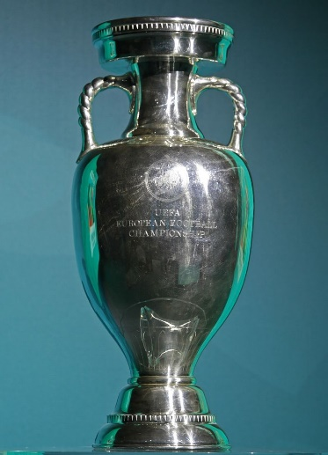
The EC is divided into different stages. The first stage is the group stage. In the group stages there are six groups, and in each group, there are four teams, everyone plays against every other team for one time. So, every teams plays three matches in this stage. The teams on place one and place two of each group are directly qualified for the next stage, there are still the best sixteen teams of this year. If you equal six plus six (the teams on the first and second place of each group) you get twelve. So, there are still four teams missing. The four best teams on the third place are also qualified. In this stage one team plays against one other team and the team that wins is qualified for the next stage, the “quarter finals”. In the quarter final it is the same concept. One teams against one other, but only eight teams are still in the tournament. After this stage only the best four teams play to win the championship. It is still the same concept like in the last two stages, it is called “semi-finals”. The last two teams make up the winner in the final, the final is still like the other stages.
https://en.wikipedia.org/wiki/UEFA_European_Championship#/media/File:Coupe_Henri_Delaunay_2017.jpg
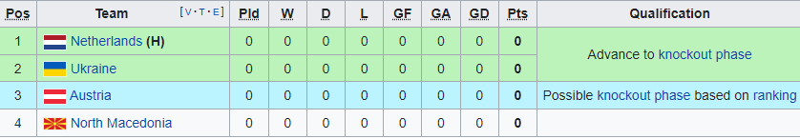
Austria is in group C. They are in one group with the Netherlands, the Ukraine and North Macedonia. Against Ukraine and North Macedonia Austria has a chance but the Netherlands are one of the favourites for the title. Maybe not as big favourites like Spain, France or England but they might be the winner that nobody expected, let’s see.
Hopefully the winning team
By Elias Kitzberger
The top players from the Austrian soccer team for the EC 2020
First of all, I show you all the players which take part in the EC for Austria:
Goalie: Daniel BACHMANN (FC Watford/ENG), Pavao PERVAN (VfL Wolfsburg/GER), Alexander SCHLAGER (LASK)
Defensive: David ALABA (FC Bayern München/Real Madrid), Aleksandar DRAGOVIC (Bayer 04 Leverkusen/Roter Stern Belgrad), Marco FRIEDL (SV Werder Bremen/GER), Martin HINTEREGGER (Eintracht Frankfurt), Stefan LAINER (Borussia Mönchengladbach/GER), Philipp LIENHART, Stefan POSCH (TSG 1899 Hoffenheim/GER), Christopher TRIMMEL (1. FC Union Berlin/GER), Andreas ULMER (FC Red Bull Salzburg)
Midfield: Julian BAUMGARTLINGER (Bayer 04 Leverkusen/GER), Christoph BAUMGARTNER (TSG 1899 Hoffenheim/GER), Florian GRILLITSCH (TSG 1899 Hoffenheim/GER), Stefan ILSANKER (Eintracht Frankfurt/GER), Konrad LAIMER (RB Leipzig/GER), Valentino LAZARO (Borussia Mönchengladbach/GER), Marcel SABITZER (RB Leipzig/GER), Louis SCHAUB (FC Luzern/SUI), Xaver SCHLAGER (VfL Wolfsburg/GER), Alessandro SCHÖPF (FC Schalke 04/GER)
Striker: Marko ARNAUTOVIC (Shanghai Port/CHN), Michael GREGORITSCH (FC Augsburg/GER), Sasa KALAJDZIC (VfB Stuttgart/GER), Karim ONISIWO (1. FSV Mainz 05/GER) https://www.fussball-wm.pro/em-2021/mannschaften/oesterreich-kader/
All of these players, play quite good, but some of them are still a lot better. I’ve chosen three of the best players from Austria. I’ve chosen David Alaba, Marcel Sabitzer and Marko Arnautovic.
David Alaba: Many people say he is the most successful soccer player from Austria of all time. For more than ten years he played for the FC. Bayern and won many titles, like for example the Champions League. Not only Bayern had seen his talent. Many famous clubs like FC. Barcelona or Real Madrid were interested in him. But till last year he never changed the club. For most it was unexpected that he is going to change the club after the summer. But he said that he needs some new experience. He decided to go to Real Madrid.
https://de.wikipedia.org/wiki/David_Alaba#/media/Datei:20180610_FIFA_Friendly_Match_Austria_vs._Brazil_David_Alaba_850_1632.jpg

Marcel Sabitzer: For many years he is playing for Red Bull Leipzig. He is still playing there. In the last two years his talent grew up a lot. In the last two years not only, he got a lot better. After Leipzig was promoted to the 1. Bundesliga 2016 they directly played for the title. Last season when ten games were still to play, they were just a few points behind the title winner FC. Bayern. But in the end of the season they finished the season still on the second place, but 13 points behind Bayern.
https://de.wikipedia.org/wiki/Marcel_Sabitzer#/media/Datei:2020-03-10_Fu%C3%9Fball,_M%C3%A4nner,_UEFA_Champions_League_Achtelfinale,_RB_Leipzig_-_Tottenham_Hotspur_1DX_3665_by_Stepro.jpg

Marko Arnautovic: For a long time, he played in England, nobody expected that he will change the club to play in China. Often successful players change their club to play in China at the end of their career to get some extra money, because the clubs in China pay more to their players than in Europe. He plays as a striker for Austria and is at the moment the best striker from Austria.
https://de.wikipedia.org/wiki/Marko_Arnautovi%C4%87#/media/Datei:20180610_FIFA_Friendly_Match_Austria_vs._Brazil_Marko_Arnautovi%C4%87_850_1633.jpg

With all these great players we might be able to play up in the EC as a great and good club and show that Austria isn’t only good at winter sports. I hope that Austria will play well and come as far as possible in the tournament.
The exciting title fight in the formula 1
Why the long winning streek of Lewis Hamilton might be ending this season
By Tim Kröpfl
Hamilton’s successes
Lewis Hamilton is the most successful formula 1 driver of all time. Since he drives for Mercedes, he was able to become 7 times world champion. Hamilton drives also the most rounds and kilomepers as a leader. With 99 poles he has also the record for the most pole positions.
Current season
Last year he was also able to become world champion, but what was happening with him? In the beginning of this season, he could win the first races, but Verstappen got better. In the city race of Monaco Verstappen won and Hamilton was only able to make the 7th place. This was happening because in a city there are a lot more curves and the red bull carfs better, in which Verstappen drives. The next race was in aserbaidschan also in a city, there in the last rounds Verstappen crashed and the race has been restarted. Unluckily the start of Hamilton was too fast, and he wasn’t able to make the curve. In this race none of them got points.
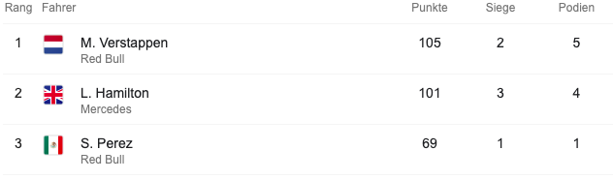
Right now, Hamilton is 4 points behind Verstappen, so this is not a big problem, but there is also a team ranking. In this ranking the points of both drivers of a team are equalled. In this ranking Mercedes is also behind red bull this is happening because of the bad performance of Valtteri Bottas, Hamilton’s teammate.
But why is this a Problem?
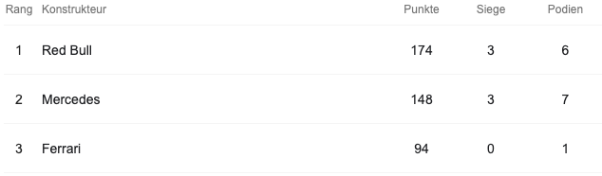
In the end of the season each team gets more money the higher they are in this ranking. Between the first and second place there are a big differenz. If red bull win Mercedes has less money to make the car better and that could have an affect the next seasons.

My opinion

Yes, I`m a Hamilton fan, but it doesn’t matter if he didn’t win this season, I only want to see an exciting season. But I’m sure that Mercedes will stay as the best formula 1 team.
The new evolution of sport
Why e-sport should be accepted as a real sport
By Clemens Froschauer
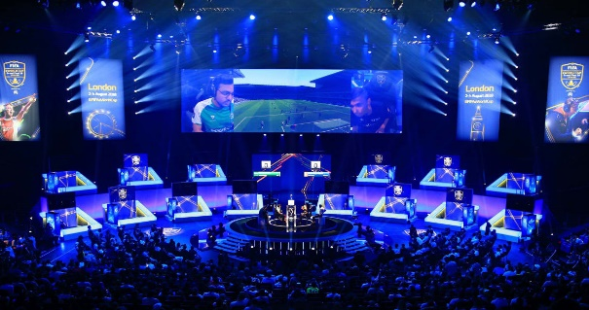
In the last few years e-sport has got more important than ever before, but many peoples say that e-sport is not a “real” sport, because you don’t move your body and burn calories. In this text you learn that e-sport is very hard to play and exhausting, but it has not yet been recognised as a real sport.

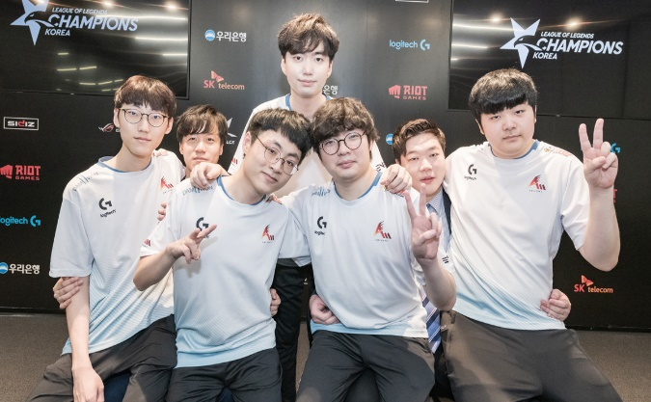
How does e-sport work?
In e-sports many different teams, play different video games against different teams. It’s important to be good as a team and not as a solo player. It’s very hard to get to the pro leagues. There are also worldwide championships, for example in League of Legends. When you win a tournament, you get most of the time money, but sometimes they play for other reasons. In the last League of Legends championship, the winning team called, DAMWON, won 2.34 million USD.

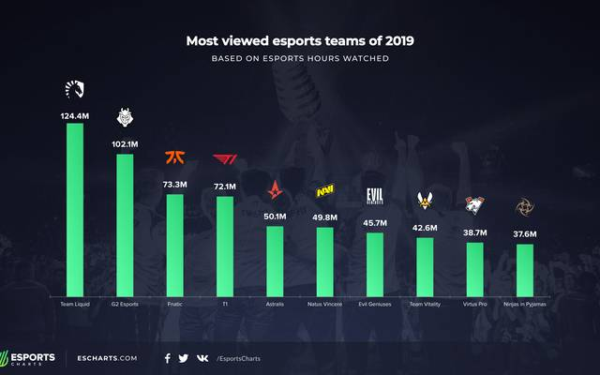
How can you start with e-sport?
First, you need to find a game in which you are very good. Then you must join a team and play smaller cups and get famous and better, sometimes players also get invitations to join a better team as reserve player. Maybe your team will get an invitation to a bigger cup or perhaps the championship group phase.

Why e-sport is very exhausting?
In e-sport the players also must train their skills, like football players, but the training sessions can be 10 hours long and they mostly are daily! It’s important to focus on those games because millimetres can decide if you win or lose, so it’s very exhausting for your mind. There are also some risks for your body. The most risks are sleep disturbances, vision issues, overuse injuries (like carpal tunnel).

I think e-sport should be accepted as a real sport, because it is as exhausting as other sports and it is not playing just for fun, because it’s very hard to play at such a high level.
The best browser-games
If you are bored and want to have fun, play these games
In this Text you can read some good games in your browser. The most of those games don’t need an installation on your device. The most games work only on PC, but some games you can also play on your phone.
By Clemens Froschauer

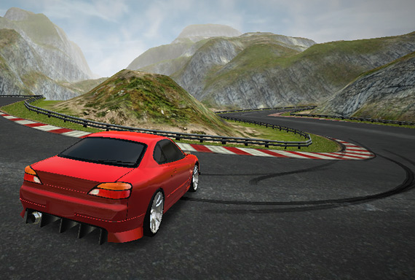
Drift Hunters:
Drift Hunters is a very cool car game in your browser. You can play it on the crazygames website, but it also works on other webpages. In this game you can choose between many different cars and drive on many different maps. The best thing on this game is that it’s completely free to play. You can buy new cars with points which you can get for drifts. The graphic is also good for a browser game and the control is very easy.
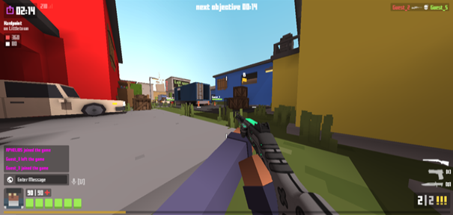
Krunker.io:
Krunker.io is a pixel shooter. You win the game when you have the most points in the end of the round. You get points when you kill your enemies. You also can buy with those points weapon skins. You can also buy with real money points for weapon skins. The only bad thing in this game is that there are many people who are cheating but you can vote to kick those players and report them. The game gets many updates, with new weapons and maps regularly.


Slither.io:
In this game you are a coloured worm and must eat points and eat the other worms to grow. You can kill other worms when their worms head crashes into your worms body. The game has no end because you can grow infinity large. The game is very fun to play when you are bored, but you can only play it alone. You can play it on the website “slither.io”. You only must type this in your browser and click the first link.

These are the three best games if you are bored. Maybe not all of these games are your taste, but you will like at least one of them. I can recommend all of these games quite a lot. I like playing all of them.

Chocolate cookies recipe
The perfect snack for hot summer days
Ingredients:
By Clemens Froschauer
- 1/2 cup sweet butter
- 1/4 cup soft brown sugar
- 1/4 cup superfine sugar
- 1 egg, lightly beaten
- a few drops of vanilla extract
- 1 1/2 cups all-purpose flour
- 2 teaspoons baking powder
- 2 tablespoons milk (optional)
- 1/2 cup shelled hazelnuts, coarsely chopped
- 2 ounces semisweet chocolate, coarsely chopped
- salt

1.

Preheat the oven to 175 degrees.

2.
Cream the butter in a bowl with both sugar types and mix the vanilla in the egg. Then mix baking powder and a bit of salt in another bowl. The next step is to shift the butter mass. If it’s necessary, you can make the mix softer with a bit of milk.

3.
Add chocolate and hazelnuts to the mixture and mix it well. Divide the mixture into 15 parts and place it on a baking tray and bake it for about 7-8 minutes. Then remove the cookies from the oven and let them cool on a cooling rack

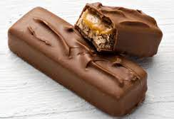
The Best Chocolate bars in Town


Ranking | Name of the Bar | Brand | Taste
1 | Snickers creamy peanut butter | Snickers | Tasty peanut butter with salted caramel
2 | Milky Way crispy rolls | Milky Way | Light milk cream in a crispy chell
3 | Lion | Nestle | Crunchy cereals with caramel and chocolate
4 | Twix classic | Twix | Crispy cookie with creamy caramel
5 | KitKat | Nestle | Waffle with chocolate
6 | Kinder Penguin | Kinder | Cake filled with a with cream
7 | Balisto Beers and Yoghurt | Balisto | Cookie with a beer and yoghurt cream
8 | Pick up strawberry cheesecake | Pick up | Tow Cookies with a chocolate in between

Jokes to laugh out loud, lol
The best jokes you can’t stop laughing
By Elias Kitzberger
Little Johnny asked his father, "Dad, can you write in the dark?"
His father said, "I think so. What do you want me to write?”
Little Johnny replied, "Oh, just sign this report card for me..."

A man receives a phone call from his doctor.
The doctor says, "I have some good news and some bad news."
The man says, "OK, give me the good news first."
The doctor says, "The good news is, you have 24 hours to live."
The man replies, "Oh no! If that's the good news, then what's the bad news?"
The doctor says, "The bad news is, I forgot to call you yesterday."
Fat patient: Doctor, I want to lose weight fast.
Doctor: It is very easy, just keep shaking your head, left and right.
Fat patient: All the time?
Doctor: No, only when someone offers you food.
'Waiter, waiter, there's a fly in my soup!'
'Don't worry, sir, the spider in the salad will get it.'

