Unit 1 Summer stories

1 Listening: Mrs Gee


a) * Listen to the audio and circle the correct answers.
1

1. | Where did Mrs Gee live when she was little? | a) Seattle | b) Singapore | c) Sydney
2. | How old was Mrs Gee when she learnt to swim? | a) three | b) four | c) five
3. | Where did Mrs Gee go ice skating in the winter? | a) on a lake | b) on a pond | c) on a river
4. | What did Mrs Gee do at weekends in Canada? She went … | a) hiking and mountain biking. | b) swimming and hiking. | c) sunbathing and mountain biking.
5. | How many times did Mrs Gee go waterskiing in Canada? | a) often | b) once | c) never

b) Listen to the audio and complete the sentences.
1

1. | When Mrs Gee was little she lived in Singapore .
2. | Mrs Gee learnt to swim when she was ______________________________.
3. | Mrs Gee went ice skating on a pond ______________________________ her house.
4. | At weekends, Mrs Gee went ______________ and _______________________.
5. | Mrs Gee ______________________________ went waterskiing in Canada.

2 Reading: A holiday to remember by Patrick Kelly

What a fantastic holiday we had this year! We went all the way to Australia to stay with my uncle and his family. The flight was good, but long and we didn’t sleep well, so we were exhausted when we got there. This was my parents’ second visit. They flew to Australia once but before I was born and that’s why everything was totally new for me. So many different types of plants, birds and animals and fish! I loved seeing the kangaroos and the furry koalas with my own eyes. They are just gorgeous.
I also really enjoyed watching and listening to the colourful birds in the mornings and in the evenings. The sounds they made were amazing. But the best thing was seeing all the wonderful fish when I learned to snorkel. I was full of excitement every time Uncle John said we were going to the beach to snorkel because of them. After a brilliant day snorkelling and building sandcastles, we liked hiking along the top of the cliffs. Walking is the best way to relax after a busy day at the beach. I can’t wait to go back to Australia again!

a) Read the text and tick T (= true) or F (= false).
 | T |  | F
- Patrick had a fantastic holiday this year.
- The Kelly family felt tired when they arrived.
- This was Patrick’s second visit to Australia.
- Patrick liked to watch birds all day.
- Patrick liked the fish in Australia most.

- Patrick thinks the best way to relax is to go for a walk.

b) * Read the text and complete the sentences with one word.

1. Patrick had a fantastic holiday this year.

2. The Kelly family felt ________________________when they arrived.

3. This was Patrick’s __________________________ visit to Australia.

4. Patrick liked to watch ______________________________in the mornings and in the evenings.

5. The animals Patrick liked most were the ___________________________________________.

6. He thinks the best way to relax after a busy day at the beach is to go _____________________.

3 Writing: The most amazing/awful holiday

a) What was your holiday like? Choose a title. Then write an e-mail (about 100 words) to your English friend about it. Use the phrases below.

went to • travelled by • swam in the • met new friends • had nice food • did a lot of •

the best/worst thing was • I would/wouldn’t like to go there again because

b) * What was your holiday like? Amazing/Awful? Write an e-mail (about 100 words) to your English friend about it. Make sure you answer all the questions.

- Where did you go?
- How did you get there?
- What did you do?
- What was the best thing?
- What was the worst thing?
- Would you like to go there again? Why/Why not?

4 Language in use: What about the Millers?

a) Match the sentence halves below.

1. | Did the Miller family have plans |  | was real?
2. | Did the Millers take |  | friends about his holiday?
3. | Did the elder son want to go |  | the e-mail aloud?
4. | Did the younger son read |  | swimming?
5. | Did Margaret Miller think the e-mail | 1 | for the holidays?
6. | Did Ian want to tell his |  | part in a competition?
7. | Was Marc Miller |  | Fun Time Travel?
8. | Was the e-mail from |  | happy with the e-mail?

b) Fill in the words in the past tense.

1. Ben built (build) a big sandcastle on the beach.

2. Jane ____________________ (go) canoeing on a lake.

3. Anne ____________________ (have) a lovely picnic beside the river.

4. Tom ___________________ (play) beach volleyball with his friends in the afternoon.

5. Guy _____________________ (read) a book under a tree in the garden.

6. John _____________________ (watch) birds flying in the sky.

7. Becky ____________________ (wear) a life jacket in the canoe.

8. Fred _____________________ (eat) some delicious haggis on holiday in Scotland.

c) Make negative sentences and write them down.

1. We went to the Highlands in the north of Scotland.

We didn’t go to the Highlands in the north of Scotland.

2. We visited an art museum in Edinburgh.

__________________________________________________________________________

3. The seals sunbathed alone.

__________________________________________________________________________

4. My brother caught a fish.

_________________________________________________________________________

5. The caterpillar was very furry.

_________________________________________________________________________

6. That was fun.

_________________________________________________________________________

7. The cliffs were very high and steep.

_________________________________________________________________________

8. There were many lizards on the rocks.

_________________________________________________________________________

d) Write questions about the children’s holiday activities in the past tense. Write a short answer.

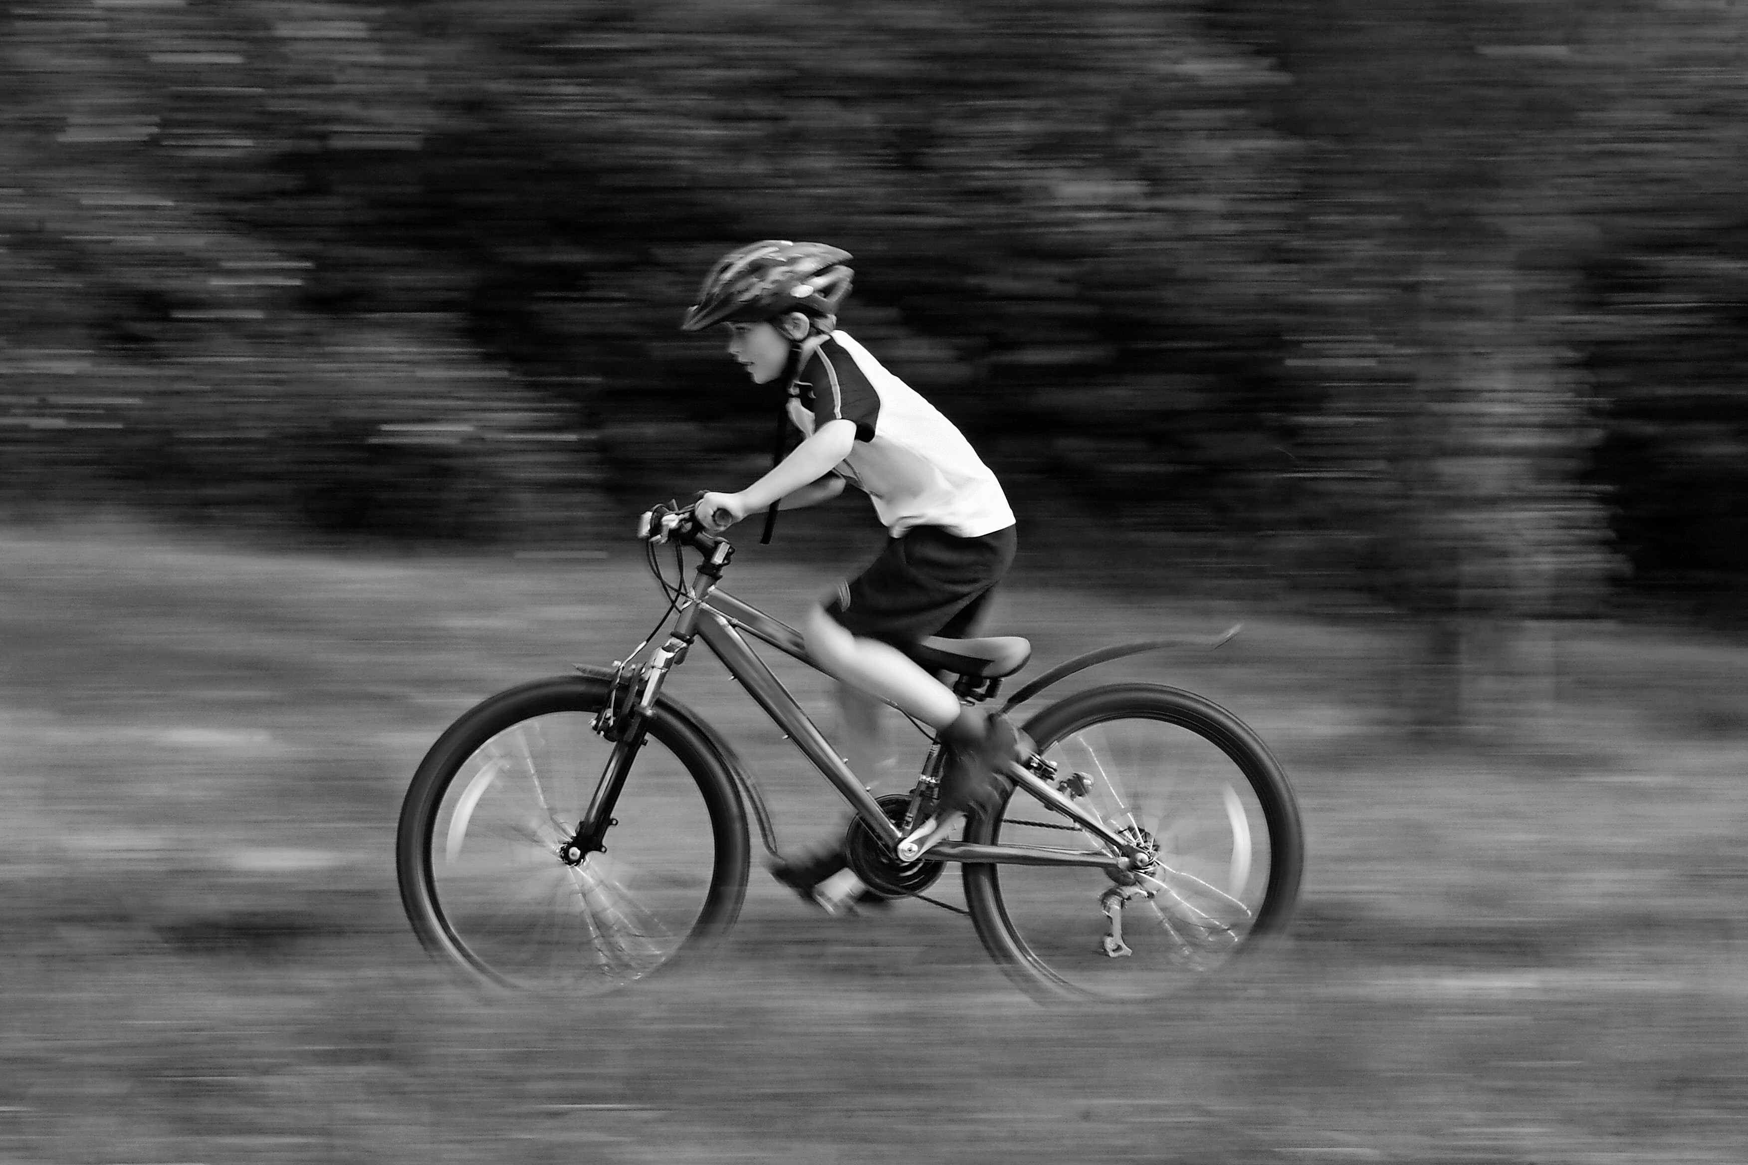 |  | 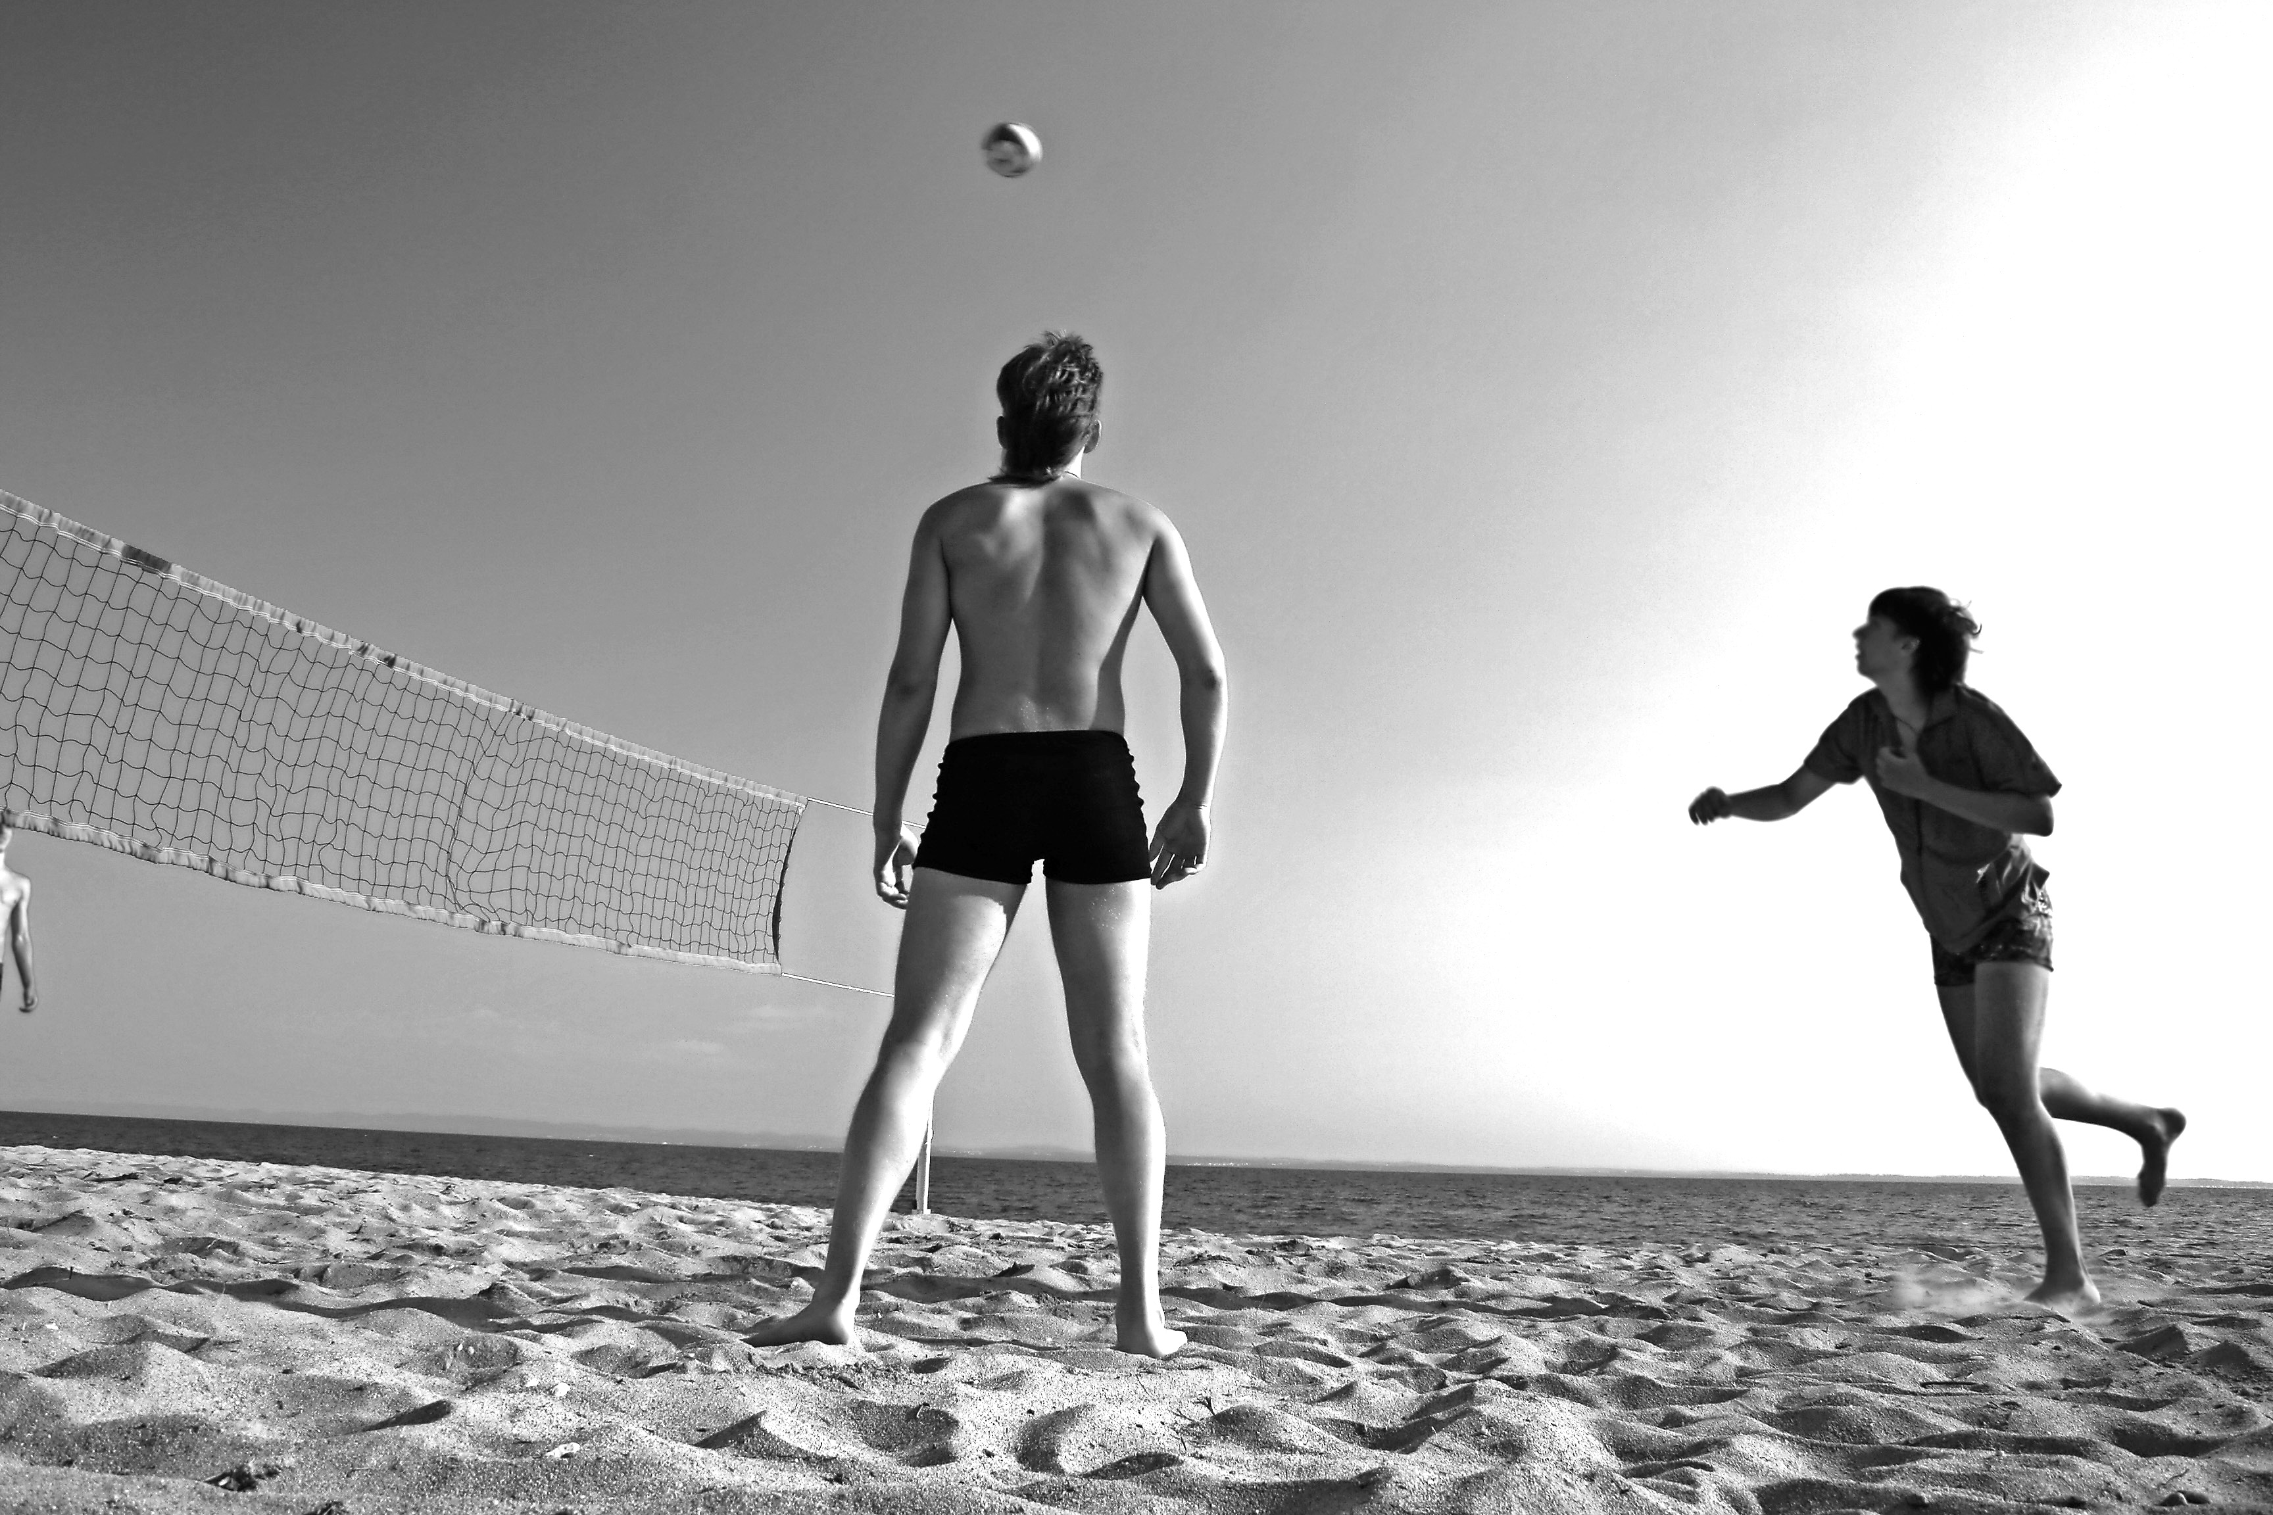
Jack () | Alice (x) |  | Terrence ()
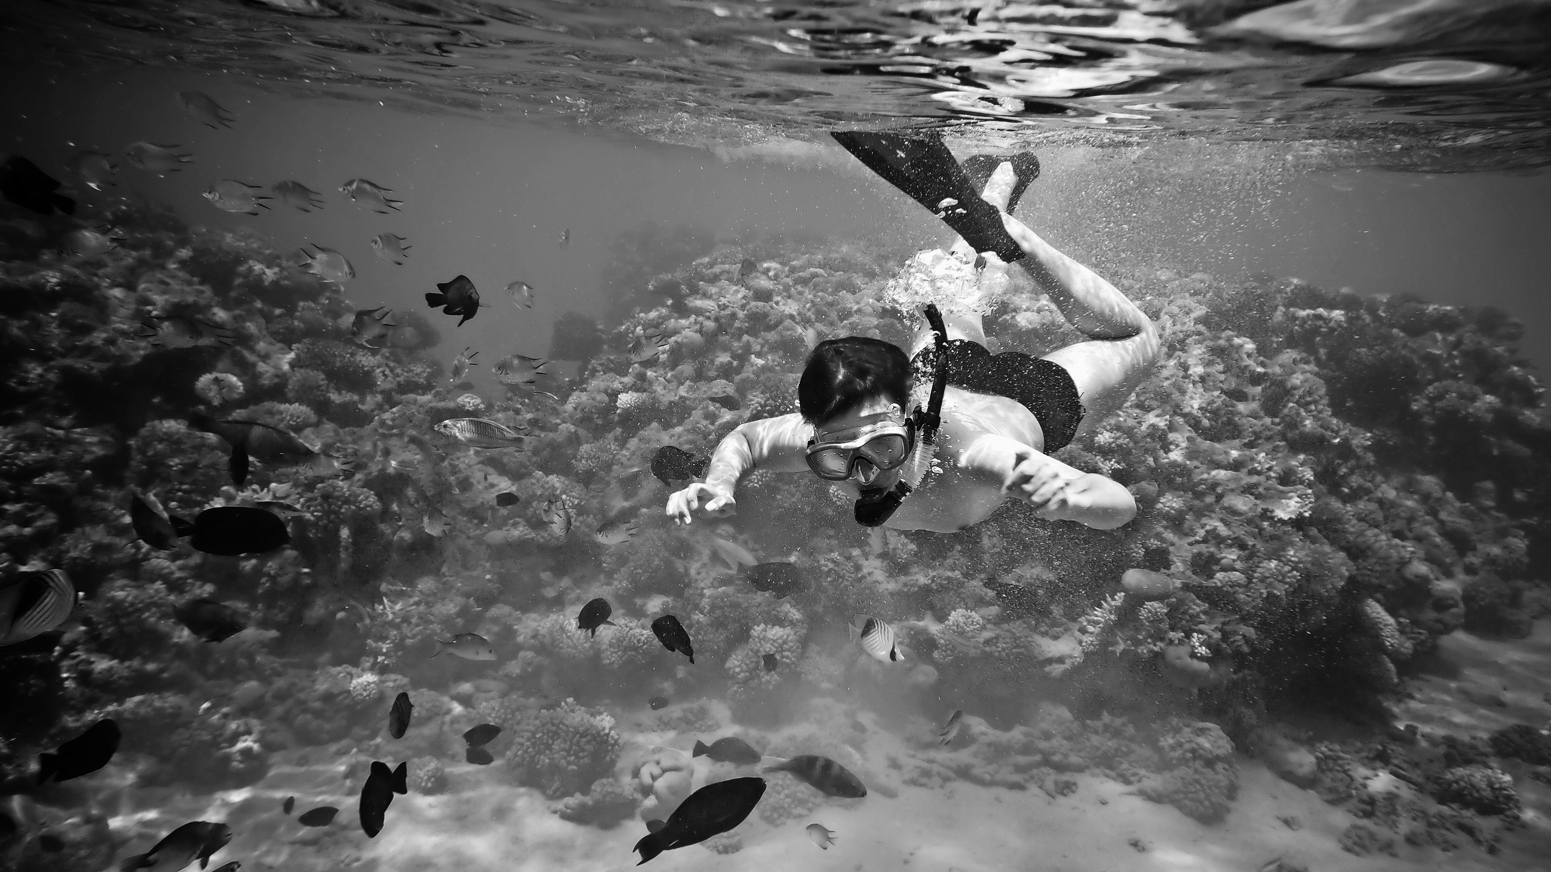 | 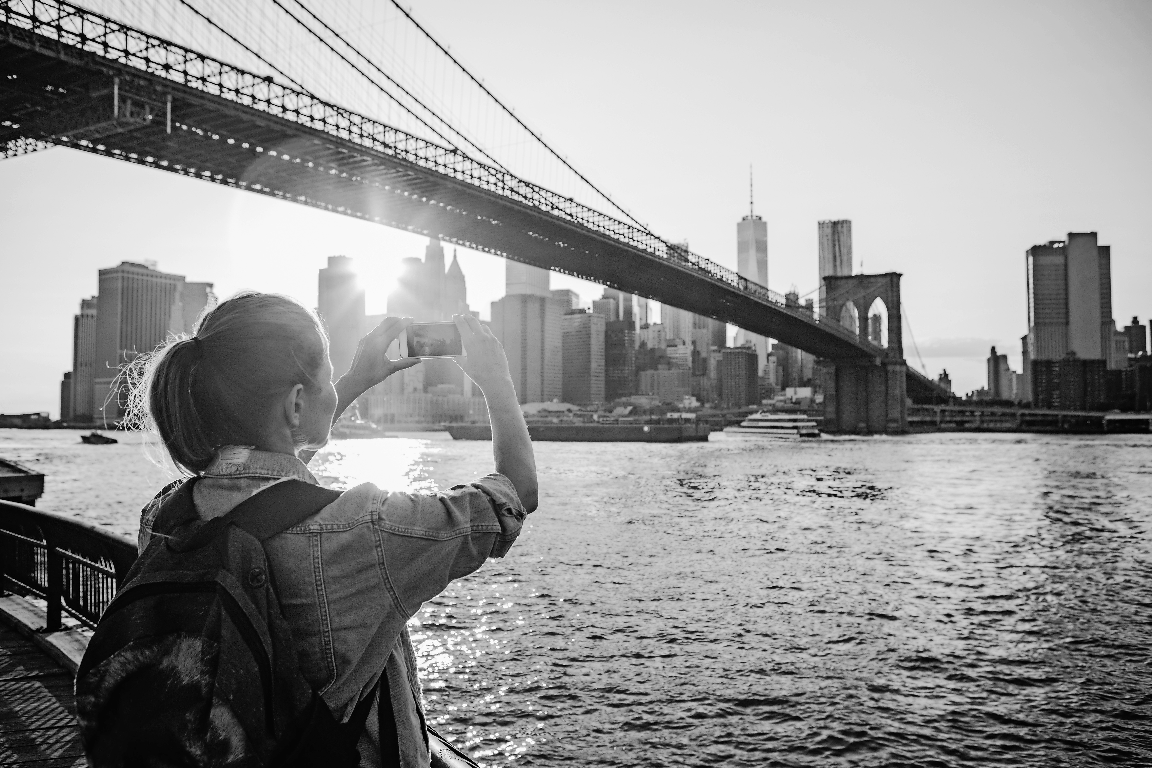 |  | 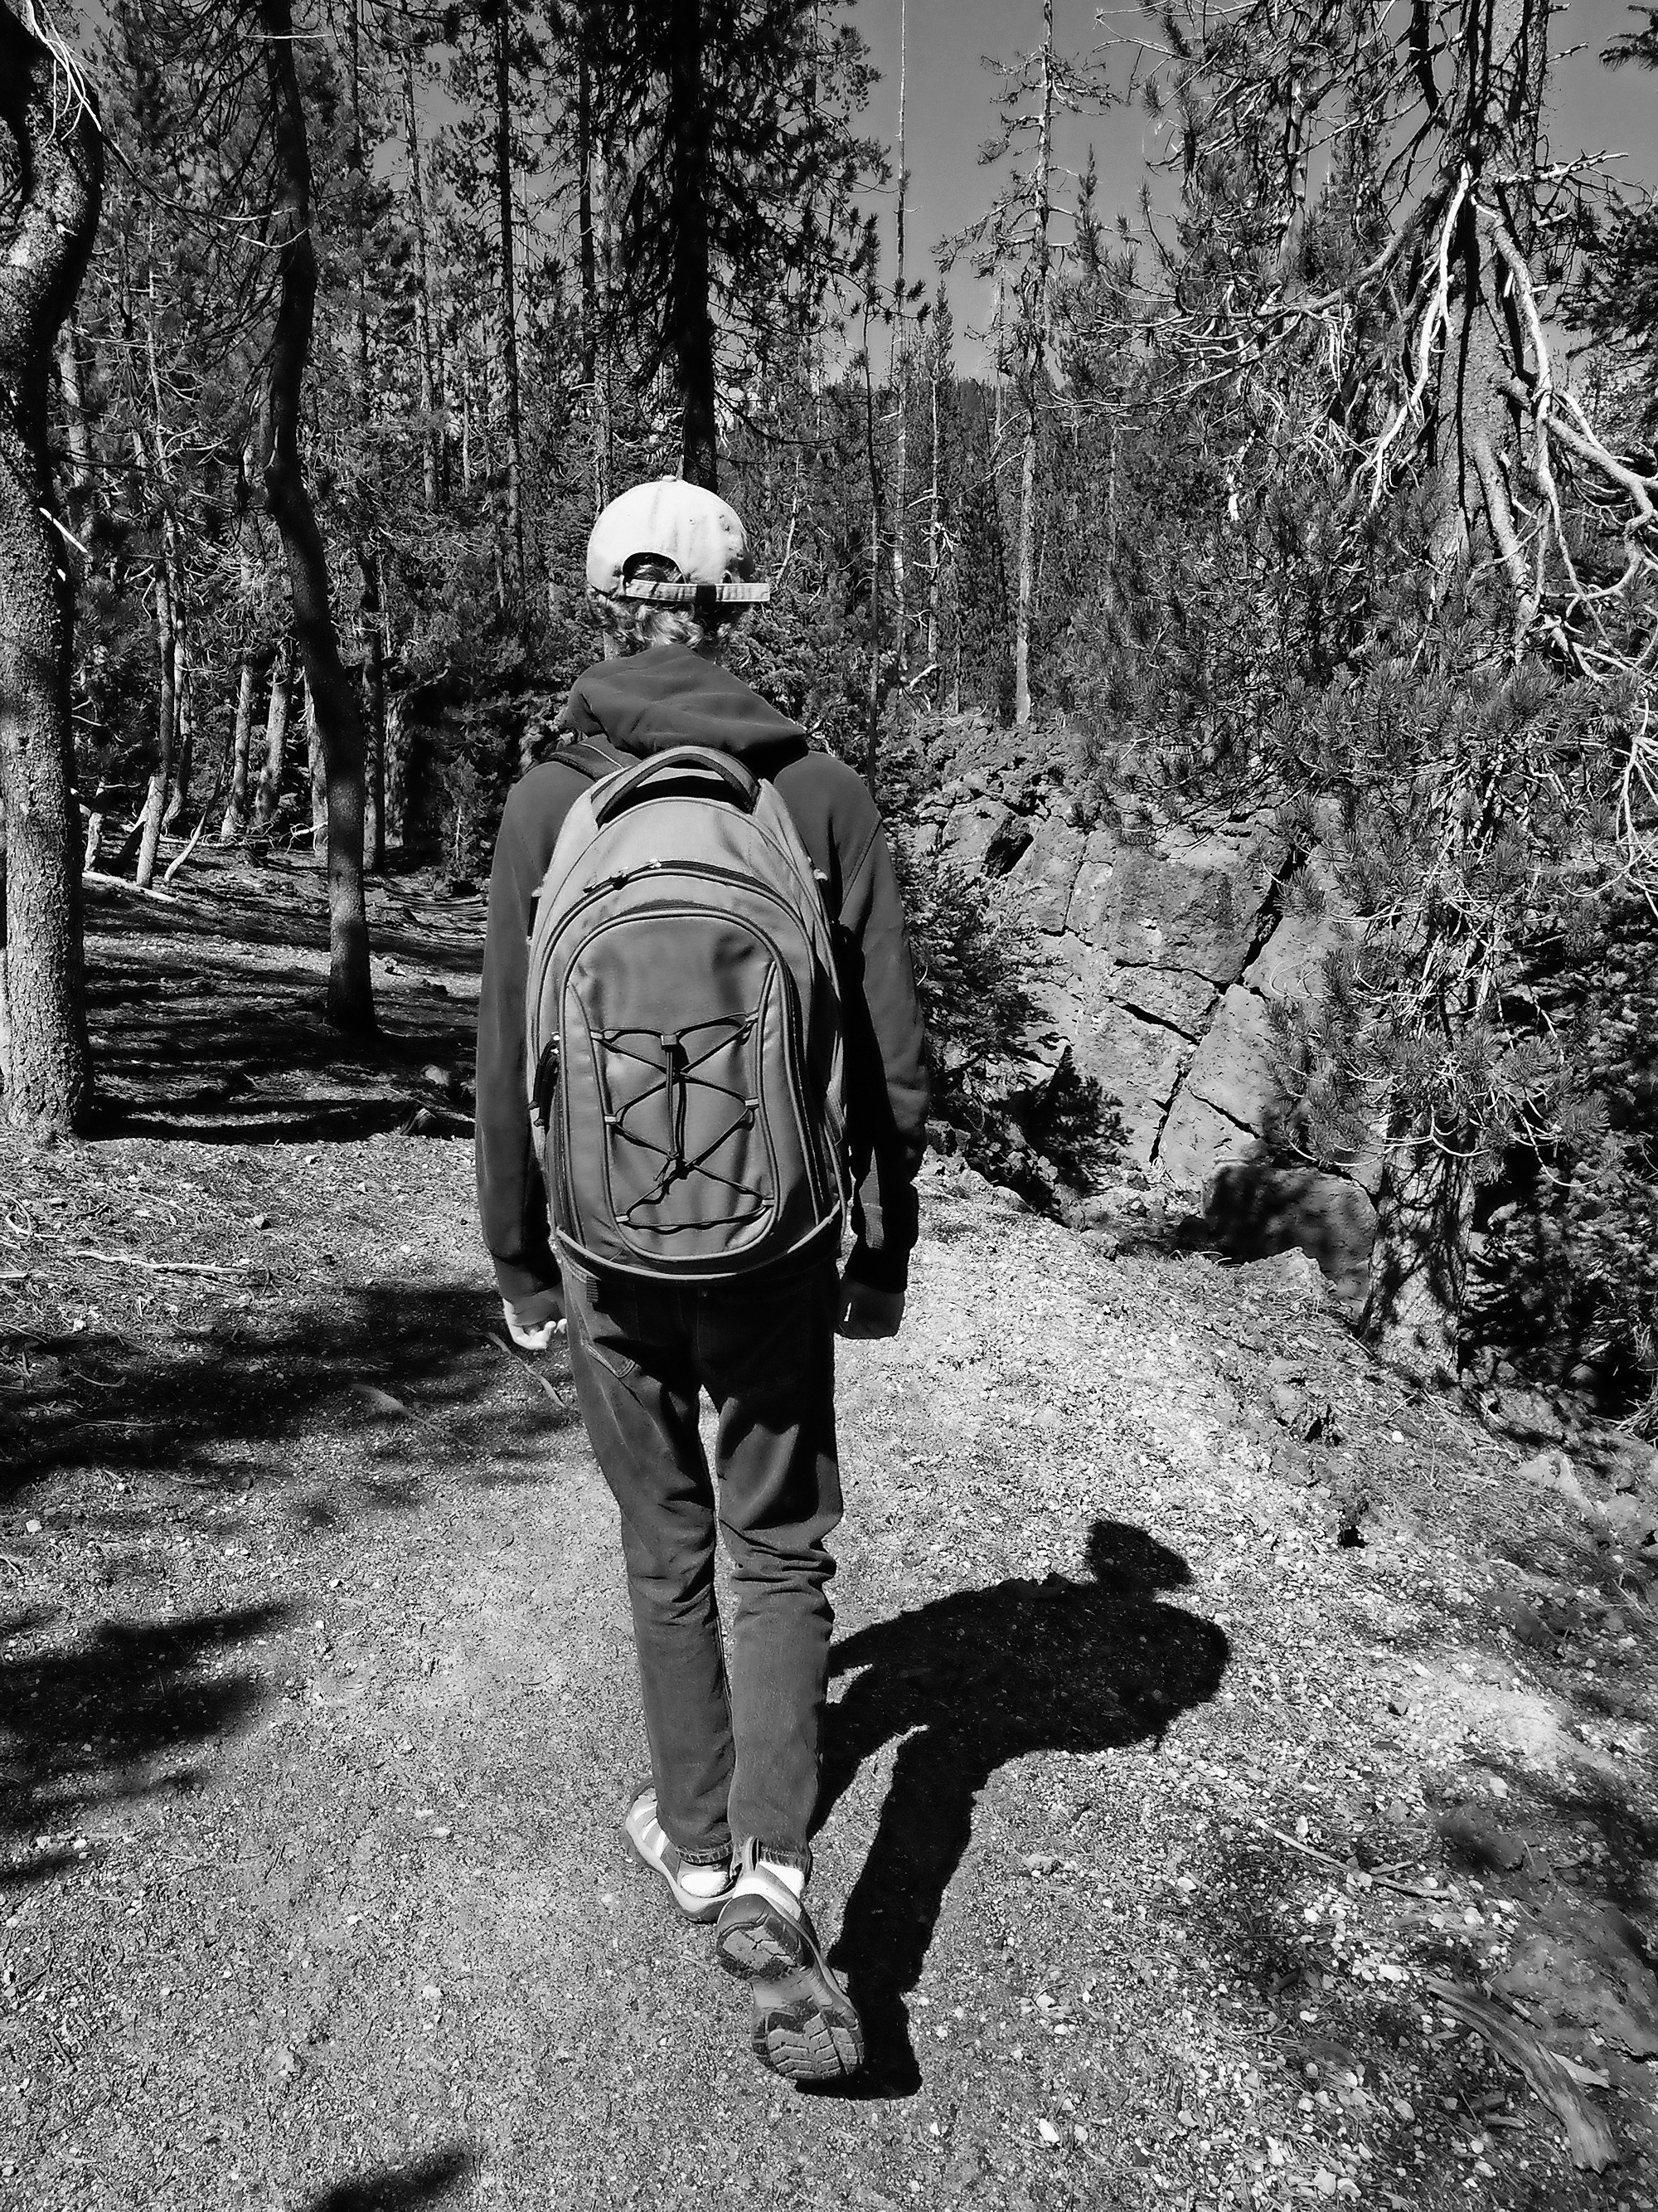
Gary (x) | Jenny (x) |  | Frank ()

1. Did Jack go mountain biking in the holidays? Yes, he did.

2. _______________________________ in the holidays? _____________________________

3. _______________________________ in the holidays? _____________________________

4. _______________________________ in the holidays? _____________________________

5. _______________________________ in the holidays? _____________________________

6. ________________________________ in the holidays? _____________________________

