Unit 2 School life

1 Listening: Podcast from a school in Kenya


a) Listen to Margaret’s podcast then tick T (= true) or F (= false).
2
 | T |  | F
- There are no boys in Margaret’s class.
- Margaret sleeps at her school.
- She can speak Spanish.
- Her favourite subject is physics.
- Margaret is speaking in the school kitchen.

- School ends on Thursdays at half past three.

b) * Listen to Margaret’s podcast and fill in the missing words.
2

- Margaret is from Kenya.

- Margaret’s ______________________________________went to school there.

- She wants to learn ________________________________________________.

- Her favourite subject is ____________________________________________.

- Margaret is speaking in the school ___________________________________.

- On Thursdays, school ends at _______________________________________.

2 Reading: Cool school trip!

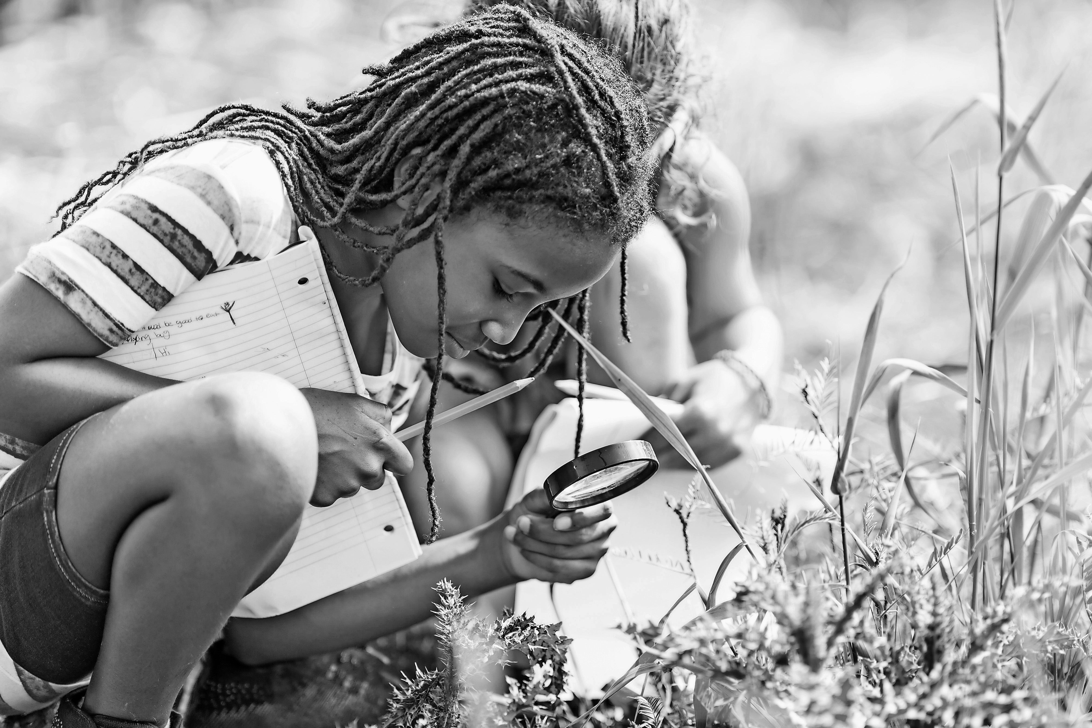 | 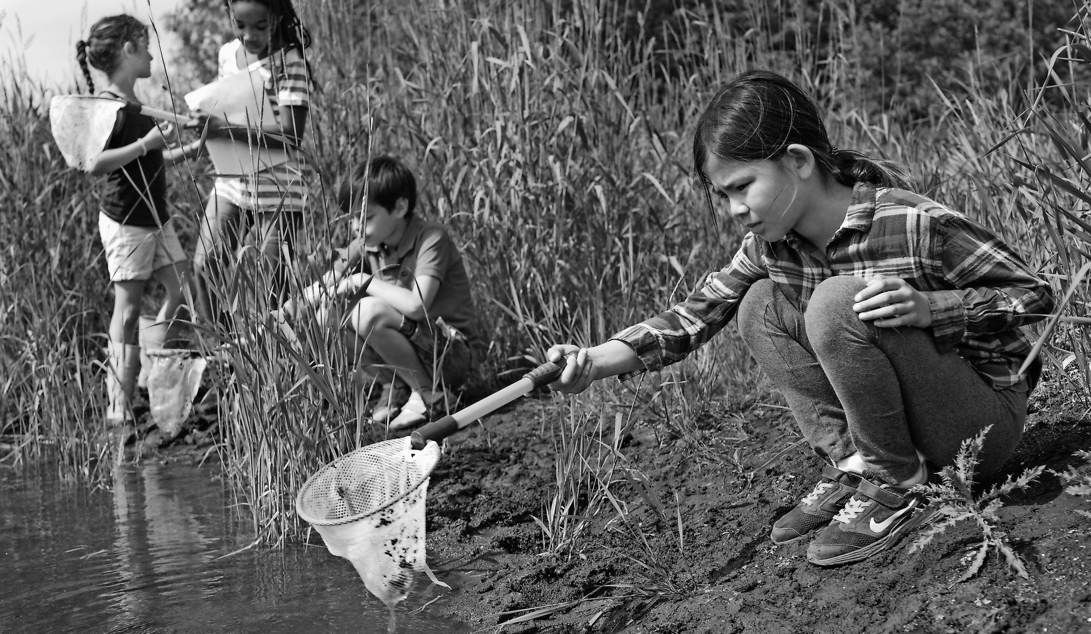 | 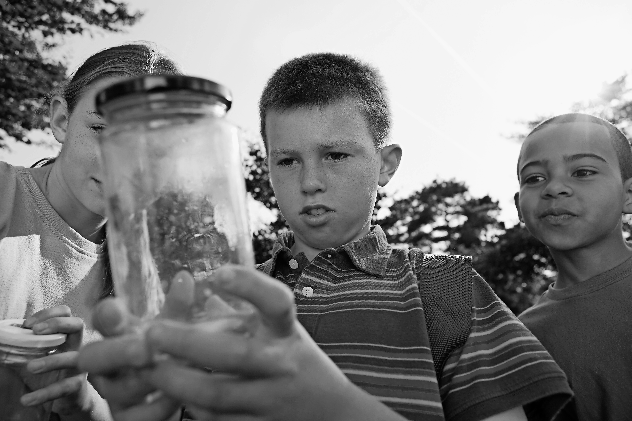
A | B | C
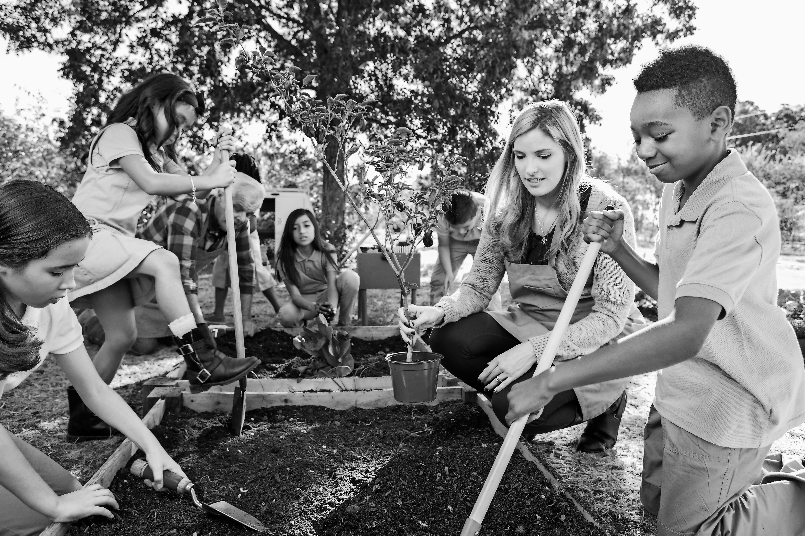 | 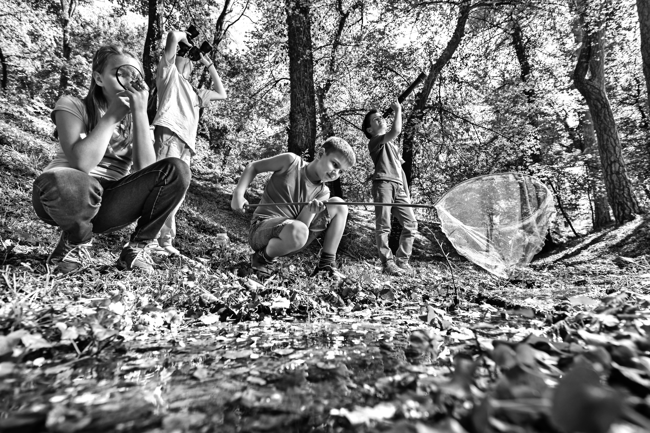 | 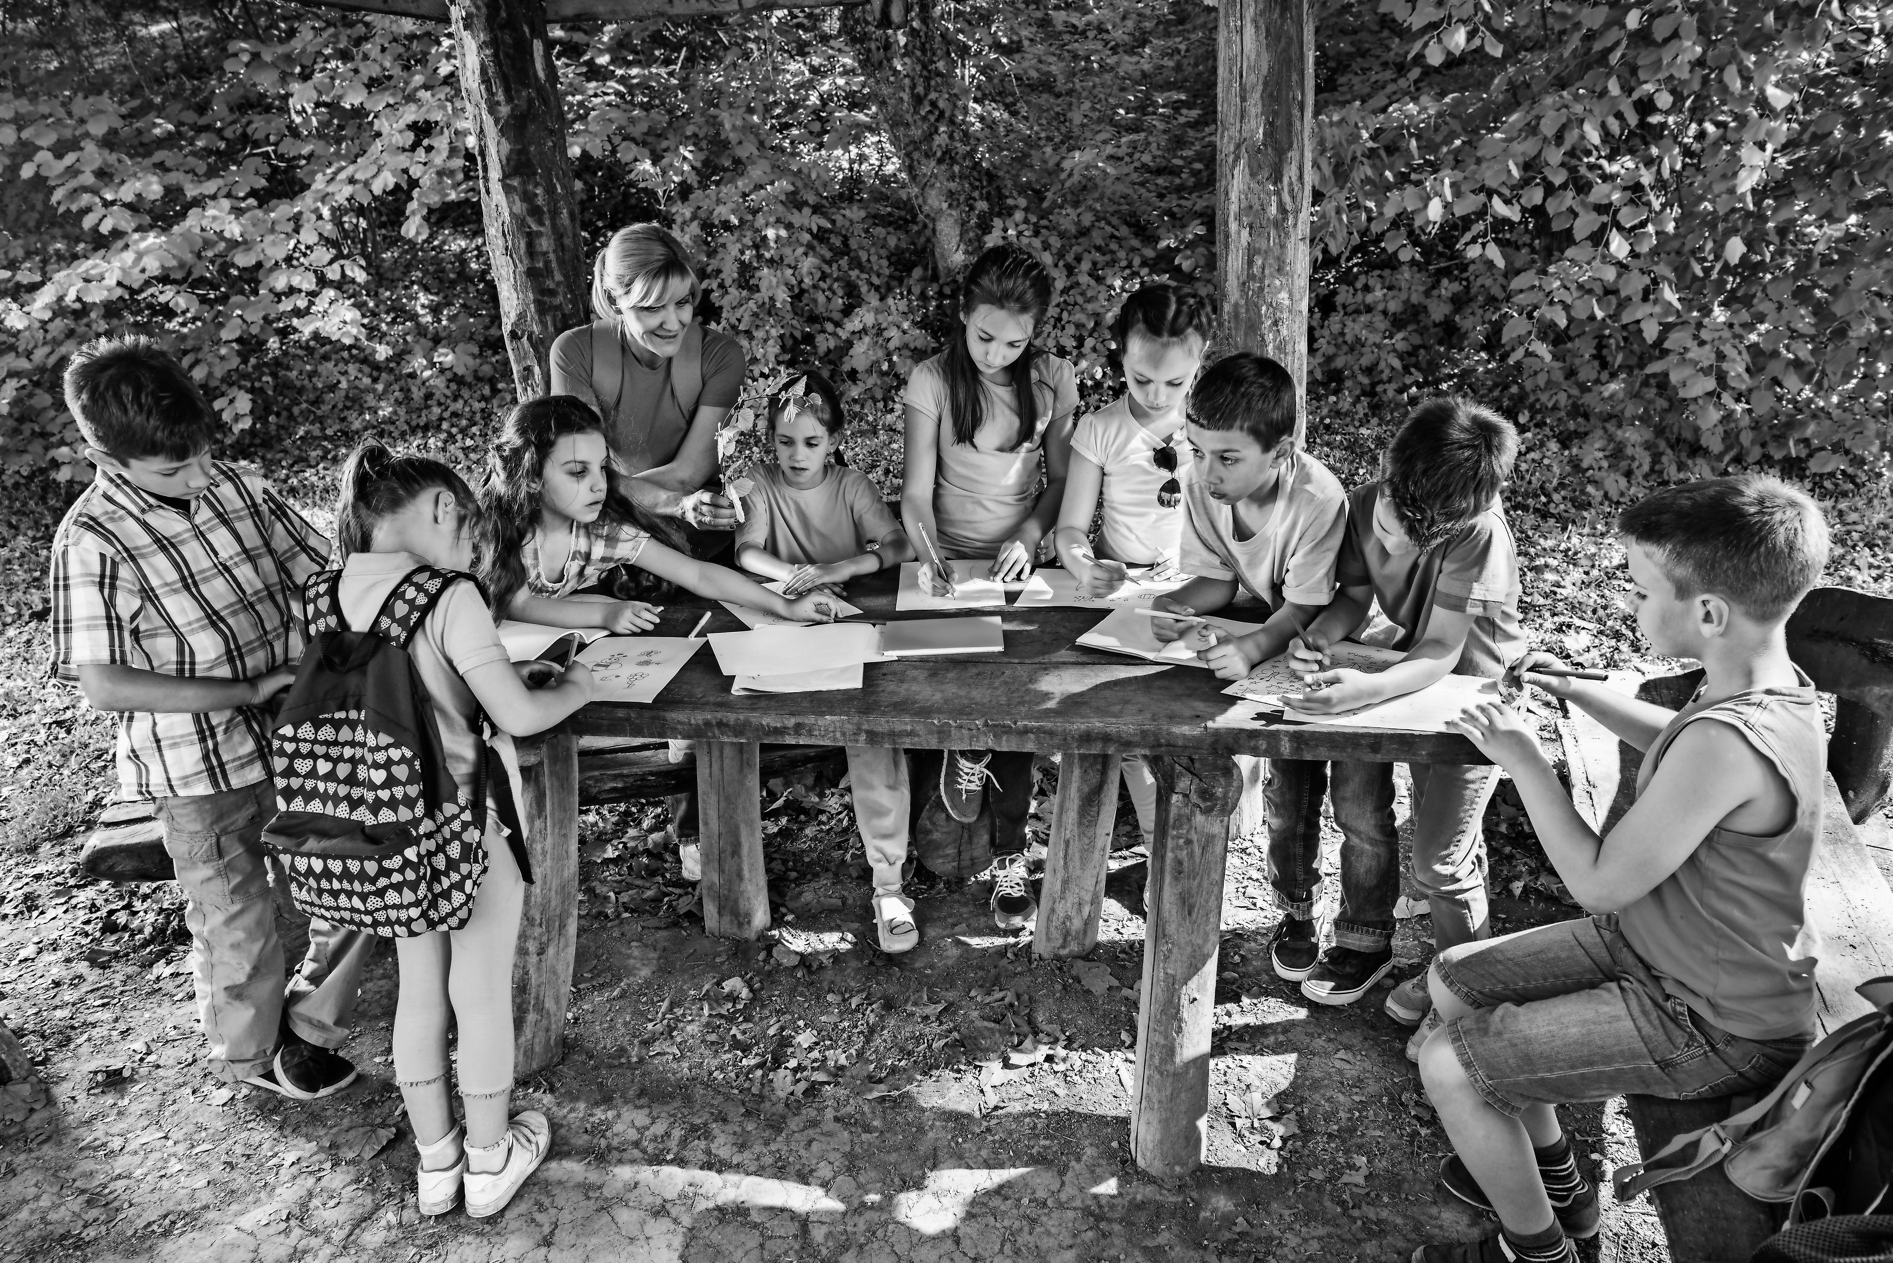
D | E | F

a) * Read the text messages from children on a school trip to their parents. Match the text messages to the correct photos. Write the correct letter next to the text message. There is one extra photo.

- We are having a fantastic school trip! Every day we have to work in a new team.
That’s cool, because I love talking to everyone. Today we went to the forest and learnt how to plant and look after very young trees. It was really interesting. D

- It was great to be outside! We had to work in teams and each of us had a special job. Some had to look carefully for birds and insects in the trees, but I was the lucky one because I had a fishing net and caught many things in the water! _____

- Had an absolutely super day! Nature all around. Most of us had a fishing net and we collected lots of things out of the water. Helen nearly ran into the water when she heard a noise in the high grass next to us! _____

- Today was brilliant! We had to concentrate on the plants and small animals around us. The insects were fascinating. We had to draw and write about what we saw. Some of my drawings looked really funny because we didn’t have a table to write on! _____

- What a great school trip! We had to find and collect something we really liked to draw and write about. Some of us sat down to do this, but most of us stood around a big table to do it. My drawing was really good! _____

b) Read the text messages from Marla to Michelle about her school trip. Match Marla’s messages with the photos. Write the correct letter in the box. There is one extra photo!

A | B | C
D | E | F

D
- We’re having a fantastic school trip! Today we went to the forest and learnt
how to plant and look after very young trees. It was really interesting.

- It was great to be outside! We had to work in teams and each of us had a special job. Some had to look carefully for birds and insects in the trees, but I was the lucky one because I had a fishing net and caught many things in the water!

- Then we went out of the forest and Mrs Davies gave most of us a fishing net
to collect more fish and insects with. Helen nearly ran into the water when she heard a noise in the high grass next to us!

- We had to concentrate on the plants and small animals around us. The insects were fascinating. We had to draw and write about what we saw. Some of my drawings looked really funny because we didn’t have a table to write on at first!

- And finally we had more time to finish drawing and writing. Some of us sat down to do this, but most of us stood around a big table to do it. I did a new drawing and it was really good in the end!

3 Writing: My dream school

a) Write a text (about 100 words) for an English school magazine about your dream school. Use the phrases below.

My dream school should/shouldn’t • I think • Of course • teachers should/shouldn’t •
parents should/shouldn’t • children should/shouldn’t • boys should/shouldn’t •
girls should/shouldn’t • In our classroom there should/shouldn’t be • I wish

b) * Write a text (about 100 words) for an English school magazine about your dream school. Make sure you answer all the questions below.

- When should/shouldn’t the lessons start/end?
- What subjects should/shouldn’t there be? Why?
- What should/shouldn’t teachers/parents do?
- What should/shouldn’t children/girls/boys do?
- What should there be in your school/classroom? Why?
- What do you wish you had more of in your school? Why?

4 Language in use: Life at school

a) What subjects are the children describing?

1. “I like learning it because there are many words that are almost the same in English, like bread is Brot, or nose is Nase.”

German

2. “It’s cool because you learn about the different countries in the world and about the people who live there.

______________________

3. “I drew this in class last week and this week I’ll use my box of paints to colour it in.”

______________________

4. “We have to bring some wool and knitting needles because we’re going to knit a winter hat tomorrow.”

______________________

5. I really love it because I’m fascinated by computers and the programs you can create with them.”

______________________

6. “We should have it first thing every day. Moving around and getting exercise puts you in a good mood for the rest of the day.”

______________________
b) Use the words in the brackets to complete the comparisons.

1. Biology is as interesting as physics because I like them both. (interesting)

2. Gardening is _______________________ cooking because I prefer growing vegetables.
(interesting)

3. Maths is ___________________________German because I’m better at numbers. (easy)

4. Mark is ________________________________ Paul because he is often serious. (funny)

5. Fiona thinks cooking is______________________ gardening because she can’t cook and she can’t garden. (difficult)

6. Norbert thinks art is ________________________ German because he prefers looking at pictures. (cool)

c) Match the sentence halves below. There is one extra half.

1. | Children should play |  | their children about their day at school.
2. | They shouldn’t use |  | friendly all the time.
3. | Parents should ask |  | outside every day.
4. | People at school should try to be |  | not in the school café.
5. | Everyone should go |  | enough time to do their homework.
6. | Children should have | 1 | with their friends in the break.
 |  |  | their mobile phones in school.

