Unit 3 My hometown

1 Listening: Excuse me, where’s the library?


a) * Listen to the dialogue and tick T (= true) or F (= false).
3
 | T |  | F
- The man wants to know the way from the bank to the library.
- It’s about twenty minutes by bike to the library.
- The man takes out a map to show the young woman.
- The man has to go past the post office.
- He has to cross Central Drive.

- He turns left after the cinema.

- He has to walk along Acorn Drive.

- He takes the second road on the right.

b) Listen to the dialogue. Draw the route on the map with a red pen. Fill in the word library in the correct space on the map.
4

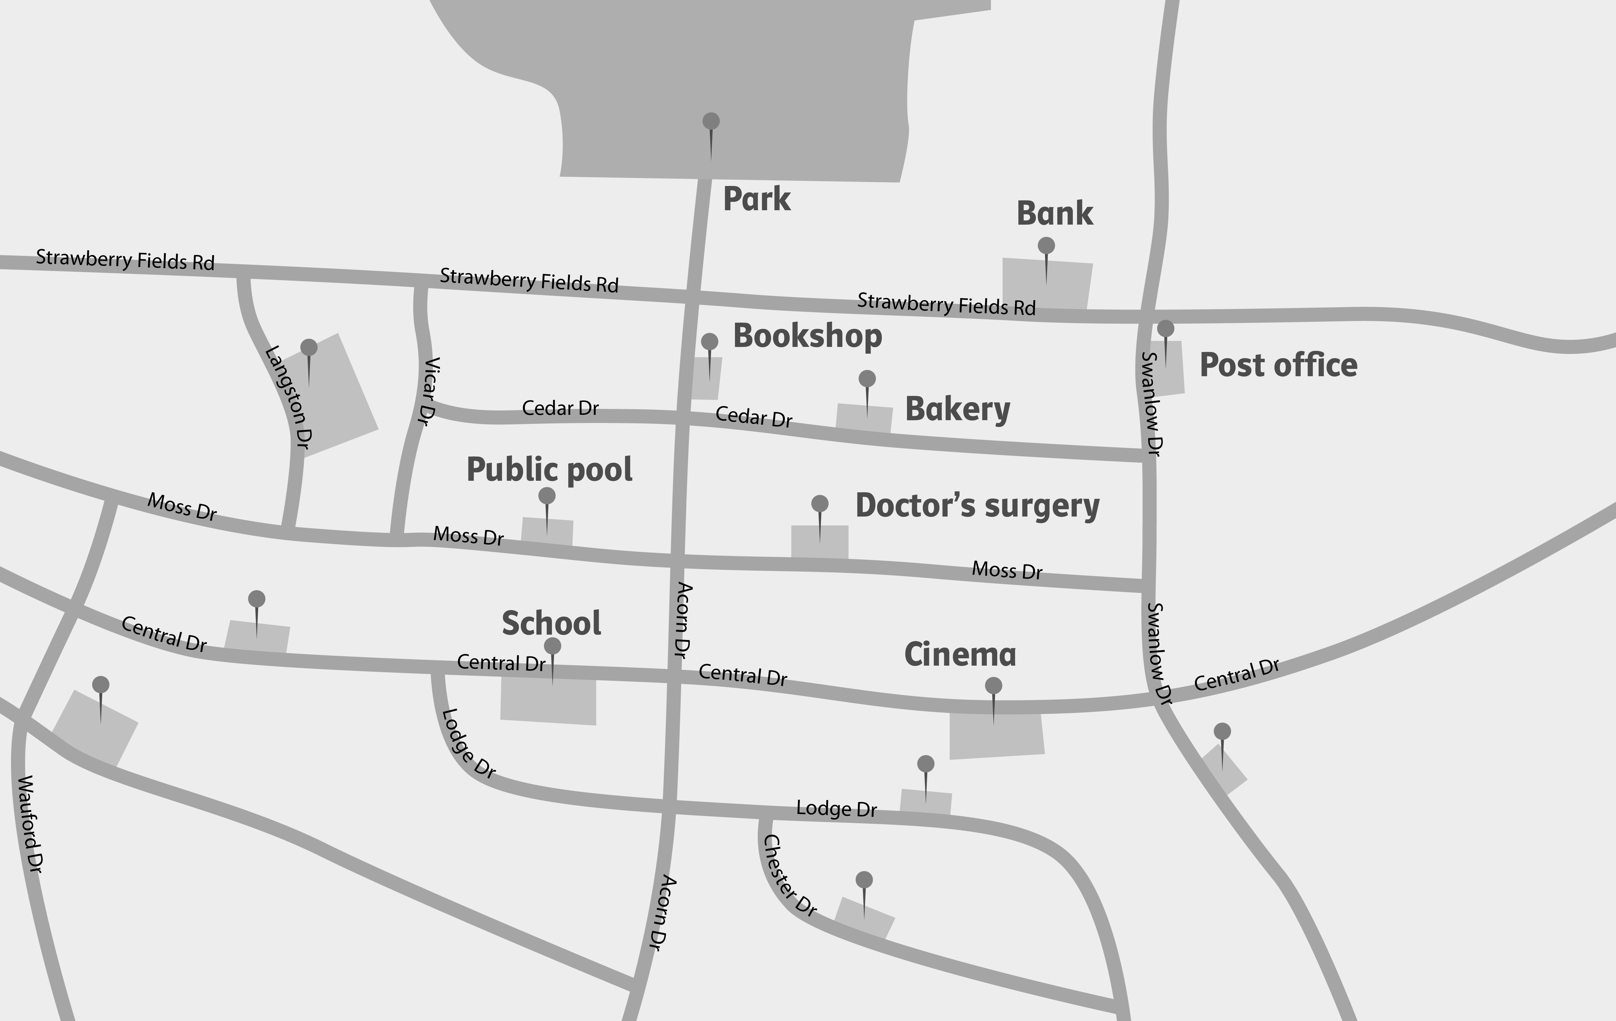

2 Reading: Where I live

a) Read the text and tick T (= true) or F (= false).

Hi, I’m Siobhan and I’m from Ireland. Before I was born, my parents decided they wanted to live in the country and so they moved to this fabulous caravan park. Most people don’t believe me when I tell them it is the only home I know.  All the caravans are traditional wooden ones. There are lots of them, but the people who live here like their peace and quiet. In the summer we like to have  a barbecue with four of the families who live next to us, but that’s it. We don’t see any other people around. Sometimes it’s too quiet here for a teenager. When I start working and earn some money I’ll be able to move into a different home. | Hi there, my name’s Dwayne and I live in Canada. When I was six we moved to this great log house out in the countryside. Before that we lived in a small flat in a horrible village.  Now we live in the forest.  At first we lived in a tent. Then we cut down the trees and used them to build our house. When it was finished we invited everyone who lived near us to our house for a party.  Lots of people came and it was great fun. We decided to make it a tradition and have a barbecue for our neighbours every year.  When I’m older I want to go to university and I’ll have to live in the city. That will be cool, too. | Hello, this is Abigail from Australia writing about where I live, the best city in the world! We lived in two cities before we came here, but they weren’t as good as this one.  We live in the old part of the city and many of the houses are made of wood, but not ours. It’s a really nice terraced house made out of red bricks.  When we moved here we were a bit lonely at first, but then we made friends with the two families next door to us. After some time we got to meet more people who live in our street and now everyone knows everyone in Acorn Road. And that’s the reason why I want to stay here for the rest of my life.

 | T |  | F
- Siobhan likes the place where she lives.
- Dwayne lives in the country.
- This is Abigail’s second home.
- Siobhan and Dwayne live in houses made of wood.
- Dwayne and Abigail know many neighbours.

- Siobhan and Abigail would like to move to a new house.

b) * Read the text and circle the correct answers. One, two or all answers can be correct.

Hi, I’m Siobhan and I’m from Ireland. Before I was born, my parents decided they wanted to live in the country and so they moved to this fabulous caravan park. Most people don’t believe me when I tell them it is the only home I know.  All the caravans are traditional wooden ones. There are lots of them, but the people who live here like their peace and quiet. In the summer we like to have  a barbecue with four of the families who live next to us, but that’s it. We don’t see any other people around. Sometimes it’s too quiet here for a teenager. When I start working and earn some money I’ll be able to move into a different home. | Hi there, my name’s Dwayne and I live in Canada. When I was six we moved to this great log house out in the countryside. Before that we lived in a small flat in a horrible village.  Now we live in the forest.  At first we lived in a tent. Then we cut down the trees and used them to build our house. When it was finished we invited everyone who lived near us to our house for a party.  Lots of people came and it was great fun. We decided to make it a tradition and have a barbecue for our neighbours every year.  When I’m older I want to go to university and I’ll have to live in the city. That will be cool, too. | Hello, this is Abigail from Australia writing about where I live, the best city in the world! We lived in two cities before we came here, but they weren’t as good as this one.  We live in the old part of the city and many of the houses are made of wood, but not ours. It’s a really nice terraced house made out of red bricks.  When we moved here we were a bit lonely at first, but then we made friends with the two families next door to us. After some time we got to meet more people who live in our street and now everyone knows everyone in Acorn Road. And that’s the reason why I want to stay here for the rest of my life.

1. | Who likes his/her home? | a) Siobhan | b) Dwayne | c) Abigail
2. | Who lives in a city? | a) Siobhan | b) Dwayne | c) Abigail
3. | This is ... first home. | a) Siobhan’s | b) Dwayne’s | c) Abigail’s
4. | Who lives in a house  made of wood? | a) Siobhan | b) Dwayne | c) Abigail
5. | Who knows many neighbours? | a) Siobhan | b) Dwayne | c) Abigail
6. | Who would like to move  to a new house? | a) Siobhan | b) Dwayne | c) Abigail

3 Writing: My hometown

a) Write a blog (about 100 words) about the place you live in. Use the phrases below.

I live in • It is • Nearby, ... • I/We often • When I am older I would like to live •

I think living in a village/in a town/in the country is ... because

b) * Write a blog (about 100 words) about the place you live in. Make sure you answer all the questions.

- Where do you live (house, apartment …)?
- What does it look like?
- Do you live in a town/in a village/in the country? What is nearby?
- What goes on there?
- Are you happy where you live? Why/Why not?
- Where would you like to live when you are older?

4 Language in use: Living in different places

a) What are the other words for the following definitions?

1. a place where you can do lots of sports sports centre
2. animals living in nature _________________________________________________

3. people living in a town/city/country … ______________________________________
4. the area near your home ________________________________________________
5. a place where you spend some days without working __________________________

6. a musical show out of doors _______________________________________________

b) Fill in the gaps with the correct form of the verb (Present tense simple or Past tense simple).

Two years ago my family and I moved (move) [1] from London to Cartmel. It __________ (be) [2] a small village in the Lake District and many tourists __________________ (like) [3] to visit the village, especially in the summer. My mum and dad ________________ (be) [4] tired with their stressful jobs in London and so they _______________ (decide) [5] to get new jobs in a more peaceful place. When they _________________ (tell) [6] me about the move I was very unhappy and ________________ (cry) [7] a lot, but it _____________________ (not stop) [8] us from moving. At first I found it difficult because I ____________________ (not know) [9] anyone and I _________________ (miss) [10] all my friends in London so much. But then I ______________ (meet) [11] Ashley and she _______________________ (show) [12] me around and introduced me to all of her friends. Now after living in Cartmel for two years I really __________________ (love) [13] it and my parents ______________ (be) [14] very happy too.

c) Put the words in the correct order and write them down.

1. I • a • dog • I • as • had • wish • a • pet

I wish I had a dog as a pet.

2. I • had • my • wish • a • I • lovely • in • room • fireplace • living

__________________________________________________________________________

3. I • bigger • wardrobe • wish • I • a • in • had • bedroom • my

__________________________________________________________________________

4. I • more • test • my • I • to • learn • wish • time • for • had • tomorrow

__________________________________________________________________________

5. I • more • to • pocket • money • had • wish • I • games • on • spend • computer

__________________________________________________________________________

__________________________________________________________________________

6. I • an • help • to • wish • I • sister • homework • with • my • had • me • older

__________________________________________________________________________

__________________________________________________________________________

